*Dear Colleagues and Friends of D31 Schools:*

*Welcome to the first issue of The Thirty-One Scoop! It is so exciting for me to be able to share with all of you some of the great things that are happening at our schools. Our schools are working to build college and career readiness, fostering environments that promote reflective thinking for students and adults, incorporating the arts into instruction, and, inter-visiting with one another, and working to share best practices and support other schools to improve student achievement.*

*Our most recent Principal Professional Learning Conference featured a workshop facilitated by former District 31 Superintendent, Jessica Jenkins and District 31 teacher, Richard O’Connor, during which principals engaged in a simulated student learning experience focused on engaging students in productive struggle. The afternoon session was devoted to having learning focused conversations with teachers. It was a day full of learning, reflection, productive conversation, and bonding. I look forward to our continued work together!*

Aimee

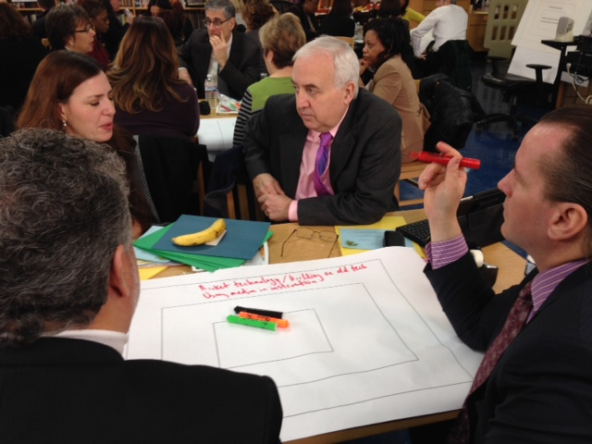 

 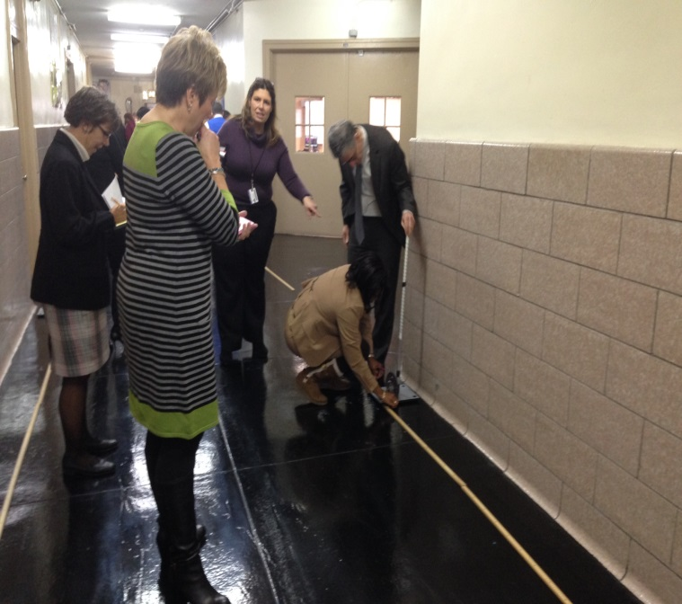

Susan E. Wagner High School – United for Performances

Principal Gary Giordano

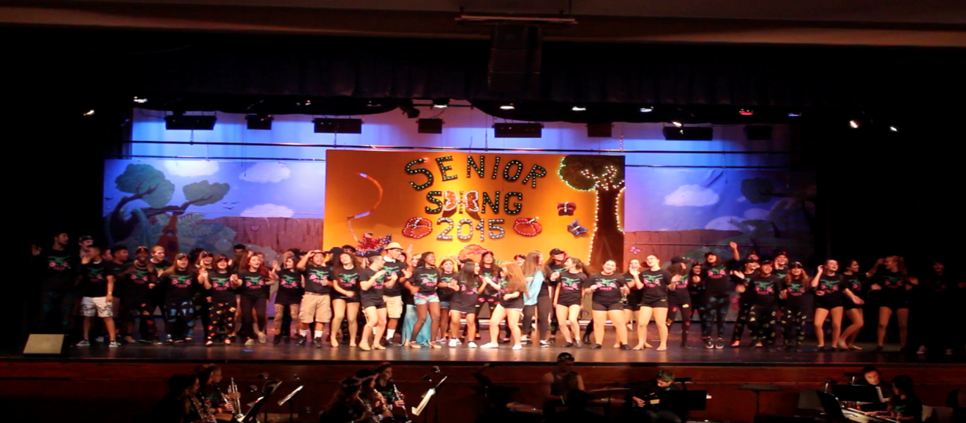

During the month of November, Susan Wagner hosted its annual performance of SING- a production known by all island-wide written and performed exclusively by the students.  The three competing acts, The Sophmen (Freshman and Sophomores) the Juniors and Seniors spend countless hours selecting music, writing lines, choreographing dance moves and putting it all together before the November 6th Opening Night.  Although all students poured their heart and soul into the performances, the Seniors stole the show with another SING Victory.

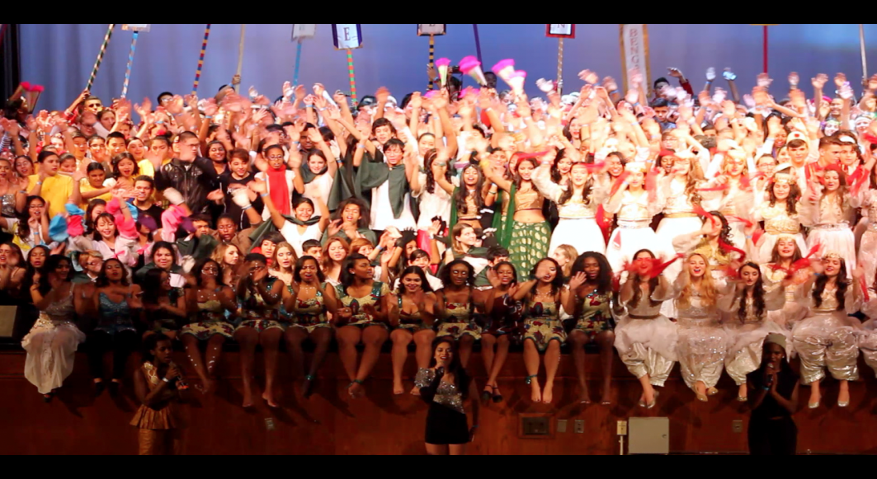

As we do every year, our Fall Term ends with our one-of-a-kind International Festival, which illustrates the many diverse cultures proudly represented at Susan Wagner High School.  This show not only reflects the school’s diversity, but exemplifies the unity and respect students share for one another.  It furthermore supports our school’s mission of educating our students to become socially conscious citizens with respect for all peoples of our society.

Port Richmond High School and a Broadway Experience

Principal Timothy Gannon

Through our partnership with the Education Department at Roundabout Theatre Company, 40 students were able to partake in a Postcard Production Workshop on December 9, 2014.  Students were divided into teams, including Acting, Stage Managing, Directing, Singing/Choreography, Lighting Design, Sound Design, Stage Crew, and House Management/Marketing, and worked to fashion a full-scale scene production from the musical *Cabaret*  within a two-hour time frame.  The following day, on December 10, we were thrilled to bring 90 students to Roundabout's production of Cabaret on Broadway, starring Alan Cumming and Emma Stone.  We are incredibly excited to expand our partnership with the wonderful folks at Roundabout, who will be working to aid students working on the Spring Musical "In the Heights," in the capacities of Music Direction and Stage Management. We will also be taking another group of students to see Roundabout's production of "On the 20th Century" in late April.

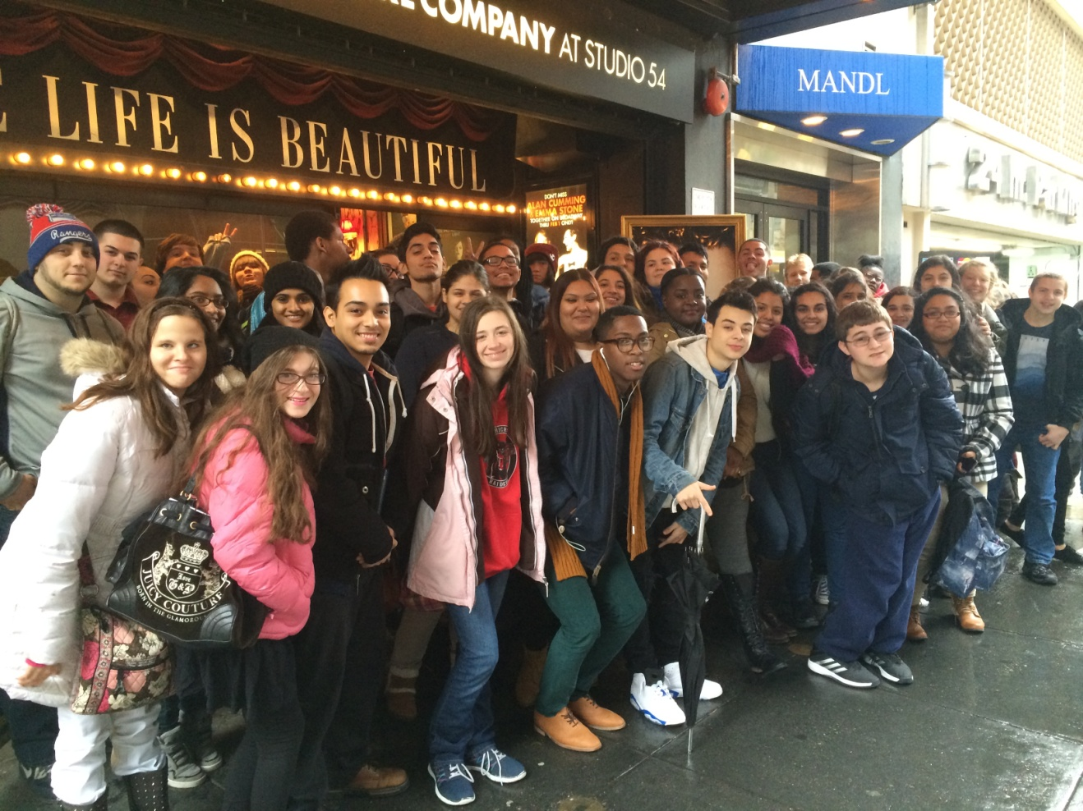

TV Production students produce episodes of our weekly news show ***Good Morning Port Richmond!*** which can be found online by *googling* GMPR!. Students also covered a news event at the request of the Borough President’s Office. Borough President Oddo and former Brooklyn Borough President Markowitz hosted an event on New Dorp Lane which highlighted the extraordinary dining experiences open to Staten Islanders across the borough. Television production students interviewed the dignitaries and provided a documentary of the evening’s activities. Good Morning Port Richmond Reporter Steven Gordillo interviews former Brooklyn Borough President Marty Markowitz

Curtis High School - Goes Hi-Tech

Principal Aurelia Curtis

By: Kailey Walters, Staff writer with the Curtis Log

Curtis has started the largest technological initiative in its over 100 year history. This new initiative involves distributing the Samsung Chromebook to nearly 500 Curtis IB and SIS students. “If technology is not in the hands of students, it is not effective,” said Principal Aurelia Curtis. With Dr. Curtis, Ms. Korten, Assistant Principal and Digital Ready School Leader, applied for a small grant from an organization called Digital Ready. Several faculty members were then sent to training over the summer to familiarize themselves with the Chromebooks. According to Dr. Curtis, the devices should let students see why technology is important in the work that they do.

Chromebooks run solely on the Internet and their own downloaded apps, including Google programs and drives. Dr. Curtis emphasized this and the importance of learning through technology. “For many of you, Google is just a search tool . . . for us; we’ve discovered a world that will truly help us put technology in the hands of the learner.”

On September 29, September 30, and October 2, students received their Chromebooks at an hour long information assembly. Ms. Korten explained the uses of the Chromebooks and how the devices would be integrated into the students’ classes. During the presentation a video by Google was also shown to further explain uses of the Chromebooks. It showed students that they can connect to the web anytime, anywhere.

The Chromebooks have batteries that last for eight hours, an entire school day, when fully charged, and “enable schools to be more efficient in terms of class time, IT work, and budget,” according to the video.

At the end of the presentation, students and parents lined up to receive the Chromebooks and pay the $40 fee for insurance and protective hard-cover cases. Insurance was paid for by parents but purchased through Curtis High School, meaning that should anything happen to the Chromebook devices, all insurance claims must be made through the school. Students were also informed of user names and passwords for their new school accounts. For protection of students’ identities, Google signed an agreement with the DOE stating that students’ last names would not be released.

In the classroom, integration of the Chromebooks is meant to “fully engage students and create a learning environment that fosters critical thinking, collaboration, communication and creativity,” according to a letter from Dr. Curtis that was sent to students’ homes.

One way this will be achieved is through Google Classroom, a brand new initiative that began on August 12. According to Ms. Korten, “It’s a nice environment to communicate with kids.” IB math teacher Ms. Francis explained how students would be able to edit their own documents online and receive instant feedback on their work from teachers. Mr. Basso, IB history teacher, discussed how students’ access to online documents could even reduce the need to buy books.

Anvitha Bollarpanda, an IB senior, expressed enthusiasm over the Chromebooks. “I’m excited because we’re going to graduate and it’s a chance to experience it this year,” she said.

Within five years, it is hoped that all Curtis students will use a Chromebook or some other school-provided device, a change that will propel Curtis further towards effective learning through technology.

CSI High School for International Studies - Gives back and goes to College for a day

Principal Joseph Canale

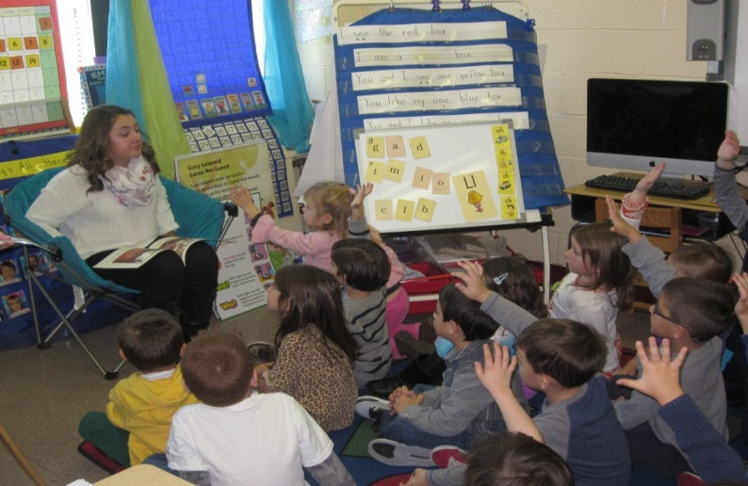 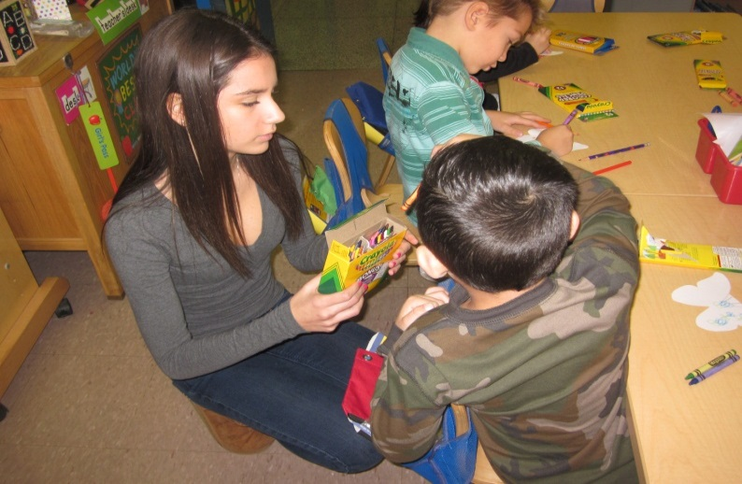

On November 14, 2014 the CSIHS Freshmen class visited elementary schools throughout Staten Island as part of the ninth grade Giving Project. The Giving Project is a service learning initiative organized by the ninth grade within their advisory classes. Each advisory picks an international folktale/short story which reflects a foreign culture. The students learn the book, and then create classroom lessons, artifacts which are appropriate for younger grades. Each advisory class then visited Island elementary school classes and taught the grade school students the story and the central themes. The event is an annual tradition that helps the CSIHS community build greater international citizenship across Staten Island.

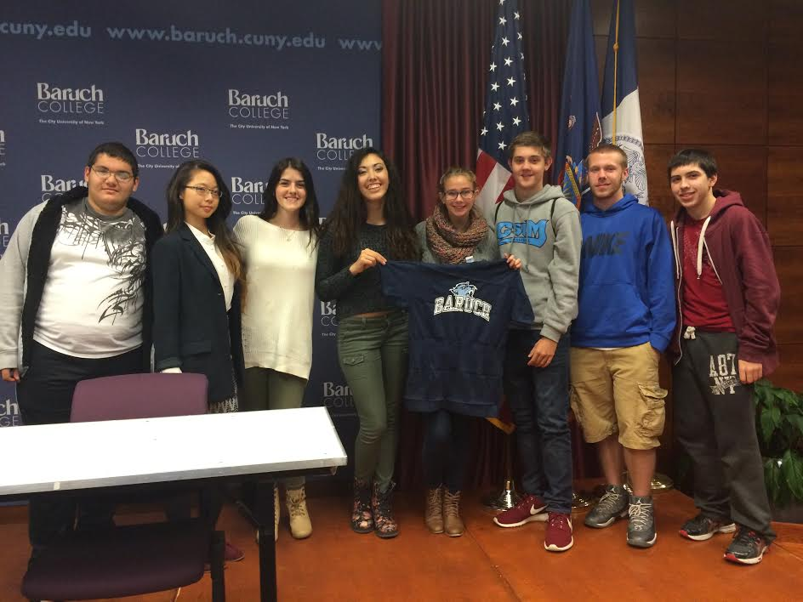

On October 24, 2014 members of the CSIHS Class of 2015 (pictured above) were selected by the Bernard Baruch College Admissions committee to participate in Baruch’s College for Day. At Baruch the excited Seniors attended college classes, were part of an admissions seminar, and participated in a symposium by currently enrolled students.

Ralph R. McKee Career and Technical High School - Recognized for Automotive Program

Principal Sharon Henry

The Greater New York Dealer’s Association (GNYDA) automotive competition, held at GNYDA in Whitestone, Queens, takes place once a year and only seniors can participate. Ralph R. McKee Career and Technical Education High School (RMHS) competed against 6 other New York City schools that have automotive programs. Most of these schools have over 200 seniors whereas RMHS has only 30 seniors. Our students come to school early in the morning and stay late to train for this event. The two students who came in 1st place were Thomas Marron and Brandon Colvil, both part of RMHS’s internship program. For the past year, these two dedicated students have been interning at Lombardi’s Harley Davidson on Bay Street in Staten Island. Thomas told his automotive teacher, M r. David Sarno, “Working there has really helped train me to become a great mechanic.”

This win gave RMHS back-to-back titles for the first time in the school’s history. Both Thomas and Brandon won up to $12,500 in scholarships. On February 10, 2015, they will compete in the state championship against the top teams in Long Island and upstate New York, as well as the second, third and fourth place teams in NYC. The winner of the state champions will go on to compete against nationwide contenders at the New York Auto show in April.

The students had to compete at 12 different work stations that challenged their knowledge of today’s high tech automobiles. The stations included electrical, brakes, tires, tool identification, steering and suspension systems. Brandon stated, “Our attention to detail is what put us over the top.” His thoughts were confirmed by some of the judges at the competition.

Mr. Sarno said, “I am so proud of my students. Accomplishments like this really help my program.”

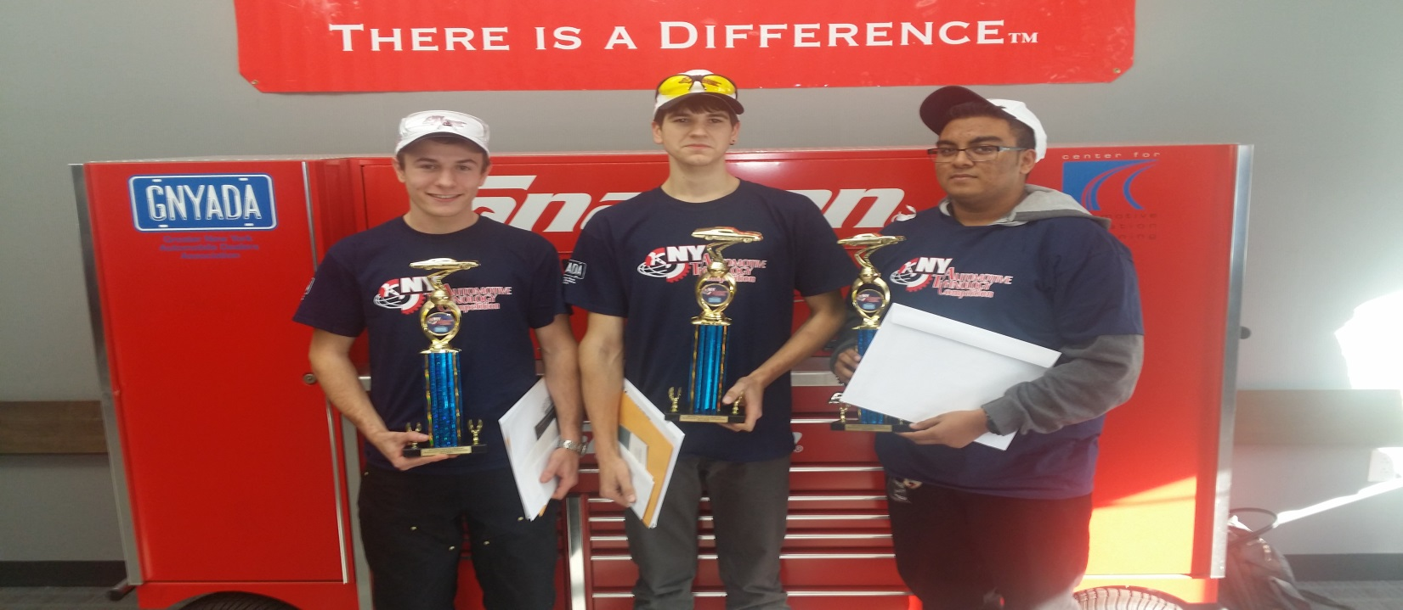

Gaynor McCown Expeditionary Learning School - Senior Class Applies for College

Principal Traci Frey

On Saturday, November 22nd, more than 80 members of the Class of 2015 and their families participated in CUNY Application Day.  With the generosity of the Staten Island Foundation, every member of the senior class was able to apply to up to 6 CUNY colleges for free.  With the assistance of a grant from the HESC Corporation, students and their families were treated to a hearty breakfast, as well as a financial aid workshop presented by a staffer from the College of Staten Island, as well as a SUNY workshop.  Application fees for a limited number of SUNY and private colleges were also covered through the HESC Foundation grant.

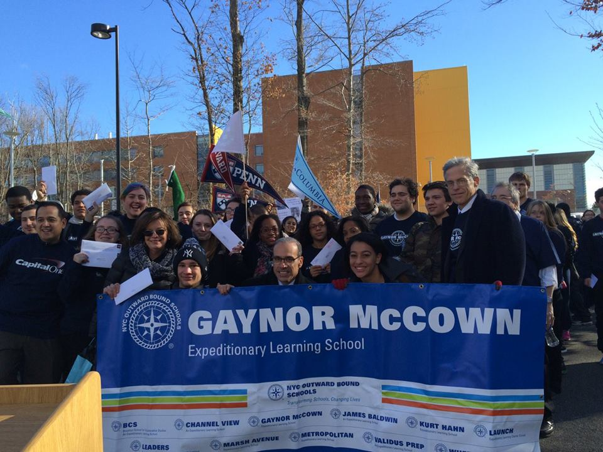

On Friday, December 12th, the Class of 2015 proudly took part in its third annual College March.  Staten Island Borough President James Oddo, Betsy Dubovsky (Exec. Dir. of the Staten Island Foundation), Ed Montesduoca (Market President of Capital One Bank), Jonathan Miller (husband of Gaynor McCown and board member of NYC Outward Bound Schools), Mario Papa (student) and Megan Cameron (student) led the seniors on their march. Capital One Bank funded sweatshirts for the seniors and t-shirts for 9-11th graders, as well as students in the Marsh Avenue EL School; funded a breakfast for the seniors served by Capital One volunteers, and sponsored the march at EL schools in all 5 boroughs of NYC as well as in 9 other schools across the country. NYC Outward Bound Schools, our partner organization from which the College March was founded, provided assistance in garnering press coverage and providing behind the scenes support to coordinate the march.  The United States Postal Service created a special hand cancelling stamp just for the march, and provided a mail truck to which the seniors deposited their applications.  It was truly a glorious day.

New Dorp High School – Shows School Spirit and helps others

Principal Deirdre DeAngelis- D’Alessio

Administrators, faculty and staff gave New Dorp students a great surprise to end Spirit Week with the release of their lively lip-syncing video to Taylor Swift’s “Shake It Off.” To date, the video has received over 50,000 hits on Vimeo (check it out! http://vimeo.com/109181115) and has really raised the spirit and morale of both students and staff. As a follow up, staff recreated Mariah Carey’s “All I Want for Christmas” (http://vimeo.com/114871621) and shared throughout classrooms during our Holiday Spirit Week Spectacular. However, the best part about both projects was that each video was filmed, edited and directed by students in New Dorp’s Academy of Communication & Media Arts. Great Job Cougars!

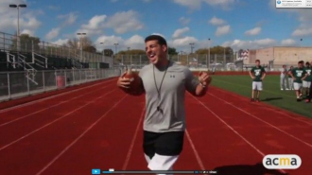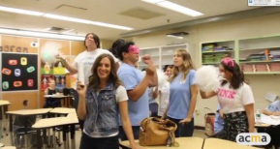

Throughout the month of December, the National Honor Society raised money for Pietro’s Foundation. Pietro is a 5 year old boy from Staten Island, who has Duchenne Muscular Dystrophy. Duchenne’s is a devastating muscle disease in children. Most boys who have it do not survive beyond their mid-20s. Those who do will be wheelchair bound by age 12 and experience social isolation. The simplest of tasks become difficult, and in the later stages, heart and breathing muscles begin to fail. The National Honor Society raised $1500 for Pietro's Foundation by participating in a school wide Pajama Day.

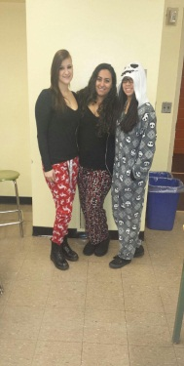 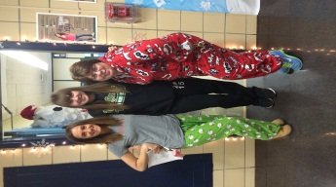 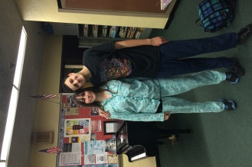

Tottenville High School – The Marching Band makes the grade

Principal Joseph Scarmato

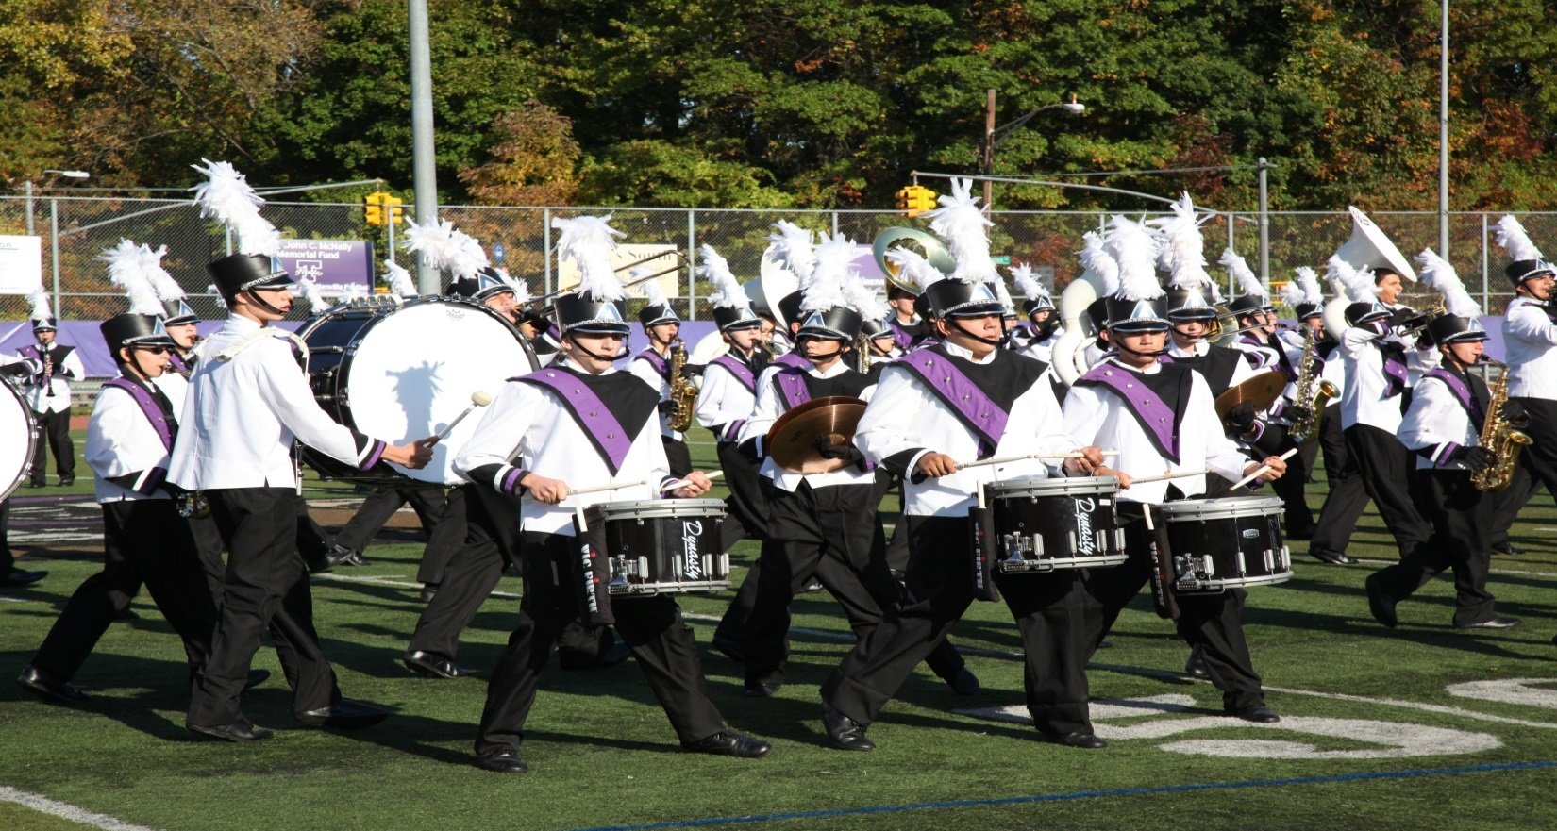On November 11th, the Staten Island Advance announced that the Tottenville High School Marching Band had been named Staten Island’s favorite high school marching band. The band received an impressive 5,209 votes. “Our victory according to the poll provided an amazing feeling. The entire band knew that we were already the best band on the island because of the endless time and effort we put into making this band what it has come to be,” said band member, Courtney Cayton. “Although we have won in the past, the feeling of winning because the people of Staten Island believe that we are the best is a whole new experience. It’s a reminder that the family that plays together, wins together.”

Band members often describe themselves as a family – the amount of time they spend with one another is comparable to the amount of time that one might spend with one’s actual family. Together with an abundance of talent, this camaraderie and dedication guarantees stellar performances. While band member, Alyssa Torres, echoed many of Cayton’s comments about the recent contest, Torres added, “The students and staff involved in the band are basically my second family, and I wouldn’t replace them for anything.” Victoria Sparandera characterized this virtual family as one that “you don’t mind being around.” Emily Carrasco discussed the friendships that she forged as a member of the band. “I have made the best friends I could have ever asked for, and it’s crazy to think that I would have never met them had I not joined band. Lauren Cassella said, “Band is love; band is life.”

Given the diminutive nature of so many of its performances, the amount of time that the band spends practicing seems somehow even more impressive. “As a band, we put months of effort and dedication into practice – countless hours spent on the field and in the band room for just an eight-minute show,” said Veronica Funk. “A lot of people don’t get that.” Veronica explained that the exhilaration of performing and the close friendships were incomparable to anything else she’d ever experienced. Brian Gallagher pointed out that all bands are not necessarily competitive. “THSMB is a competitive field band, which means we march and play a show to be judged in competition against other bands.” The recent Staten Island Advance competition confirmed that THSMB knows how to compete and how to win.

The Michael J. Petrides School – Petrides Got Talent

Principal Joanne Buckheit

December provided many opportunities for Petrides School staff and students to show their talents on our stage!

Our annual Winter Concert showcased hundreds of student musicians, including students in grades 6 through 12.

The holiday themed show included performances by our Middle and High School Concert Bands, Jazz Band, Middle and High School Choirs, Middle and High School Orchestras.

Bravo to all our performers and to music teachers Vincent Bunnicell, Tom Cintula and DeAnna Eliot on a job well done!

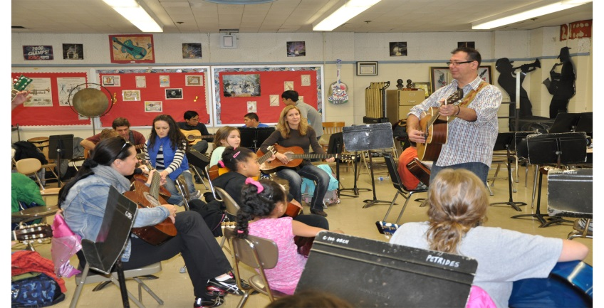

In December, Petrides families were invited to participate in our **Rock Star Guitar** event. Talented teachers Vincent Bunnicelli, Tom Cintula and Antonio Rodriguez provided a rock star experience for participants; teaching parents and their children some basic cords and encouraging them to jam with some more experiences players.

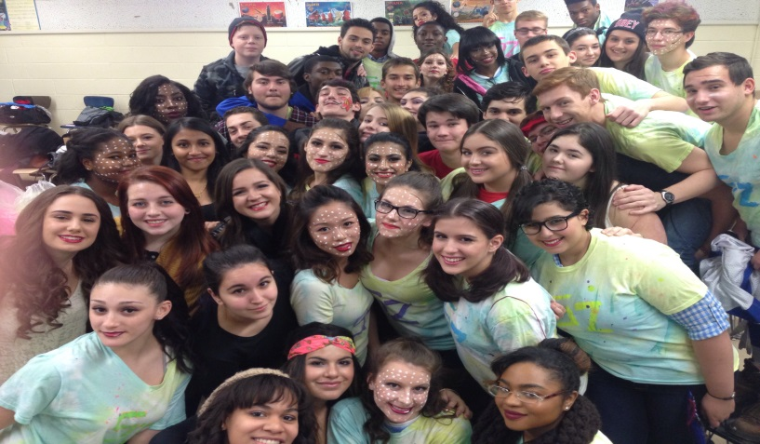

***SING!*** is an annual student-run musical production put on by high schools throughout New York City, including here at the Petrides School! It is a theater competition between the various grades, (senior-sophomore vs. junior-freshman); always entertaining and lots of fun!

Staten Island Technical High School

Principal Mark Erlenwein

Staten Island Technical High School's new Career Development Center (CDC) is buzzing with numerous opportunities each week, offering students of all grade levels the opportunity to explore various career pathways, via our “Backpack to Briefcases” series, as well as, Job Shadowing and potential internship and other Work Based Learning opportunities.

The CDC just launched the Tech Life Cafe (TLC), which provides students, faculty and staff an opportunity to purchase healthy snacks at cheaper prices than the fast food establishments nearby. SITHS students are learning how to operate the Tech Life Cafe as part of SITHS's CTE-Work Based Learning initiative, gaining valuable real-world life skills and experience. The Tech Life Cafe is collaboration with community-based organization, Lifestyles for the Disabled, who operate the Lifestyles Cafe, a fully functional restaurant on the campus of the Lifestyles for the Disabled on Staten Island.

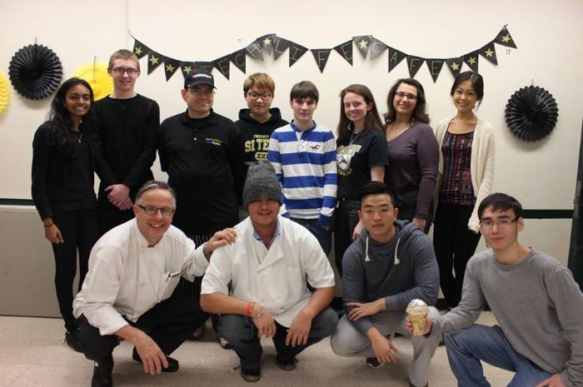

On October 31st the SITHS Marching Band debuted at PS 1 and PS 50's March of Dimes Halloween Parade, under the leadership of Band Director, Robert Rams, along with over 70 energized and excited students, after many months of preparation and only five-weeks since the start of school. The SITHS Marching Band appeared once again on December 10th at the Mayor’s Christmas Party for Handicap students at JFK Airport and on January 8th performed at a televised basketball game at Wagner College.

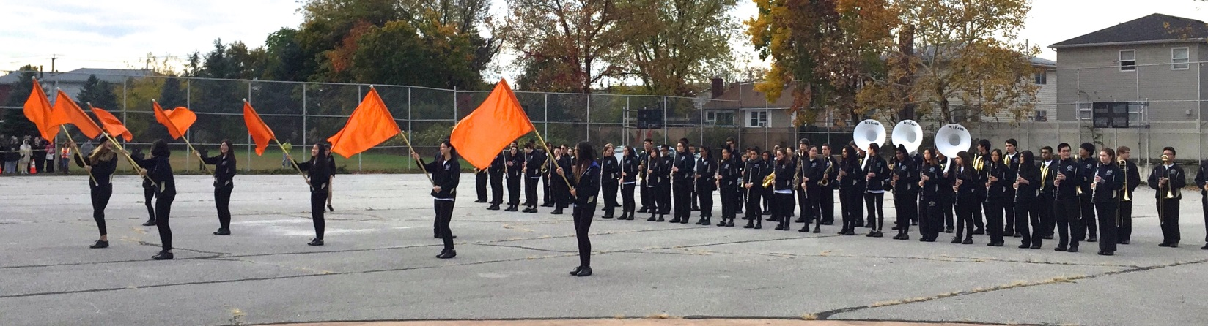

Marsh Avenue School for Expeditionary Learning – Student-Led Conferences

Principal Cara DeAngelo

Student-Led Conferences provide an alternative to the traditional Parent-Teacher Conferences. They require that students take primary responsibility for their academic progress towards mastery of specific learning targets or objectives. In doing so, students acquire self-confidence and poise as they maturely speak for themselves concerning their own work performance and habits.

Student-Led Conferences begin long before the scheduled conference itself. Students maintain their own portfolio for each academic subject. These student assessment notebooks contain a record of the student’s state test scores, learning surveys, independent reading logs, analytical papers, creative writing assignments, math tasks, Spanish projects, science articles, artwork, course tasks and assessments, projects, and reflections. Students also record their progress towards self-selected goals. At the Student-Led Conference, the student leads the parent through a discussion of this portfolio, highlighting areas of struggle that required perseverance, sharing accomplishments, and reflecting upon emotional growth.

While parents can always make arrangements to meet with a child’s teacher, the Student-Led Conference is a wonderful opportunity for the student to conduct his or her own academic evaluation. Students emerge from these conferences with a sense of fulfillment and direction.

Aimee Horowitz

Superintendent of High Schools

District 31 & High School Renewal Initiative

Kelly Doyle

Borough Family Advocate to Superintendent Aimee Horowitz

715 Ocean Terrace, A-141

Staten Island, New York 10301

Superintendent Contact Number - 718-390-1594

Borough Family Advocate Contact Number – 718-420-5626

**Important Dates for February**

February 3, 2015 – Staten Island Federation of PTA’s Art & Essay Contest forwarded to high schools

February 9, 2015 – Meeting of Staten Island Federation and President’s Council

February 27, 2015 – Girls Empowerment Conference to be held at CSI High School of International Studies

February 11, 2015 – March 11, 2015 – Citywide Council for High Schools elections – Parents are encouraged to utilize computer(s) at a school, library or the District Office. Two (2) representatives from Staten Island are needed.

March 20, 2015 – Legislative Forum - an opportunity to engage in an educational forum with local politicians.

We look forward to our next edition where the High School Renewal Initiative will join District 31. Topics will include school wide instructional initiative and Best Practices.

