Chemical Change Notes
- Le Chatelier’s principle, predict the effect of changes in concentration, temperature, and pressure
- Rate of reaction changes when - decrease in concentration of reactants or increase in concentration of products with time
- Reaction rates depend on such factors as concentration, temperature, and pressure.
- Catalyst - increases the reaction rate
- Enzymes are proteins that catalyze biochemical reactions without altering the reaction equilibrium and the activities of enzymes depend on the temperature, ionic conditions, and the pH of the surroundings.
- 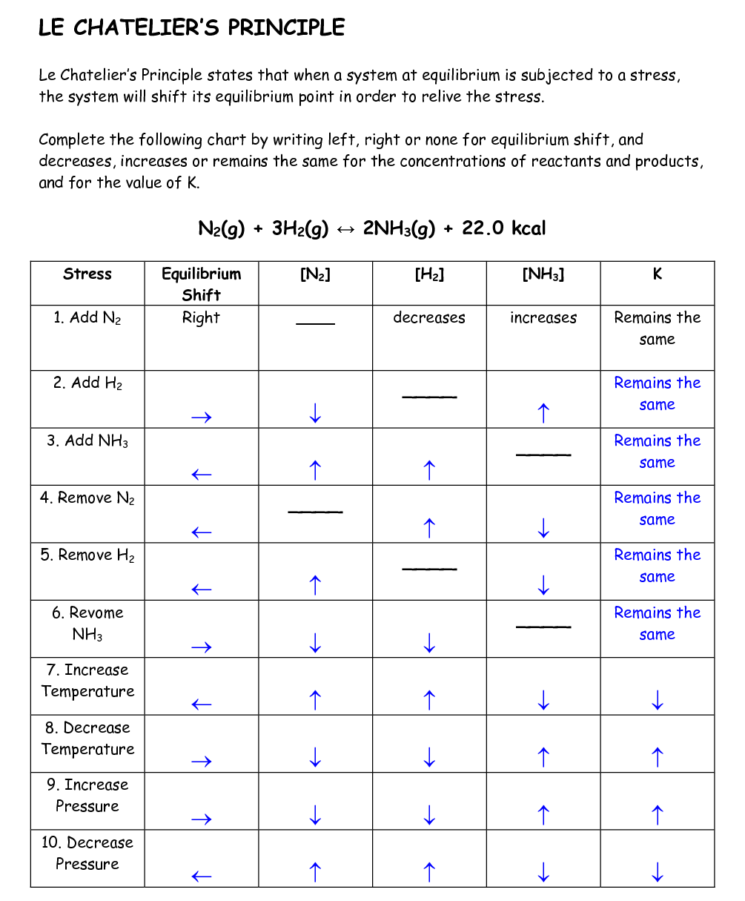

Factors affecting rate of reaction.
Collision Theory: Reactant particles must collide in order for reaction to take place.
(a) Concentration
Con. Increase -Rate of reaction increases
Probability of collision increases
(b) Pressure
Increase P – increase collisions
(c) Temperature
Increase temperature, more molecules move faster


 