Excel Assignment Five

You are to create a spreadsheet that looks like the following:

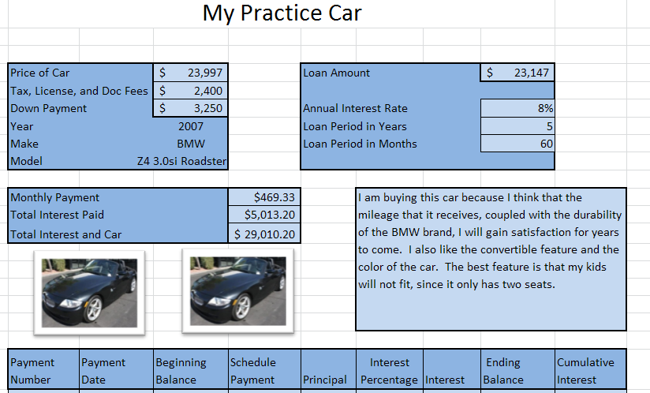

- You will prepare to purchase two different cars for 3 distinct time periods in your life and a dream car for if you won the lottery tomorrow.
  - Two high school cars – You have the budget between $6000-$7000 and will put $750 down. 8% APR and finance for 4 years
  - Two college cars – You will have the budget between $8500-$12500 and will put down $1250. 12.5% APR and finance for 5 years
  - Two college graduate cars – You will have the budget between $23000 and $27,000 and will put $3250 down. 6.875% APR and finance for 6 years
- You will name each sheet of your excel assignment the year and model of your car, for example 2007 Z4 Roadster
- You must write a description with 4 reasons why you chose the car you did.
- You must include two pictures of the car of your choice.

