Assg: HON Assignment to be completed in notebook.
Watch the following the cellular respiration video which can be found on our school website. Answer the following questions in your notebook. Write the question out with the answer OR write with complete sentences. Show me for credit when finished.

- Explain the illustration below?
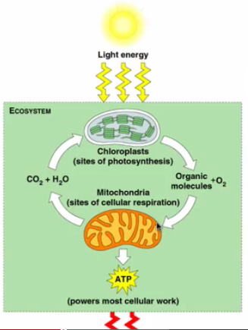
- What is cellular respiration?
- What is the ultimate goal of cellular respiration?
- What is anaerobic respiration?
- What is the job of NAD and FAD ?
- Where is the ETC located in the mitochondria?
- Why does the mitochondria have cristae?
- What is the chemical equation for photosynthesis?
- What do you notice about the chemical equation for cellular respiration and photosynthesis?
- Glycolysis occurs in the of the cell, Kreb cycle occurs in the of the cell and ETC occurs in the of the cell.
- Explain the steps of glycolysis. Be sure to identify the reactant, products and any other important molecule(s) that show up in between. Use the illustration below as needed.
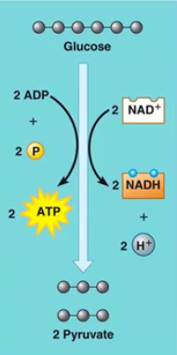
- What are the products of the Kreb Cycle?
- What is oxidative phosphorylation?
- Explain how ATP is synthesized in the ETC. Use the illustration below as needed. 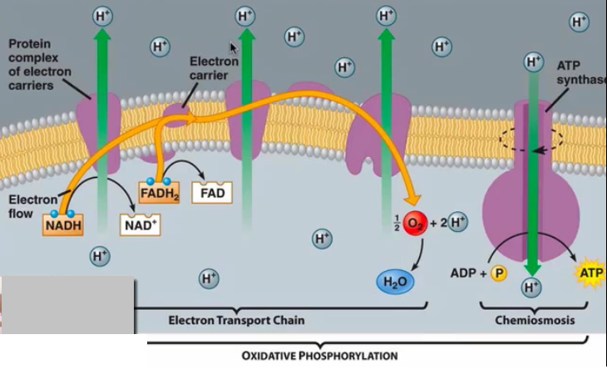
- How does ATP synthase work to make ATP?
- Why would fermentation take place?
- Why does fermentation need to take place?

