Notes about motion along a straight line:
Given a function, s(t) that is moving along a straight line…
Average velocity over the interval [a,b]=

Instantaneous velocity at time t=

$+ velocity means __________________________- velocity means ________________________________$
Instantaneous speed at time t =

Instantaneous acceleration at time t=
$If velocity and acceleration have the same signs$: _____________________________________
$If velocity and acceleration have opposite signs:$ _____________________________________
If ….
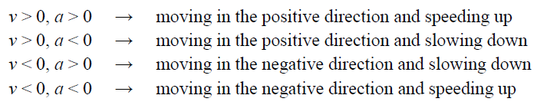

Describe the motion of the particle shown in the graphs below.
Example:
A particle is moving along the x-axis such that the distance from the origin is represented by $s\left(t\right)=2t^{3}-21t^{2}+60t+3 for t≥0$.
(a) When is the object moving to the left / right?

(b) When is the object speeding up? Slowing down?

(c) What is the average velocity over the first 5 seconds?

(d) What is the total distance traveled over the first 10 seconds?

