Excel Assignment Six

You are to create a spreadsheet that looks like the following:

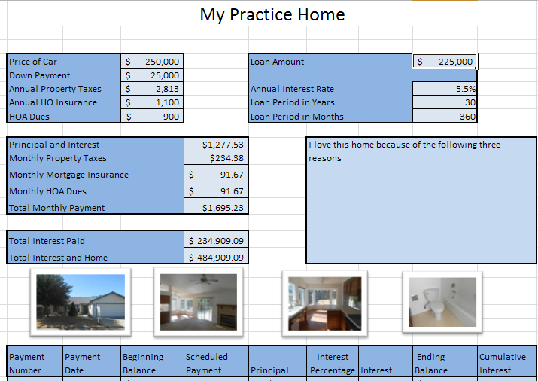

- You will prepare to purchase two different homes for 3 distinct time periods in your life and a dream home for if you won the lottery tomorrow.
  - Two “Starter Homes” – You have the budget between $125,000-$175,000 and will put 10% down, get an 8% interest rate and finance for 30 years. Your Homeowners insurance will be $850 per year and you will have HOA dues of $360 per year.
  - Two “First Family Homes” – You will have the budget between $250,000-$350,000 and will put down 15% with a 6% interest rate and finance for 30 years. Your Homeowners insurance will be $1150 per year and you will have HOA dues of $540 per year.
  - Two “Large Homes” – You will have the budget between $350,000 and $500,000 and will put 25% down with a 4.875% APR and finance for 30 years. Your Homeowners insurance will be $1350 per year and you will have HOA dues of $900 per year.
  - Dream Home – Your budget will be unlimited with an APR of 3.25% Your homeowners insurance will be $45,000 per year and you will have HOA dues of $90,000 annually.
- You will name each sheet of your excel assignment Home 1 through Home 7
- You must write a description with 3 reasons why you chose the home you did.
- One of each of the three types of homes above need to be purchased in a 30 mile radius of King City. The other 4 homes can be anywhere you would like to live
- You must include four pictures of the homes of your choice.

