Setting Infinite Campus to Automatically Open in Campus Instruction
When you open Infinite Campus, you currently go to the App Switcher in the top right corner to access Campus Instruction. If you would like to set your program so it automatically opens into Campus Instruction, follow these simple steps:
When you open Campus Instruction scroll down the left side and select Account Settings.
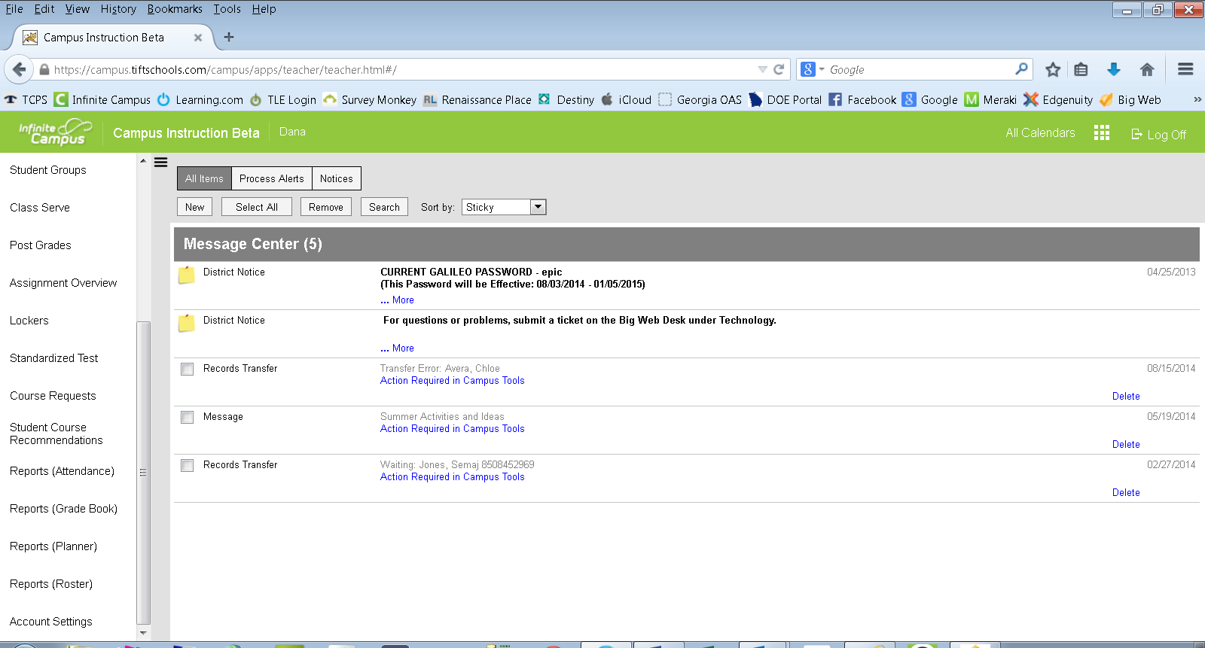

When you click on Account Settings the first option on the right side allows you to “Select the Application You Would Prefer to Load on Campus Login.” Choose Campus Instruction from this drop down menu then click Save.

C