Assg: ALL Name
Punnett Square plus MORE! Date pd.
 | Complete dominance |  | Complete dominance is…CIRCLE  - When the recessive allele is completely masked when the dominant allele is present.  - When the phenotype of a heterozygous genotype is a blend between the dominant and recessive alleles.  - When the phenotype of a heterozygous genotype shows both the dominant and recessive alleles.  - When the dominant allele is completely masked when the recessive allele is present.  Example: Having dimples is a dominant phenotype while not having dimples is a recessive phenotype. Use “D” or “d” and complete the chart.
 | Genotype | Phenotype
Homozygous dominant

Homozygous recessive

Heterozygous

 | Incomplete dominance |  | Incomplete dominance is…CIRCLE  - When the recessive allele is completely masked when the dominant allele is present.  - When the phenotype of a heterozygous genotype is a blend between the dominant and recessive alleles.  - When the phenotype of a heterozygous genotype shows both the dominant and recessive alleles.  - When the dominant allele is completely masked when the recessive allele is present.  Example: If an offspring inherits 2 dominant alleles, the size of eyes are large. If an offspring inherits 2 recessive alleles, the size of eye are small. If an offspring inherits a dominant and recessive alleles, the size of eyes are medium. Use “E” or “e” and complete the chart.
 | Genotype | Phenotype
Homozygous dominant

Homozygous recessive

Heterozygous

 | Complete dominance |  | Codominance is…CIRCLE  - When the recessive allele is completely masked when the dominant allele is present.  - When the phenotype of a heterozygous genotype is a blend between the dominant and recessive alleles.  - When the phenotype of a heterozygous genotype shows both the dominant and recessive alleles.  - When the dominant allele is completely masked when the recessive allele is present.  Example: In certain breeds of dogs, if an offspring inherits 2 dominant alleles the fur is black. If an offspring inherits 2 recessive alleles the fur is white. However when an offspring inherits a dominant and recessive allele, the fur is black and white! Use “B” or “b” and complete the chart.
 | Genotype | Phenotype
Homozygous dominant

Homozygous recessive

Heterozygous

In humans the allele for albinism (use “A” or “a”) is recessive to the allele for normal skin pigmentation. Make a key below.
AA = _____________________ | Aa = _____________________ | aa = _____________________

If two carriers have children, what is the probability that a child will have normal skin pigment if this is inherited autosomal? What is the chance that a child will be albino? Complete the punnett square on the next page.

This is…  Complete  Codominance  Incomplete | Write:  “pairs 1-22” or  “pair 23” | Write:  inherit  “2 alleles” or  “just one” |  | I must include XX for mother & XY for father  Write: “yes” or “no” | Parent 1  Parent 2
_____________________________________ |  |  | - What is the genotypic ratio?
_____________________________________ |  |  | - What is the phenotypic ratio?
_____________________________________ |  |  | - What is the probability of producing an affected offspring?
_____________________________________ |  |  | - What is the probability of producing a child that is unaffected?
_____________________________________ |  |  | - What is the probability of producing a child that is a carrier?

Purple people eaters have one horn. One-horn is dominant to the mutation no horns. Show the cross of a purple people eater that is heterozygous for horns with a purple people eater that has the mutation. Summarize the genotypes & phenotypes of the possible offspring if horns is inherited autosomal. Make a key and then complete the punnett square to find out.
HH = _____________________ |  |  | Hh = _____________________ |  |  |  | hh = _____________________
This is…  Complete  Codominance  Incomplete | Write:  “pairs 1-22” or  “pair 23” | Write:  inherit  “2 alleles” or  “just one” |  |  | I must include XX for mother & XY for father  Write: “yes” or “no” | Parent 1  Parent 2
_____________________________________ |  |  |  | - What is the genotypic ratio?
_____________________________________ |  |  |  | - What is the phenotypic ratio?
_____________________________________ |  |  |  | - What is the probability of producing a mutated offspring?
_____________________________________ |  |  |  | - What is the probability of producing a offspring that is normal?
_____________________________________ |  |  |  | - What is the probability of producing a offspring that is a carrier?
In certain breeds of cattle when an offspring inherits 2 dominant alleles the coat color is red. When the offspring inherits 2 recessive alleles the coat color is white. When the offspring inherits one of each, the coat color is roan (a pinkish coat color). Summarize the genotypes & phenotypes of the possible offspring when a roan cow is mated with a roan bull. Make a key and then complete the punnett square to find out.
RR = _____________________ |  |  | Rr = _____________________ |  |  |  | rr = _____________________
This is…  Complete  Codominance  Incomplete | Write:  “pairs 1-22” or  “pair 23” | Write:  inherit  “2 alleles” or  “just one” |  |  | I must include XX for mother & XY for father  Write: “yes” or “no” | Parent 1  Parent 2
_____________________________________ |  |  |  | - What is the genotypic ratio?
_____________________________________ |  |  |  | - What is the phenotypic ratio?
_____________________________________ |  |  |  | - What is the probability of producing red coat cattle?
_____________________________________ |  |  |  | - What is the probability of producing white coat cattle?
_____________________________________ |  |  |  | - What is the probability of producing roan coat cattle?

On planet Zelda, having purple eyes is a mutation over the normal orange eyes. This mutation is inherited X-linked recessive. If a father with purple eyes marries a mother with orange eye who also carries the purple eye gene; what is the probability of producing orange and purple eyes in their offspring? Make a key and then complete the punnett square to find out.
_____=_________________________ |  |  | _____=_________________________ |  |  |  | _____=_________________________
This is…  Complete  Codominance  Incomplete | Write:  “pairs 1-22” or  “pair 23” | Write:  inherit  “2 alleles” or  “just one” |  |  | I must include XX for mother & XY for father  Write: “yes” or “no” | Parent 1  Parent 2
_____________________________________ |  |  |  | - What is the genotypic ratio?
_____________________________________ |  |  |  | - What is the phenotypic ratio?
_____________________________________ |  |  |  | - What is the probability of producing a mutated offspring?
_____________________________________ |  |  |  | - What is the probability of producing a offspring that is normal?
_____________________________________ |  |  |  | - What is the probability of producing a offspring that is a carrier?

A cross between a black cat & a tan cat produces a tabby pattern (black & tan fur together). Summarize the genotypes & phenotypes of the possible offspring when these tabby cats mate. Make a key and then complete the punnett square to find out.
TT = _____________________ |  |  | Tt = _____________________ |  |  | tt = _____________________
This is…  Complete  Codominance  Incomplete | Write:  “pairs 1-22” or  “pair 23” | Write:  inherit  “2 alleles” or  “just one” |  | I must include XX for mother & XY for father  Write: “yes” or “no” | Parent 1  Parent 2

_____________________________________ | - What is the genotypic ratio?
_____________________________________ | - What is the phenotypic ratio?
_____________________________________ | - What is the probability of producing black fur?
_____________________________________ | - What is the probability of producing tan fur?
_____________________________________ | - What is the probability of producing tabby fur?

In seals, having whiskers is inherited autosomal recessive while the mutation not having whiskers is inherited autosomal dominant. Cross a parent that is heterozygous no whiskered with a parent that has whiskers.
NN = _____________________ |  |  | Nn = _____________________ |  |  |  | nn = _____________________
This is…  Complete  Codominance  Incomplete | Write:  “pairs 1-22” or  “pair 23” | Write:  inherit  “2 alleles” or  “just one” |  |  | I must include XX for mother & XY for father  Write: “yes” or “no” | Parent 1  Parent 2
_____________________________________ |  |  |  | - What is the genotypic ratio?
_____________________________________ |  |  |  | - What is the phenotypic ratio?
_____________________________________ |  |  |  | - What is the probability of producing a mutated offspring?
_____________________________________ |  |  |  | - What is the probability of producing a offspring that is normal?
_____________________________________ |  |  |  | - What is the probability of producing a offspring that is a carrier?

The illustration on the right is a pedigree. A pedigree is a diagram of a family tree showing the occurrence of heritable characters in parents and offspring over multiple generations.  - What is the inheritance pattern?  - Autosomal dominant  - Autosomal recessive  - X-linked recessive  - X-linked dominant  - Y-linked  - Couple 1 and 2 had children 3, 4, 5, and 6. Show the punnett square to support your above answer. | 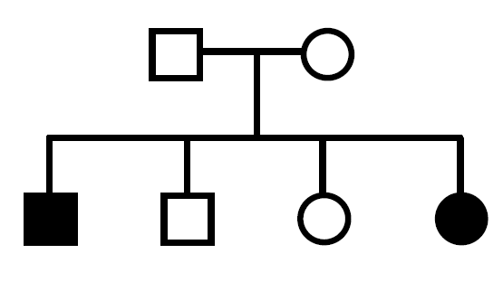
- What is the inheritance pattern?  - Autosomal dominant  - Autosomal recessive  - X-linked recessive  - X-linked dominant  - Y-linked  - Couple 1 and 2 had children 3, 4, 5, and 6. Show the punnett square to support your above answer. | 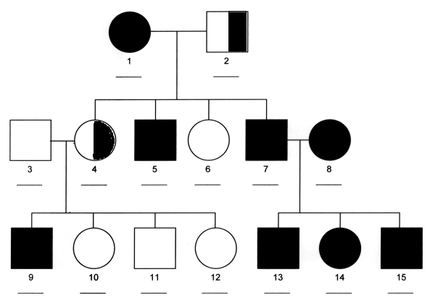

3. Couple 3 and 4 had children 9, 10, 11, and 12. Show the punnett square to support your above answer.

