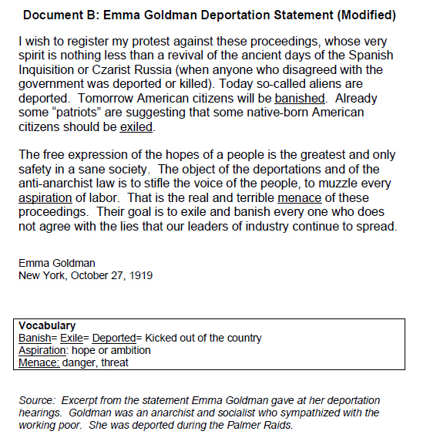

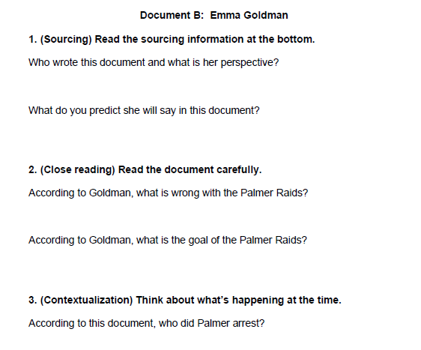

4. (Corroboration) Use evidence from “The Case Against the Reds” document and Emma Goldman document to answer the question:
Why did Palmer arrest thousands of people and deport hundreds between 1919-1920?

