Names___________________ ______________________
Date_____________ Period_______

Ionic Bonding Worksheet

I. Draw a Lewis Dot diagram and answer the questions for the following elements.

Element | Lewis Dot Diagram | Note
Ne |  |  | This element has its Lewis Dot diagram completely full (eight valence electrons). It is called chemically stable. Note that 0 Valence electrons is also a chemically stable configuration.
1. How many electrons does this element have in its outer energy level?
2. How many valence electrons does it take to make an element chemically stable?

Element | Lewis Dot Diagram | Note
F |  |  | A atom with a net positive or negative charge is called an ion. A negatively charged ion is called an anion.
1. How many electrons does this element need to gain to achieve a stable configuration (eight valence electrons)?
2. Each electron gained gives the atom a negative charge. What is the total negative charge for the element? |  |  |  |  | -

Element | Lewis Dot Diagram | Note
Na |  |  | Note: A atom with a net positive or negative charge is called an ion. A positively charged ion is called a cation.
1. How many electrons does this element need to gain to lose a stable configuration (zero valence electrons)?
2. Each electron lost gives the atom a positive charge. What is the total positive charge for the element is |  |  |  |  | +

II. Fill in the following table. The first column is the number of electrons the element needed to gain a stable configuration, the second is its oxidation number, the third is whether or not it is an anion or cation.

Electrons | Ion Charge Number | Anion/Cation
Gained 1 | -1 | Anion
Lost 1 | +1 | Cation
Gained 2
Lost 2
 | -3
 | +3

III. Knowing that the elements in groups 1-2, and 13-18 usually have ion charges of +1,+2,+3,+4, or -3,-2,-1: For the following elements, write a Lewis Dot diagram, the charge number, and whether or not the element is a cation, and anion, or chemically stable.

Element | Lewis Dot Diagram | Common charge Number | Cation, Anion, or Chemically stable?
O
Ba
Cl
Al
Ar
Ca
N
K
I

V. Write Lewis Dot Reactions (as shown above in the two examples on the last page) for the following elements:

A. Barium (Ba) and Oxygen

B. Aluminum and Flourine

C. Potassium and Iodine

D. Challenge (extra credit): Calcium and Nitrogen

IV. Binary Ionic Compounds
Sometimes an element will give an electron to another so that both can reach stable configurations. They form what is called an ionic compound. Note that most ionic compounds are formed by just two elements. These are called binary ionic compounds.

Sometimes one element wants to lose the exact same number of elements that another wants to gain. Table Salt (sodium chloride) an example of this: Example (from our physical science book):

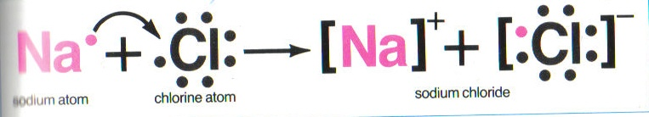

Sometimes, the positive and negative charge numbers don’t cancel out. This means we have to have more than one of at least one of the elements to each side of the equation.

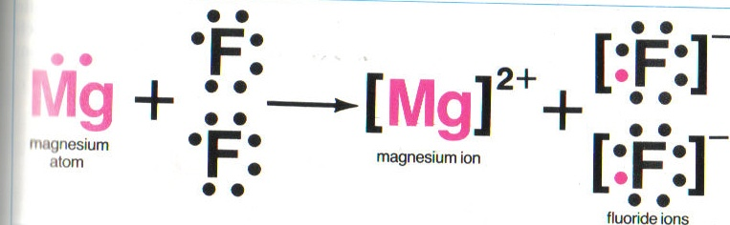
Pictures taken from: Merrill Physical Science. Macmillan/Mc-Graw-Hill Publishing Company: Ohio. 1993. pg 271, 277.

