AP Biology Reading Guide Name _______________________ Period ___________
Chapter 47: Animal Development
Copyright © 2010 Pearson Education, Inc.

Chapter 47: Animal Development
Overview
- An organism’s development is controlled by the genome of the zygote as well as by molecules from the mother that are in the cytoplasm of the egg. What are these proteins and RNAs called?
- What is cell differentiation?
- How do cytoplasmic determinants affect cell differentiation?
- What is morphogenesis?

Concept 47.1 After fertilization, embryonic development proceeds through cleavage, gastrulation, and organogenesis
5. What is the acrosome of a sperm? What does it contain?
6. The figure below shows sea urchin fertilization. Label the following: sperm acrosome, sperm nucleus, jelly coat of egg, sperm-binding receptors, cortical granules, vitelline layer, egg plasma membrane, and fertilization envelope.
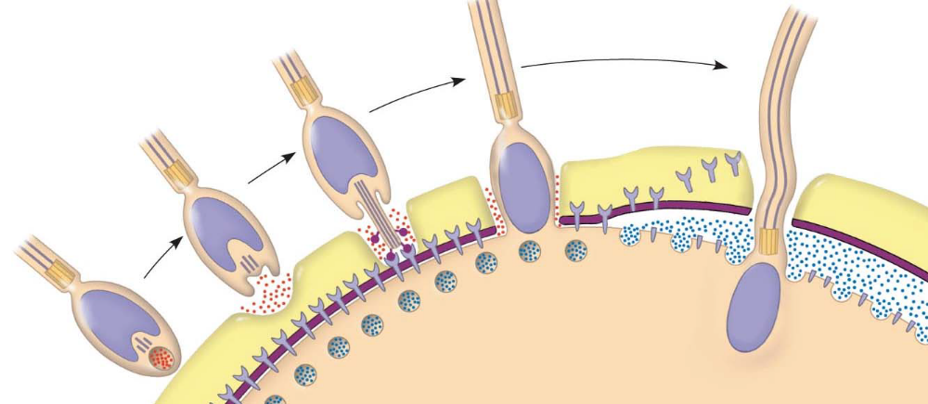
7. Describe what happens in the acrosomal reaction.
8. The fusion of the egg and sperm plasma membranes allows sodium ions to flow into the egg. How does this result in a fast block to polyspermy?
9. Describe the cortical reaction.
10. How is the fertilization envelope formed?
11. Why is the fertilization envelope considered a slow block to polyspermy?
12. Sperm binding activates a signal transduction pathway in which calcium ions are released from the endoplasmic reticulum. What are two outcomes of the elevated calcium ion level?
13. Now that you have studied sea urchin fertilization in some detail, study the section Fertilization in Mammals and make a list of what you consider the essential differences. You should have at least three differences.
14. The early mitotic divisions of the zygote to form a ball of cells are called cleavages. What is unique about cleavage?
15. How do the early cleavages set the stage for subsequent developmental events?
16. On the figure below, label and describe each of the following: fertilization envelope, zygote, blastomere, blastula, and blastocoel.
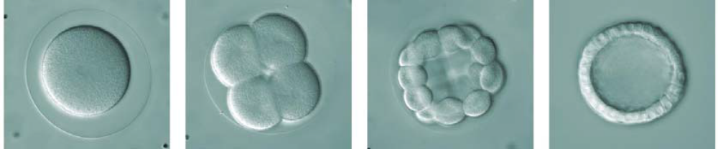

fertilization envelope
zygote
blastomere
blastula
blastocoel
17. What animals show holoblastic cleavage?
18. What is meroblastic cleavage? What animals show this type of cleavage?
24. The early cleavages are followed by gastrulation. Visualize punching in a partially inflated ball with your fist. This would result in a layer of the ball being pushed to the inside. In essence, this is what occurs in gastrulation. These layers establish the future embryonic germ layers. So remember this: gastrulation establishes the germ layers. What are the three germ layers of the embryo?
25. You should know at least two derivatives of each germ layer. Refer to Figure 47.14 in your text, and select three tissues to learn from each layer. Use this chart to help organize your learning.
