Great Wall of China – Like a gigantic sleeping dragon, the Great Wall snakes up and down across the grasslands, mountains, plateaus and desserts, stretching to an highly impressive length 5, 500 miles, winding down from east to west of China.
The Great Wall of China is not one continuous wall as many believe, but a long collection of short walls that follow the crest of several hills on the southern regions of the Mongolian plain. This attraction is also known as “the long Wall of 10,000 Li”, extending 5, 500 miles across the land.
The very first set of walls was created during the Qin Dynasty (221-206 BCE), which was initially designed to prevent the Mongol nomads from evading China. The walls were primarily built using stones and earth in wooden frames.
While there were some modifications and additions made to the simple, crude walls over the next millennium, the majority of its construction started all throughout the Ming Dynasty (1388-1644 CE).
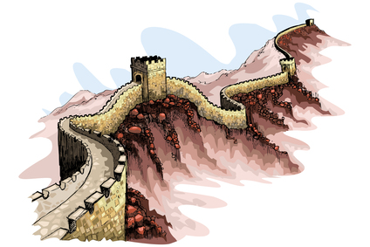 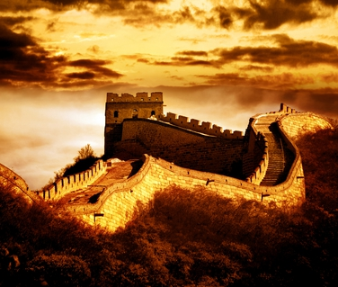 At this period, the fortifications made increased the walls by up to 25 feet in height and 15 to 30 feet wide at its base, just enough to allow passage of wagons and marching troops. At regular intervals, there were watch towers and guard stations established all throughout its length. However, since the Great Wall as constructed sporadically, the Mongol invaders did not have any trouble breaching the walls by simply going around it. This meant, the walls proved to be unsuccessful and did not really serve its primary purpose, which later on prompted ancient Chinese to abandon it.
In addition, the policy of mollification which was made during the Ch’ing Dynasty designed to pacify the Mongol leaders have also limited the need for the walls. However, through the 17th and 20th centuries, with the help of Western contact, the legend of the Great Wall helped generate tourism in China. In the 20th century, massive rebuilding and restoration efforts were made to preserve what is truly a legacy that China can be truly proud of.

