Laplace Transform Formulas

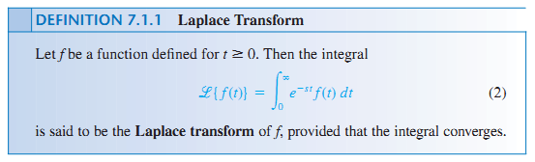

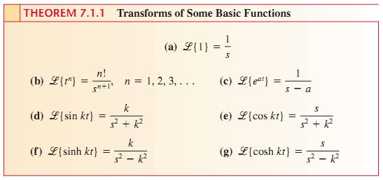

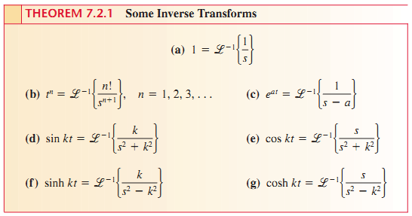

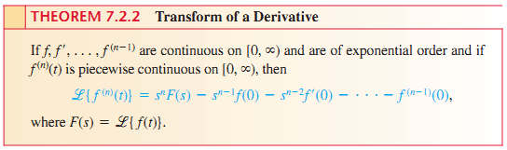

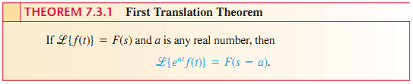

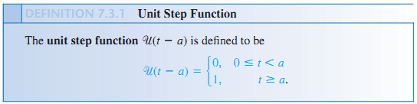

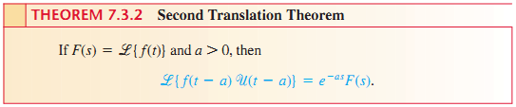

Alternate Form of 2nd Translation Theorem : 