Lecture: Classical Republicanism

12.1.3 Explain how the U.S. Constitution reflects a balance between the classical republican concern with promotion of the public good and the classical liberal concern with protecting individual rights; and discuss how the basic premises of liberal constitutionalism and democracy are joined in the Declaration of Independence as "self-evident truths."


The ________ good
What is best for the _________ people.
collectivism

The Roman Republic promoted the ______________ _________.
What was best for society was known as classical ________________.

An example of promoting public good would be _____________________. Another example would be ___________________.
Right of the __________. Rights of the _________ may be given up for the rights of the _________. ___________: the majority is always making the _______. Your representative is making a decision on what he believes is the best for all of his _________________ (people he represents).

REPUBLICANISM IN DEMOCRACY


James Madison defined the differences between _______________ and ______________.

Democracy
_________ communities..
Works best in
The _________
administer the government
Works best in
Republic
________ communities.
The people elect
_______________
Who govern the government.
_________________.
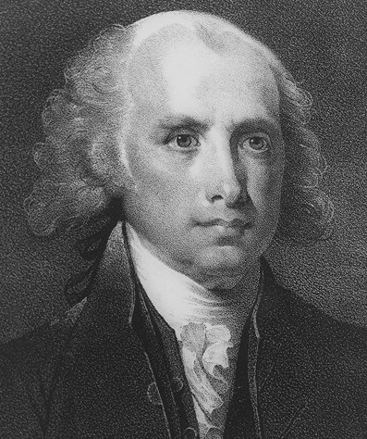
Madison believed America could and should have a ______________ form of government. Those who believed in republicanism were called ______________. Madison believed that people were motivated primarily by ______________.The pursuit of self-interest could in its own way further the common good.


PAIR SHARE:
Separation of powers limits the government by ________________________.

Favored a constitution that _________ government by
*
*
“If all people were angels, there would be no need for government.” -Madison

