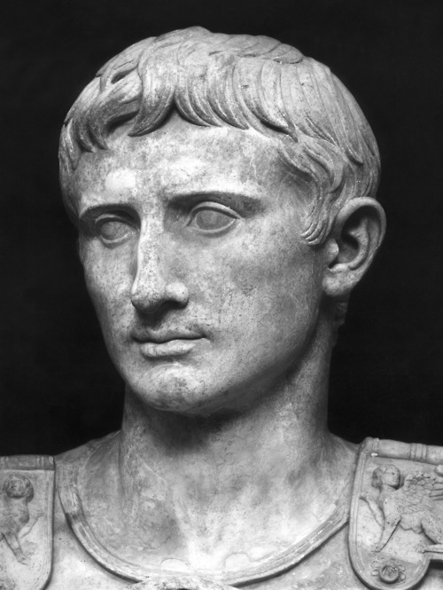
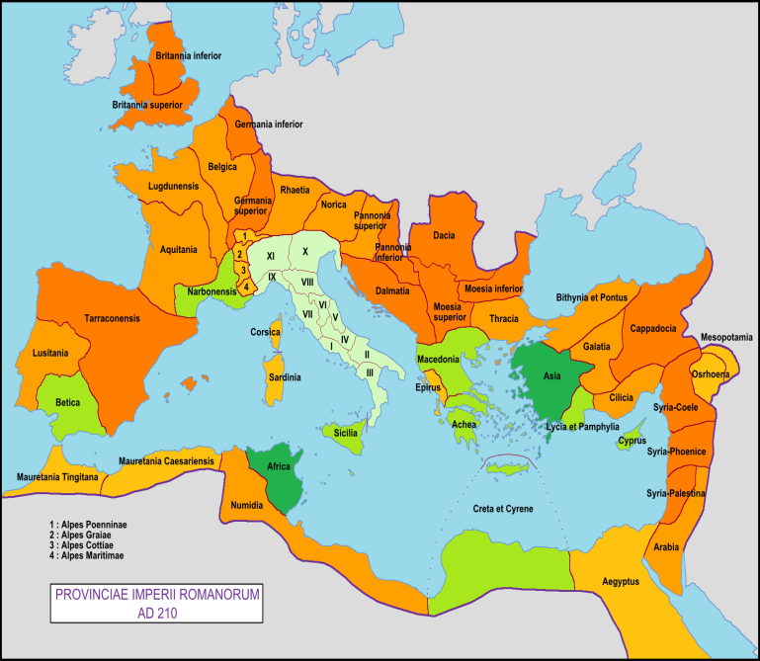

TABLE OF CONTENTS
- COVER PAGE
- TABLE OF CONTENTS
- PPT ON ROMAN EMPIRE (leave 1page front &back)
- JULIUS CAESAR PPT

