Categorilla WORLD BIRTH RATE EXTREMES

Shade (in contrasting colors) and label countries from the two extreme categories.

 | Lowest Crude Birth Rates |  |  | Highest Crude Birth Rates
1 | Japan |  | 1 | Niger
2 | Italy |  | 2 | Mali
3 | Germany |  | 3 | Uganda
4 | Austria |  | 4 | Afghanistan
5 | Singapore |  | 5 | Sierra Leone
6 | Czech Republic |  | 6 | Burkina Faso
7 | Bosnia |  | 7 | Somalia
8 | South Korea |  | 8 | Angola
9 | Slovenia |  | 9 | Ethiopia
10 | Taiwan |  | 10 | Congo

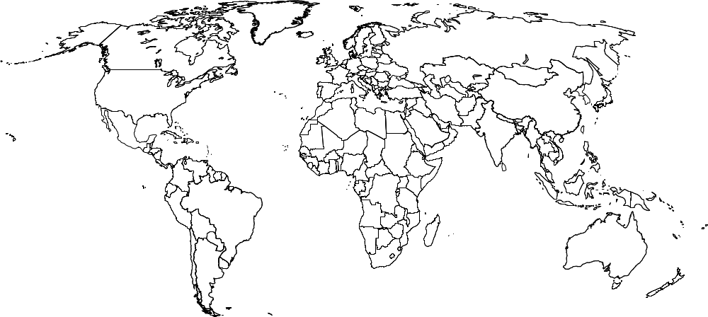

What causes countries to have high and low crude birth rates?

