Student A and Student B
Due: 10/22/12
World Geography: 2nd Period

Ms. Watts’ Day Off
Locales and Events
Symbolic: Statue of Liberty
The Statue of Liberty is on Ellis Island in New York. This statue is of a woman holding a book and torch, with a chain at her feet. This monument is made out of copper. In order to see this statue up close you can travel by a ferry. This statue was a gift from the France to the United States. The statue represents freedom and the United States. It is used to be a welcoming signal to immigrants arriving from other countries. We picked this as our symbolic place because it means a lot to America, and it shows people there is still hope and that we are lucky to have freedom.
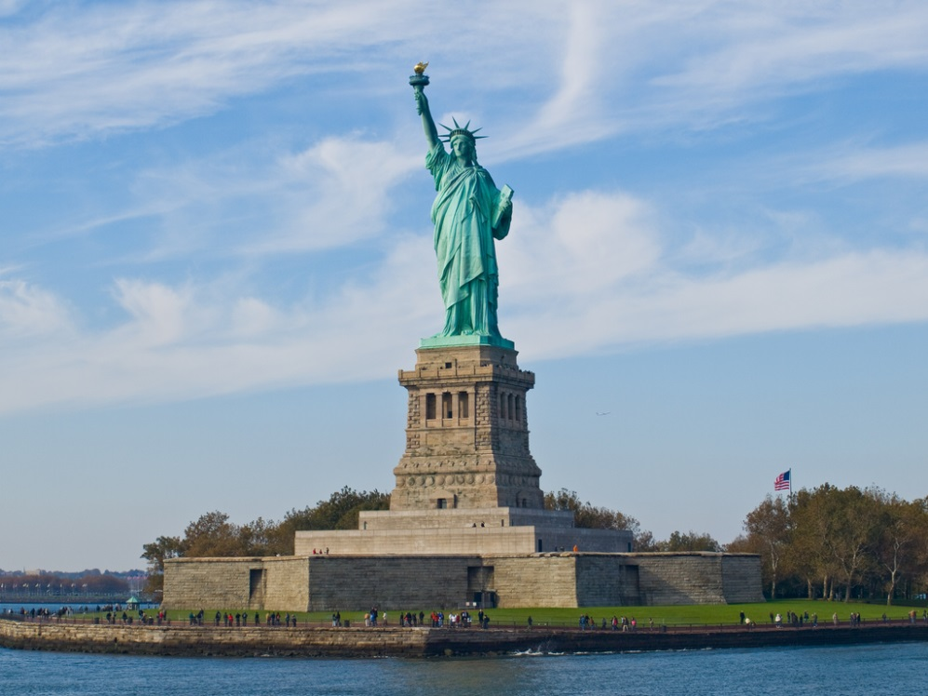

Business/Economic: Wall Street
In Wall Street, New York, NY is the world’s largest stock exchange. It is an interesting place because this is where America trades stocks. New York’s stock exchange is one of the major stock exchanges in the U.S. The other one is American Stock Exchange. Both stock exchanges headquarters are in New York along with others, but those two are the two main ones. Other things located on Wall Street are the Trinity Church and the Federal Reserve gold vaults. We chose this as our economic location because we have heard of Wall Street but we were not entirely sure what it was, and we wanted to learn more about it.
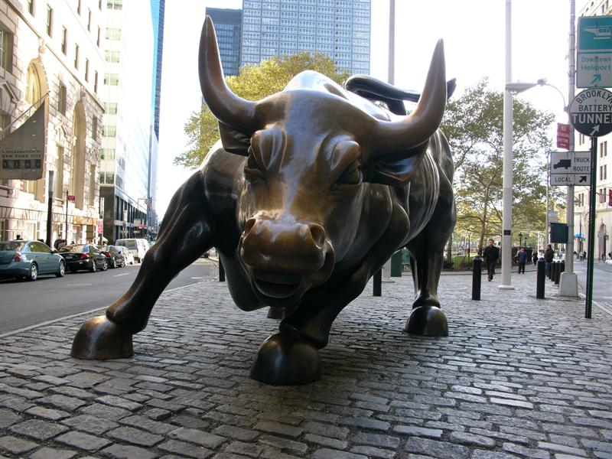

Culinary: Serendipity
Serendipity is located at 225 East 60th street New York, NY 10022. This café/shop was New York’s first coffee house boutique. It started out small but soon the demand was too much and they had to expand. The café serves unique food including frozen hot chocolate and ranges from hamburgers to crepes. The coffee shop doubles as a boutique which sells various items such as: hot chocolate mix, desserts, mugs, cookie jars, etc. This shop has also been visited by many well known people like Sarah Palin, Ashley Tisdale, Zach Effron, and Bill Clinton. We chose this as our culinary location because it’s a unique place with good food and is one of the most famous cafes in New York.

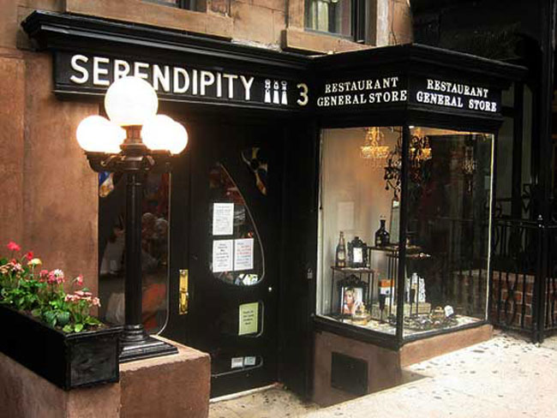

Athletic: Basketball game - Los Angeles vs. New York
This basketball game is at 1:00 p.m. at Madison Square Garden, Pennsylvania Plaza, New York, NY. The game is between Los Angeles and New York. We think the game will last an hour and 45 minutes. The Los Angeles Lakers are a professional basketball team, and are considered one of the most successful teams in history. They have won 16 championship games: The last one won was in 2010. The New York Knicks are a professional basketball team in New York. The Knicks was a good team for a while then they started losing. When they got a new coach they started winning again. They went to the finals three times, but lost all three. The game between these two teams will be interesting to watch. We picked this game because basketball is an interesting sport and it will be a fun thing to do in New York.
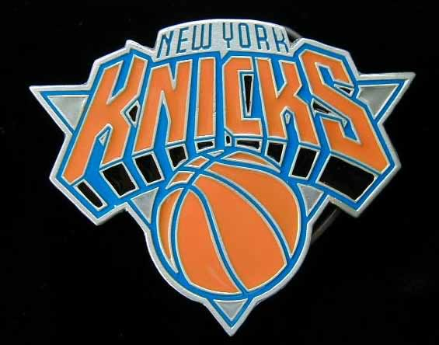

Artistic: Museum of Modern Art
The Museum of Modern Art, better known as MoMA, is located at 11 West 53rd Street, New York, NY 10019. It has many things to do including tours, exhibitions, lectures, events, and classes. The goal of MoMA is to inspire art, creativity, show the connection between the past and present, and to help and show modern art. The Museum presents these ideas in various mediums like paintings, film, photography, etc. We chose this for our artistic location because the art work is very unique and the ideas that the MoMA illustrate are very interesting and they show them in a unique and beautiful way.
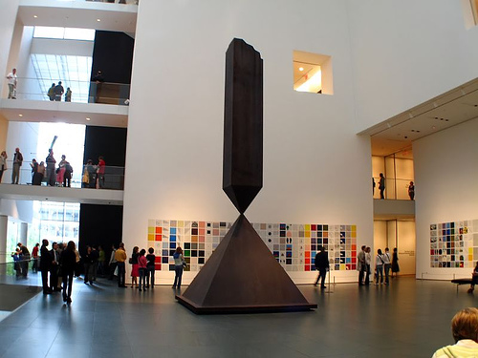

Cultural: The 9/11 Memorial
The 9/11 Memorial is a very interesting memorial located at the former twin tower locations. It is the memorial honoring the people that died in the 9/11 attack at the World Trade Center, the airplanes site near Shanksville, Pa, and the Pentagon. About 3,000 names are written on the walls of the two reflection pools. These pools are the “foot prints” of the twin towers. We picked this because everyone knows what happened on 9/11 and honoring those who died is very respectful. Plus it is a beautiful place to go because it is peaceful and very sacred.



Environmental: Central Park
This is a Public Park at the center of Manhattan and New York. The park is owned by the city and has been there since 1857. We picked this place because it is a nice place to be. It is calm and very beautiful so a lot of people go here to see the beauty, and enjoy a nice day at the park. There is not as much crime as there used to be. Now the crime rate is low. This is a national historic landmark, so it is maintained very well. We picked this as our environmental location because it is outside in the fresh air where there are a lot of animals and plants. This park is a nice place where you can enjoy the beauty and look at the different wonders of the huge park.
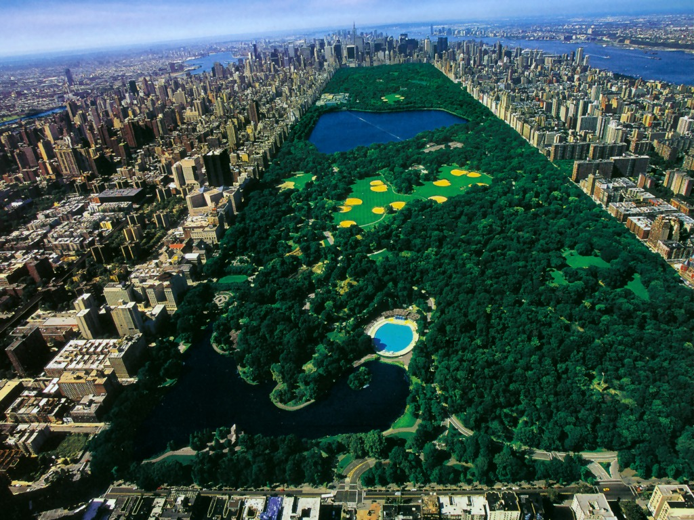

Itinerary
*All travel between locations is done by a car which we preordered.
8:00 a.m. - Arrive at Downtown Manhattan heliport
20 minutes for travel
8:20 a.m.-9:20 a.m. - Central Park
18 minutes for travel
9:38 a.m.-10:40 a.m. - 9/11 Memorial
5 minutes for travel
10:45 a.m.-11:30 a.m. - Statue of Liberty
18 minutes for travel
11:50 a.m.-12:50 p.m. - Serendipity
9 minutes for travel
1:00 p.m.-2:45 p.m. - Los Angeles vs. New York Basketball
5 minutes for travel
2:50 p.m.-4:50 p.m. - Museum of Modern Art
16 minutes for travel
5:05 p.m.-5:50 p.m. - Wall Street
5 minutes for travel
6:00 p.m - return to heliport

Compare and Contrast
In 2011, New York City had a population of 8,244,910 while Austin had a population of 1,765,010. A very big difference between Austin and New York City is how much more populated NYC is to Austin. NYC is a megalopolis and is more crowded and urban than Austin. But these two cities also have some human characteristics in common. Both places have hundreds of languages used, and both have English as the most common. NYC and Austin also have huge cultural events even though they celebrate different things. For example some events in Austin are SXSW and the Zilker Kite festival. Whereas some events in NYC are New Year's Eve at Times Square and the Macy's Thanksgiving Day Parade.

These two places also have differences and similarities in their physical characteristics. Although both cities are in America, NYC is located in the North East region on the Atlantic Coast. Whereas Austin is in the southern region and in the center of Texas. Because the two are in different locations, the cities have some differences in weather, flora, and fauna. Both cities have rivers flowing through them, NYC's Hudson and East Rivers and Austin's Colorado River. Austin has extreme summers and mild winters and though NYC does get a lot cooler than Austin, it still has warmer seasons than the surrounding areas. However, New York City does receive snow and Austin usually does not.

Participation
Student A - Timeline, Paragraphs (9/11 Memorial, Wall Street, Basketball game, Central park, and the Statue of Liberty), Map, and Presentation
Student B - Research for the Statue of Liberty and Central Park, Bibliography, and Pictures, Compare and Contrast, Paragraphs (Serendipity, and Museum of Modern Art), and Edited Paper.

Works Cited
"ABOUT MoMA." MoMA. N.p., n.d. Web. 18 Oct. 2012. <http://www.moma.org/about/>.
"EXHIBITIONS &AMP; THE COLLECTION." MoMA. N.p., n.d. Web. 18 Oct. 2012. <http://www.moma.org/explore/exhibitions/upcoming>.
"Geography of Austin-Texas." HowStuffWorks. N.p., n.d. Web. 18 Oct. 2012. <http://geography.howstuffworks.com/united-states/geography-of-austin-texas.htm>.
N.p., n.d. Web.
"Population - New York City Department of City Planning." Population - New York City Department of City Planning. N.p., n.d. Web. 18 Oct. 2012. <http://www.nyc.gov/html/dcp/html/census/pop_facts.shtml>.
"Serendipity 3." Serendipity 3. N.p., n.d. Web. 18 Oct. 2012. <http://www.serendipity3.com/history.htm>.
"Serendipity 3." Serendipity 3. N.p., n.d. Web. 18 Oct. 2012. <http://www.serendipity3.com/history.htm>.
"Statue Cruises." Statue of Liberty and Ellis Island. N.p., n.d. Web. 18 Oct. 2012. <http://statuecruises.com/schedule.aspx>.
N.p., n.d. Web. 20 Oct. 2012. <http://www.911memorial.org/>.
"Austin Life and Travel Tips: Austin, Texas - TX, USA." Austin Life and Travel Tips: Austin, Texas - TX, USA. N.p., n.d. Web. 18 Oct. 2012. <http://www.austin.world-guides.com/austin_life.html>.
"Free Museum of Modern Art Tickets - Save $25." MoMA New York. N.p., n.d. Web. 18 Oct. 2012. <http://www.newyorkpass.com/tickets/Museum_of_Modern_Art_>.
"Texas Population, 2011." Population Data (Projections) for Texas Counties, 2011. N.p., n.d. Web. 18 Oct. 2012. <http://www.dshs.state.tx.us/Chs/popdat/ST2011.shtm>.
"Wall Street." Wikipedia. Wikimedia Foundation, 22 Oct. 2012. Web. 22 Oct. 2012. <http://en.wikipedia.org/wiki/Wall_Street>.

