EUROPEAN HISTORY AP
Packet #2
16th-17th centuries
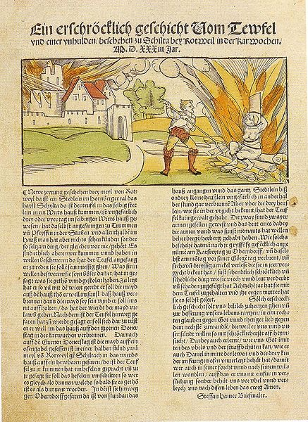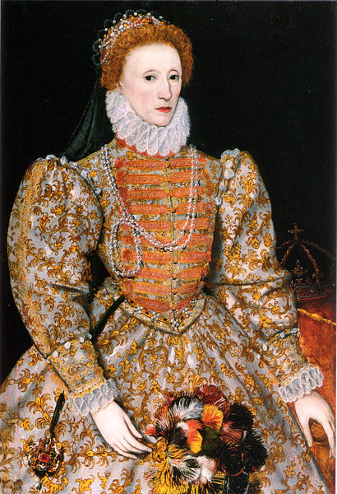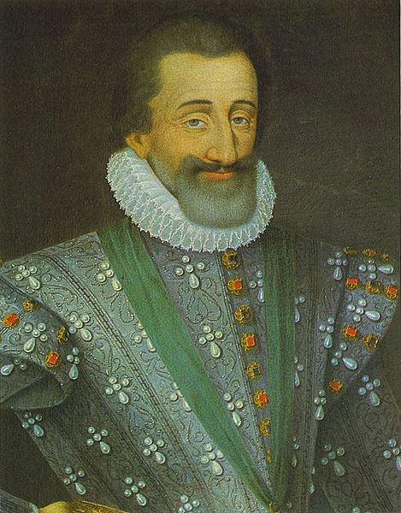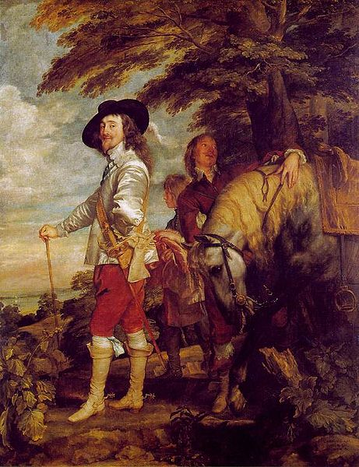
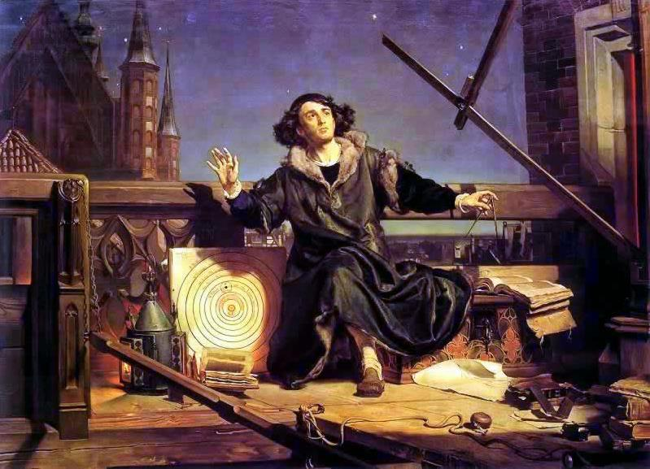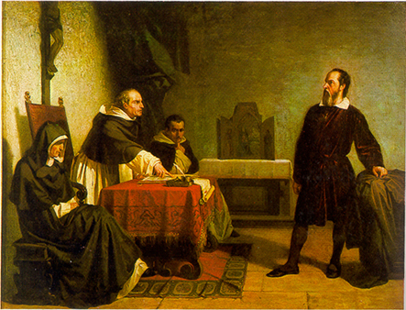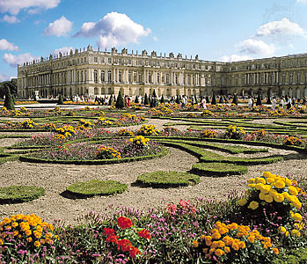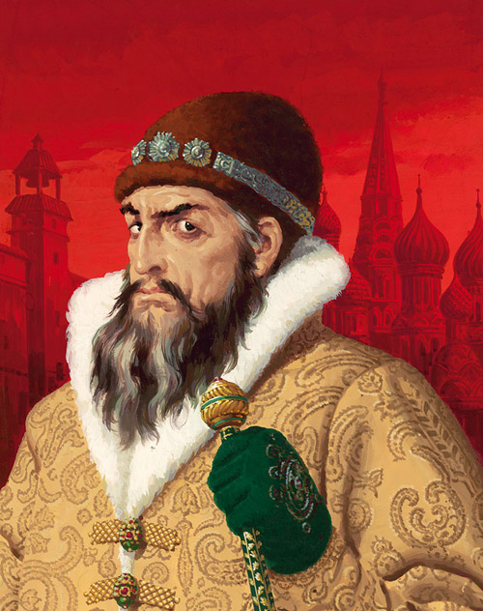

1. The Hammer of Witches Heinrich Kramer and Jacob Sprenger: The upheavals of the period between 1560 and 1660 included growing violence against women in the form of persecuting women as witches. While witch hunting was widespread, it was particularly prevalent in Germany, where both Catholics and Protestants took part in the hunts and persecutions. Authorities often used witch-hunters’ manuals as guides to belief about witches. The most influential of these manuals, the Malleus Maleficarum (The Hammer of Witches) was written in 1486 by two Dominican Inquisitors. The following excerpt focuses on why most witches were women. As the first question, why a greater number of witches is found in the fragile feminine sex than among men...the first reason is, that they are more credulous, and since the chief aim of the devil is to corrupt faith, therefore he rather attacks them…the second reason is, that women are naturally more impressionable, and …the third reason is that they have slippery tongues, and are unable to conceal from their fellow-women those things which by evil arts they know….But the natural reason is that she is more carnal than a man, as is clear from her many carnal abominations. And it should be noted that there was a defect in the formation of the first woman, since she was formed from a bent rib, that is, a rib of the breast, which I bent as it were in a contrary direction to a man. And since through this defect she is an imperfect animal, she always deceives….And this is indicated by the etymology of the world; for Femina comes from Fe and Minus, since she is ever weaker to hold and preserve the faith….To conclude. All witchcraft comes from carnal lust, which is in women insatiable.

2. 1586 – 1590 TO MARY, QUEEN OF SCOTS At the opening of the trial of Mary, Queen of Scots, at Fotheringhay on 12th October, I586, the Commissioners delivered her this personal letter from Queen Elizabeth. Translated from the French October 1586.: You have in various ways and manners attempted to take my life and to bring my kingdom to destruction by bloodshed. I have never proceeded so harshly against you, but have, on the contrary, protected and maintained you like myself. These treasons will be proved to you and all made manifest. Yet it is my will, that you answer the nobles and peers of the kingdom as if I were myself present. I therefore require, charge, and command that you make answer for I have been well informed of your arrogance.
Act plainly without reserve, and you will sooner be able to obtain favour of me.

ELIZABETH.

3. Queen Elizabeth's Speech to the troops before the battle with the Armada At a time when rulers wee kings, not queens Elizabeth realized that her followers might doubt her ability to lead at such an important hour. The following speech shows how she turned this doubt into an asset. "I know I have the body of a weak and feeble woman; but I have the heart and stomach of a king, and of a king of England too; and think foul scorn that ... Spain, or any prince of Europe should dare to invade the borders of my realm; to which rather than any dishonour shall grow by me, I myself will take up arms, I myself will be your general, judge, and rewarder of every one of your virtues in the field.... By your concord in the camp, and your velour in the field, we shall shortly have a famous victory over those enemies of my God, of my kingdoms, and of my people."
4. Queen Elizabeth I, "The Golden Speech" I do assure you there is no prince that loves his subjects better, or whose love can countervail our love. There is no jewel, be it of never so rich a price, which I set before this jewel: I mean your love. For I do esteem it more than any treasure or riches.... And, though God has raised me high, yet this I count the glory of my crown, that I have reigned with your loves. This makes me that I do not so much rejoice that God has made me to be a Queen, as to be a Queen over so thankful a people....Of myself I must say this: I never was any greedy, scraping grasper, nor a strait, fast-holding Prince, nor yet a waster. My heart was never set on any worldly goods, but only for my subjects' good. What you bestow on me, I will not hoard it up, but receive it to bestow on you again. Yea, mine own properties I account yours, to be expended for your good....There will never Queen sit in my seat with more zeal to my country, care for my subjects, and that will sooner with willingness venture her life for your good and safety, than myself. For it is my desire to live nor reign no longer than my life and reign shall be for your good. And though you have had and may have many princes more mighty and wise sitting in this seat, yet you never had nor shall have any that will be more careful and loving....
5. The Monstrous Regiment of Women "To promote a woman to bear rule, superiority, dominion or empire above any realm, nation, or city is repugnant to nature, contumely to God, and the subversion of good order, of all equity and justice." So wrote the Scottish theologian John Knox (1513- 72) in The First Blast of the Trumpet Against the Monstrous Regiment of Women (1558). Although he made his points more emphatically than many others, Knox was only repeating the commonplace notions of his day. He could quote Aristotle and Aquinas as well as a host of secular authorities to demonstrate female inadequacies: "Nature, I say, cloth paint them forth to be weak, frail, impatient, feeble, and foolish." He could quote Saint Paul along with the ancient Fathers of the Church to demonstrate the "proper" place of women-"Man is not of the woman, but the woman of the man." But no stacking up of authorities, no matter how numerous or revered, could erase the fact that all over Europe in the sixteenth century women could and did rule. In the Netherlands, Mary, Queen of Hungary (1531 -52), and Margaret of Parma (1559- 67) were successful regents. Jeanne d'Albret (1562- 72) was queen of the tiny state of Navarre, territory claimed by both France and Spain but kept independent by this remarkable woman. Catherine de Medicis (1560-89), wife of one king of France and mother of three others, was the effective ruler of that nation for nearly thirty years. Mary, Queen of Scots (1542-87), was the nominal ruler of Scotland almost from her birth. England was ruled by two very different women, the Catholic Mary I (1553- ~ 58) and her Protestant half-sister Elizabeth I (1558- l 1603). The problems faced by this long list of queens and regents were more than just the ordinary cares of government. The belief that women were inherently inferior in intelligence, strength, and character was so pervasive that for men like Knox, a woman ruler was almost a contradiction in terms. Yet this was not the view taken by everyone, and female rule had its defenders as well as its detractors. One set of objections was overcome by the traditional medieval theory of the two bodies of the monarch. This argument was developed to reconcile the divine origins and functions of monarchs with their very real human frailties. In the theory of the two bodies, there was the body natural and the body politic. Both were joined together in the person of the ruler, but the attributes of each could be separated. Rule of a woman did nothing to disrupt this notion. In fact, it made it easier to argue that the frailties of the body natural of a woman were in no way related to the strengths of the body politic of a monarch.
6. William of Orange Defends Himself to the Dutch Estates Branded an outlaw by Philip II of Spain, the Protestant Dutch Prince William of Orange defended himself to his countrymen in an eloquent address known as the Apology (1581).Is this a rhetorical speech of the kind we still hear today – making an enemy’s condemnation a badge of honor? Did being branded as an outlaw by the Spanish king put William in greater danger? If so, from whom? How did William’s life end in 1584? Did the condemnation by the Spanish King have anything to do with it?

What could be more gratifying in this world, especially to one engaged in the great and excellent task of securing liberty for a good people oppressed by evil men, than to be mortally hated by one’s enemies, who are at the same time enemies of the fatherland, and from their mouths to receive a sweet testimony to one’s fidelity to his people and to his obstinate oppression to tyrants and disturbers of the peace? Such is the pleasure that the Spaniards and their adherents have prepared for me their anxiety to disturb me. They have but gratified me by that infamous proscription by which they sought to ruin me. Not only do I owe to them this favor, but also the occasion to make generally known the equity and justice of my enterprises…
My enemies object that I have “established liberty of conscience.” I confess that the glow of fires in which so many poor Christians have been tormented is not an agreeable sight to me, although it may rejoice the eyes of the duke of Alba and the Spaniards; and that it has been my opinion that persecutions should cease in the Netherlands…
They denounce me as a hypocrite, which is absurd enough…As their friend, I told them quite frankly that they were twisting a rope to hang themselves when they began the barbarous policy of persecution…
As for me personally…it is my head that they are looking for, and they have vowed my death by offering such a great sum of money [25,000 crowns]. They say that the war can never come to an end so long as I am among you…
If, gentlemen, you believe that my exile, or even my death, may serve you, I am ready to obey your behests. Here is my head, over which no prince or monarch has authority save you. Dispose of it as you will for the safety and preservation of our commonwealth. But if you judge that such little experience and energy as I have acquired through long and assiduous labors, if you judge that the remainder of my possessions and of my life can by of service to you, I dedicate them to you and to the fatherland.

7. Henry IV Recognizes Huguenot Religious Freedom By the Edict of Nantes (April 13, 1598), Henry IV recognized Huguenot religious freedoms and the rights of Protestants to participate in French public institutions. Here are some of its provisions.
We have by this perpetual and irrevocable Edict pronounced, declared, and ordained and we pronounce, declare, and ordain:
I. Firstly, that the memory of everything done on both sides from the beginning of the month of March, 1585, until our accession to the Crown and during the other previous troubles, and at the outbreak of them, shall remain extinct and suppressed, as if it were something which had never occurred…
II. We forbid all our subjects, of whatever rank and quality they may be, to renew the memory of these matters, to attack, be hostile to, injure or provoke each other in revenge for the past, whatever may be the reason and pretext…but let them restrain themselves and live peaceably together as brothers, friends, and fellow citizens…
III. We ordain that the Catholic, Apostolic and Roman religion shall be restored and reestablished in all places and districts of this out kingdom and the countries under out rule, where its practice has been interrupted…
XXVII. In order to reunite more effectively the wills of our subjects, as is our intention, and to remove all future complaints, we declare that all those who profess or shall profess the aforesaid so-called Reformed religion are capable of holding and exercising all public positions, honours, offices, and duties whatsoever…in the towns of out kingdom…notwithstanding all contrary oaths.

8. DIVINE RIGHT ARGUMENTS OF JAMES I King James I (1603-1625) argued strongly for monarchical authority, as is illustrated in the following selection. The state of monarchy is the supremest thing upon earth; for kings are not only God’s lieutenants upon earth, and sit upon god’s throne, but even by God himself are called gods. There be three principal similitudes that illustrate the state of monarchy: one taken out of the word of God; and the two other out of the grounds of policy and philosophy. In the Scriptures kings are called gods, and so their power after a certain relation compared to the divine power. Kings are also compared to fathers of families: for a king is truly PARENS PATRIAE, the politique father of his people. And lastly, kings are compared to the head of this microcosm of the body of man.

Kings are justly called gods, for that they exercise a meaner or resemblance of divine power upon earth: for if you will consider the attributes to God, you shall see how they agree in the person of a king. God hath power to create or destroy, make or unmake at his pleasure, to give life or send death, to judge all end to be judged nor accountable to none; to raise low things and to make high things low at his pleasure, and to God are both souls and body due. And the like power have kings: they make and unmake their subjects, they have power of raising and casting down, of life and of death, judges over all their subjects and in all causes and yet accountable to none but God only….

First, that you do not meddle with the main points of government; that is my craft…. to meddle with that were to lessen me… I must not be taught my office.

Secondly, I would not have you meddle with such ancient rights of mine as I have received from my predecessors…. All novelties are dangerous as well in a politic as in a neutral body, and therefore I would be loath to be quarreled in my ancient rights and possessions; for that were to judge me unworthy of that which my predecessors had and left me.

9. King James I Defends Popular Recreation The English Puritans believed in strict observance of the Sabbath, disapproving any sports, games, or general social conviviality on Sunday. James U thought that these strictures prevented many Roman Catholics from joining the Church of England. In 1618, he ordered the clergy of the Church of England to read the Book Sports from their pulpits. in this declaration, he permitted people to engage in certain sports and games after church services. His hope was to allow innocent recreations on Sunday while encouraging people to attend the Church of England. Despite the king’s good intentions, the order offended the Puritans. The clergy resisted his order and he had to withdraw it. With our own ears we heard the general complaint of our people, that they were barred from all lawful recreation and exercise upon the Sunday’s afternoon, after the ending of all divine service, which cannot but produce two evils: the one the hindering of the conversion of many(Roman Catholic subjects), whom their priests will take occasion hereby to vex, persuading them that no honest mirth or recreation is lawful or tolerable in our religion, which cannot but breed a great discontentment in our people’s hears, especially as such as are peradventure upon the point of turning (to the Church of England): the other inconvenience is, that this prohibition barreth the common and meaner sort of people from using such exercises as may make their bodies more able for war, when we or our successors shall have occasion to use them; and in place thereof sets up filthy tipplings and drunkenness, and breeds a number of idle and discontented speeches in their ale-houses. For when shall the common people have leave to exercise, if not upon the Sundays and holy days, seeing they must apply their labor and win their living in all working days?...

10. Parliament Presents Charles I with the Petition of Right After becoming monarch in 1625, Charles I (1625-1649) imposed unparliamentary taxes, coerced freemen, and quartered troops in transit in private homes. These actions deeply offended Parliament, which in 1628, refused to grant him any funds until he rescinded those practices by recognizing the Petition of Right (June 1628), The Petition constituted a general catalog of the offenses associated with the exercise of arbitrary royal authority. (The Lords Spirit and Temporal, and commons in Parliament assembled) do humbly pray your Most Excellent Majesty, that no man hereafter be compelled to make or yield any gift, loan, benevolence, tax, or such like charge, without common consent by Act of Parliament; and that none be called to make answer, to take such oath, or to give attendance, or be confined, or otherwise molested or disquieted concerning the same, or for refusal thereof; and that no freeman, in any such manner as in before-mentioned, be imprisoned or detained; and that your Majesty will be pleased to remove the said soldiers and mariners (who have been quartered in private homes), and that your people may not be so burdened in time to come; and that the foresaid commissions for proceeding by martial law, may be revoked and annulled; and that hereafter no commissions of like nature may issue forth to any person or persons whatsoever, to be executed as aforesaid, lest by colour of them any of your Majesty’s subjects be destroyed or put to death, contrary to the laws and franchise of the land.
All which they most humble pray of your Most Excellent Majesty, as their rights and liberties according to the laws and statues of his realm.

11. John Milton Defends Freedom to Print Books Certain Puritans were as concerned about resisting potential tyranny from Parliament as from the monarchy. During the English Civil War, the Parliament passed a very strict censorship measure. In “Areppagitica” (1644), John Milton, later the author of Paradise Lost (1667), attacked this law and contributed one of the major defenses of the freedom of the press in the history of Western culture. In the passage that follows, he compares the life of a book with the life of a human being. I deny not but that it is of greatest concern in the Church and Commonwealth to have a vigilant eye how books demean themselves as well as men; and thereafter to confine, imprison, and do sharpest justice on them as (if they were criminals); for books are not absolutely dead things but do contain a progeny of life in them to be as active as that soul was whose progeny they are; nay, they do preserve as in a vial the purest efficacy and extraction of that living intellect that bred them….He who kills a man kills a reasonable creature, God’s Image; but he who destroys a good book, kills reason itself, kills the Image of God, as it were….Many a man lives(as) a burden to the Earth; but a good book is the precious life-blood of a master spirit, embalmed and treasured up on purpose to a life beyond life.

12. John Milton, “TO THE LORD GENERAL CROMWELL” Some impression of the Puritans’ devotion to the Lord Protector, Oliver Crowell, and their hope that he would bend every effort to purge England of papish error, is conveyed by the sonnet “To the Lord General Cromwell” by the great Puritan poet, John Milton.

TO THE LORD GENERAL CROMWELL, May 1652, on the proposals of certain ministers at the committee for propagation of the Gospel

Cromwell, our chief of men, who through a cloud
Not of war only, but detractions rude,
Guided by faith and matchless fortitude,
To peace and truth thy glorious way hast ploughed,
And on the neck of crowned Fortune proud
Hast reared God’s trophies, and his work pursued,
While Darwen stream, with blood of Scots imbrued,
and Dunbar field, resounds thy praises loud,
And Worcester’s laureate wreath; yet much remains
To conquer still; Peace hath her victories
No less renowned than War: new foes arise,
Threatening to bind our souls with secular chains.
Help us to save free conscience from the paw
Of hireling wolves, whose Gospel is their maw.

13. The Instrument of Government. The government of the Commonwealth of England, Scotland, and Ireland, and the dominions thereunto belonging.
I. That the supreme legislative authority of the Commonwealth of England, Scotland, and Ireland, and the dominions thereunto belonging, shall be and reside in one person, and the people assembled in Parliament: the style of which person shall be the Lord Protector of the Commonwealth of England, Scotland, and Ireland.
III. That all writs, processes, commissions, patents, grants, and other things, which now run in the name and style of the keepers of the liberty of England by authority of Parliament, shall run in the name and style of the Lord Protector, from whom, for the future, shall be derived all magistracy and honours in these three nations; and have the power of pardons (except in case of murders and treason) and benefit of all forfeitures for the public use; and shall govern the said countries and dominions in all things by the advice of the council, and according to these presents and the laws.
IV. That the Lord Protector, the Parliament sitting, shall dispose and order the militia and forces, both by sea and land, for the peace and good of the three nations, by consent of Parliament; and that the Lord Protector, with the advice and consent of the major part of the council, shall dispose and order the militia for the ends aforesaid in the intervals of Parliament.
XIV. That all and every person and persons, who have aided, advised, assisted, or abetted in any war against the Parliament, since the first day of January, 1641 (unless they have been since in the service of the Parliament, and given signal testimony of their good affection thereunto) shall be disabled and incapable to be elected, or to give any vote in the election of any members to serve in the next Parliament, or in the three succeeding Triennial Parliaments.
XV. That all such, who have advised, assisted, or abetted the rebellion of Ireland, shall be disabled and incapable for ever to be elected, or give any vote in the election of any member to serve in Parliament
XXIV. That all Bills agreed unto by the Parliament, shall be presented to the Lord Protector for his consent; and in case he shall not give his consent thereto within twenty days after they shall be presented to him, or give satisfaction to the Parliament within the time limited, that then, upon declaration of the Parliament that the Lord Protector hath not consented nor given satisfaction, such Bills shall pass into and become laws, although he shall not give his consent thereunto; provided such Bills contain nothing in them contrary to the matters contained in these presents.
XXXIII. That Oliver Cromwell, Captain-General of the forces of England, Scotland and Ireland, shall be, and is hereby declared to be, Lord Protector of the Commonwealth of England, Scotland and Ireland, and the dominions thereto belonging, for his life.
14. Galileo, the Astronomer: Galileo’s study of the heavens was an important step in the development of the scientific methods. Study his statement below and answer the questions that follow. …..the moon is not perfectly smooth, free from inequalities, and exactly spherical, as a large school of philosophers considers with regard to the moon and the other heavenly bodies. On the contrary, it is full of inequalities, uneven, full of hollow and protuberances [bulges], just like the surface of the earth itself, which is varied everywhere by lofty mountains and deep valleys….
The next object which I have observed is the essence or substance of the Milky Way. By the aid of a telescope, anyone may behold this in a manner which so distinctly appeals to the senses that all the disputes which have tormented philosophers through so many ages are exploded by the irrefutable [proven] evidence of our eyes, and we are freed from wordy disput4es upon the subject. For the galaxy is nothing else but a mass of innumerable stars planted together in clusters. Upon whatever part of it you direct the telescope, straightaway [at once] a vast crowd of stars presents itself to view. Many of them are tolerably [rather] large and extremely bright, but the number of small ones is quite beyond determination [learning].

15. The Discourse on Method Rene Descartes Seventeenth-century science needed new philosophical and methodological standards for truth to replace those traditionally used to support scientific assumptions. These were forcefully provided by Rene Descartes (1596-1650) in his Discourse on Method (1637). Born and educated in France, but spending his most productive years in Holland, Descartes gained fame as a mathematician, physicist, and metaphysical philosopher. The following excerpt from this Discourse contains the best-known statement of his approach to discovering truth.

In place of the multitude of precepts of which logic is composed, I believed I should find the four following rules quite sufficient, provided I should firmly and steadfastly resolve not to fail of observing them in a single instance.
The first rule was never to receive anything as a truth which I did not clearly know to be such; that is, to avoid hast and prejudice, and not to comprehend anything more in my judgments than that which should present itself so clearly and so distinctly to my mind that I should have no occasion to entertain a doubt of it.
The second rule was to divide every difficulty, which I should examine into as many parts as possible, or as, might be required for resolving it.
The third rule was to conduct my thoughts I an orderly manner, beginning with objects the most simple and the easiest to understand, or order to ascend as it were by steps to the knowledge of the most composite, assuming some order to exist even in things which did not appear to be naturally connected.
The last rule was to make enumerations so complete, and reviews so comprehensive that I should be certain of omitting nothing.

16. Bishop Bousset Defends the Divine Right of Kings The revolutions of the seventeenth century caused many to fear anarchy far more than tyranny, among them the influential French bishop Jacques-Benigne Bossuet (1627-1704), the leader of French Catholicism in the second half of the seventeenth century. Louis XIV made him court preacher and tutor to his son, for whom Bossuet wrote the celebrated Universal History. In the following excerpt, Bossuet defends the divine right and absolute power of kings. He depicts kings as embracing in their person that whole body of the state and the will of the people they govern and, as such as being immune from judgment by any mere mortal. The royal power is absolute….The prince need render account of his acts to no one. “I counsel thee to keep the king’s commandment, and that in regard of the oath of God. Be not hasty to go out of his sight; stand not on an evil thing for he doeth whatsoever pleaseth him. Where the word of a king is, there is power; and who may say undo him. What doest thou? Whoso keepeth the commandment shall feel no evil thing” [Eccles. 8;2-5]. Without this absolute authority the king could neither do good nor repress evil. It is necessary that his power be such that no one can hope so escape him, and finally, the only protection of individuals against the public authority should be their innocence. This confirms the teaching of St. Paul: “Wilt thou then not be afraid of the power? Do that which is good” [Rom.]

God is infinite, God is all. The prince, as prince, is not regarded as a private person: he is a public personage, all the state is in him, the will of all the people is included in his. As all perfection and all strength are united in God, so all the power of individuals is united in the person of the prince. What grandeur that a single man should embody so much!...

Behold an immense people united in a single person; behold this holy power, paternal and absolute; behold the secret case which governs the whole body of the state, contained in a single head; you see the image of God in the king, and you have the idea of royal majesty. God is holiness itself, goodness itself, and power itself. In these things lies the majesty of God. In the image of these things lies the majesty of the prince.

17. Mémoires: The Aristocracy Undermined in France Saint-Simon Louis XIV of France was the most powerful ruler of his time. He had inherited the throne as a child in 1643. He took personal command by 1661 ruling France until his death in 1715. Contemporary rulers viewed him as a model ruler. One of the ways in which he reinforced his position was by conducting a magnificent court life at his palace of Versailles. There, nobles hoping for favors or appointments competed for his attention and increasingly became dependent upon royal whim. One of those nobles, the Duke of Saint-Simon (1675-1755), felt slighted and grew to resent the king. Saint-Simon chronicled life at Versailles in his Mémoires. In the following excerpt, he shows how Louis XIV used this court life to his own ends.
Frequent fetes, private walks at Versailles, and excursions were means which the King seized upon in order to single out to mortify [individuals] by naming the persons who should be there each time, and in order to keep each person assiduous and attentive to pleasing him. He sensed that he lacked by far enough favors to distribute in order to create a continuous effect. Therefore he substituted imaginary favors for real ones, through jealousy—little preferences which were shown daily, and one might say at each moment—[and] through his artfulness. The hopes to which these little preferences and these honor gave birth, and the deference which resulted form them—no one was more ingenious than he in unceasingly inventing these sorts of things…………….Louis XIV carefully trained himself to be well informed about what was happening everywhere, in public places, in private homes, in public encounters, in the secrecy of families or of [amorous] liaisons. Spies and tell tales were countless. They existed in all forms: some who were unaware that their denunciations went as far as [the King], others who knew it; some who wrote him directly by having their letters delivered by routes which he had established from them, and those letters were seen only by him, and always before all other things; and lastly, some other who sometimes spoke to him secretly in his cabinets, by the back passageways……………. In everything he loved splendor, magnificence, profusion. He turned this taste into a maxim for political reasons, and instilled it into his court on all matters. One could please him by throwing oneself into fine food, clothes, retinue, buildings, gambling. These were occasions which enabled him to talk to people. The essence of it was that by this he attempted and succeeded in exhausting everyone by making luxury a virtue, and for certain persons a necessity, and thus he gradually reduced everyone to depending entirely upon his generosity in order to subsist. In this he also found satisfaction for his pride through a court which was superb in all respects, and through a greater confusion which increasingly destroyed natural distinctions. This is an evil which, once introduced became the internal cancer which is devouring all individuals—because form the court it promptly spread to Paris and into the provinces and the armies, where person, whatever their position are considered important only in proportion to the table they lay and their magnificence ever since this unfortunate innovation—which is devouring all individuals, which forces those who are in a position to steal not to restrain themselves form doing so for the most part, in their need to keep up with their expenditures; [a cancer] which is nourished by the confusion of social positions, pride, and even decency and which by a mad desire to grow keeps constantly increasing, whose consequences are infinite and lead to nothing less than ruin and general upheaval.

18. A STATE VISIT BY PETER THE GREAT Louis de Rouvroy, Duc de Saint-Simon, was a French courtier who lived at Versailles in the late 1600s and early 1700s. His Memoirs are famous for the picture they give of court life at Versailles. Saint-Simon also recorded a visit that Peter the Great of Russia made to France in 1717. The Czar was admired for his great curiosity in matters of government, trade, education, and police. Everything he did brought out the vast scope of his knowledge and his powers of reasoning. It was astonishing to see how he blended majesty at once lofty, proud, delicate, sustained, and natural, with a monarch’s courtesy, which everyone felt in varying degrees depending on their rank. He had a kind of familiarity which stemmed from an independent spirit; but he had not shaken off the strong imprint of his country’s ancient barbarism, which made him impatient, abrupt, and incapable of tolerating contradiction, though his opinions wavered. He displayed the brazenness of a king who felt himself everywhere at home, he wanted to do and see everything in his own way, and everyone had to bend to his wishes and demands....He was a very tall man, extremely well built, on the thin side, with a rather round face, a high forehead, and fine eyebrows;...he had beautiful black eyes, large alert, piercing, and well set. When he wanted it to be, his expression was majestic and gracious, otherwise it was stern and fierce, with a recurring tic that twisted his whole face and frightened people. He would take on a wild and terrible look, but it only lasted a moment, and his face would go back to normal.....The King Louis XV went to see the Czar. The Czar was at the door to greet him, watched him get out of his carriage, and led him to his room, where there were two identical armchairs ... The astonishment was general when the Czar grabbed the King under both arms, lifted him in the air, and kissed him. Despite his age [seven years old], the King displayed no fear at this unexpected greeting. For the King’s benefit, the Czar strikingly displayed graciousness, tenderness, and natural courtesy which also brought out his grandeur, his equality of rank, and the slight superiority due to his age. He praised the King highly and convinced everyone he had been charmed by him....

19. Poem In Praise of Peter (Russian poet Mikhail Lomonosov—1747)

Inscription for a Statue of Peter the Great

Behold the sculpture here of him, who, most audacious,
Most wise, forewent his ease to serve, supremely gracious
Toward his people: chose the rank of lowliest knave,
And reigned—exemplar, he upheld the laws he gave;
He put his scepter by, reached, rather, for the spanner [a wrench];
His power he hid, unfurling science’s bright banner.
He built a city; none bore battle’s brunt as he;
He visited far lands, and journeyed oversea;
To gather artists, to train soldiers was his doing,
The enemies at home, as those abroad, subduing:
There’s Peter, father of the fatherland, in brief;
An early deity our Russia is adoring;
Many the altar fires before this figure soaring,
The hearts beholden to him, many beyond belief.

20. Jean-Baptiste ColbertA LETTTER TO THE MERCHANTS OF MARSEILLES, 1664

Very dear and well beloved:
Considering how advantageous it would be to this realm to reestablish its foreign and domestic commerce...We have resolved to establish a council particularly devoted to commerce, to be held every fortnight in our presence, in which all the interests of merchants and the means conducive to the revival of commerce shall be considered and determined upon, as well as all that which concerns manufactures.
We also inform you that we are setting apart, in the expenses of our state, a million livres each year for the encouragement of manufactures and the increase of navigation, to say nothing of the considerable sums which we cause to be raised to supply the companies of the East and West Indies;
That we are working constantly to abolish all the tolls which are collected on the navigable rivers;
That there has already been expended more than a million livres for the repair of the public highways, to which we shall also devoted our constant attention;
That we will assist by money from our royal treasury all those who wish to reestablish old manufactures or to undertake new ones;
That we are giving orders to all our ambassadors or residents at the courts of the princes, our allies, to make, in our name, all proper efforts to cause justice to be rendered in all cases involving our merchants, and to assure for them entire commercial freedom.
That we will comfortably lodge at our court each and every merchant who has business during all the time that he shall be obliged to remain there....
That all the merchants and traders by sea who purchase vessels, or who build new ones, for traffic or commerce shall receive from us subsidies for each ton of merchandise which they export or import on the said voyages.
We desire, in this present letter, not only to inform you concerning all these things, but to require you, as soon as you have received it, to cause to be assembled all the merchants and traders of your town of Marseilles, and explain to them very particularly our intentions in all matters mentioned above, in order that, being informed of the favorable treatment which we desire to give them, they may be the more desirous of applying themselves to commerce. Let them understand that for everything that concerns the welfare and advantage of the same they are address themselves to Sieur Colbert....

