Option E5 Questions Name: ______________________________
- Label the regions of the brain, including the function of each:
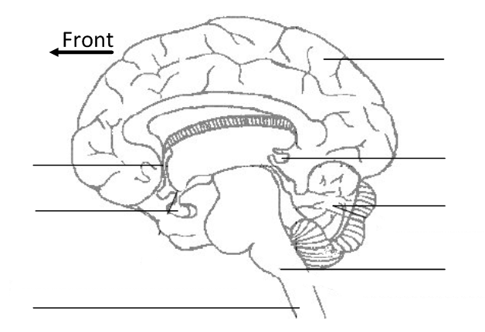
- Discovery of the functions of parts of the brain is due to a number of areas of research over the last couple of centuries. Outline each of the methods below and explain what they have told us about the brain.

- fMRI
- Define fMRI.

- Outline how fMRI works.

- Outline an experiment that shows how fMRI has been used to determine the function of a brain region.

- Brain Lesion studies
- Define lesion.

- Outline the effects of lesions on brain function.

- Outline the famous discovery of Broca’s area and its importance in language development.
- Animal experimentation
List the three types of animal experiments into brain function:
The Central Nervous System (CNS) consists of the brain and spinal cord. Peripheral nerves make up the peripheral nervous system, which is divided into the autonomic and somatic systems.
- Distinguish between the autonomic and somatic nervous systems.

- The autonomic nervous system is further divided into the sympathetic, parasympathetic and enteric nervous systems.
- Distinguish between the overall functions of the sympathetic and parasympathetic systems.

- The sympathetic and parasympathetic systems can regulate heart rate, blood flow to the gut and control of the iris, among other functions.
Complete the table below, outlining these functions:
 | Sympathetic |  | Parasympathetic
Neurotransmitters |  |  | Acetylcholine (Ach)
Nerve pathways | Sympathetic nerves
Heart rate | Stimulus:  Elevated CO₂ levels in blood |  | Stimulus:
Heart rate | Receptors:  Chemoreceptors in medulla oblongata |  | Receptors:
Heart rate | Action | Effect | Action | Effect
Heart rate | Stimulates SA node | Increases heart rate
Blood flow to gut | Stimulus: |  | Stimulus:
Blood flow to gut | Receptors: |  | Receptors:
Blood flow to gut | Action | Effect | Action | Effect
Blood flow to gut |  |  | Relaxes blood vessels to gut | Increases blood flow to gut, allowing for ‘rest and digest’
Iris control | Stimulus: |  | Stimulus:
Iris control | Receptors: |  | Receptors:
Iris control | Action | Effect | Action | Effect
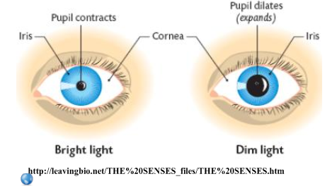
- Explain the pupil reflex as a response to bright light:
Stimulus:

Receptor:

Sensory neuron:

Relay neurons:

Motor neurons:

Effector muscles:

Effect:

- The pupillary response can be used to determine brain death.
- Distinguish between cardiac and brain death.

- Explain why the pupillary response is a good indicator of brain death, with reference to the functions of the medulla oblongata.

- Pain is an unpleasant or aversive sensation associated with an action which causes the body harm or trauma.
- What is a function of pain in terms of survival?

- Outline the pain pathway:
Stimulus:
Receptors:
Sensory neurons:
Function of the brain:

- Endorphins are protein-based molecules that can block pain impulses.
- State why this might be useful in survival.

- Explain the effect of endorphins on synaptic transmission in the brain.

- Suggest a method by which pain-related brain regions can be identified.

- Suggest reasons why morphine is a highly effective painkiller and can be used in cases of serious injury.

