Heating in the Atmosphere  Convection- Mostly occurs in the bottom layers. Hot material rises cold falls.  Conduction- mostly in the Thermosphere and troposphere. Heating due to contact with heated item.  Radiation- Heating due to location near heating source. Magnetosphere  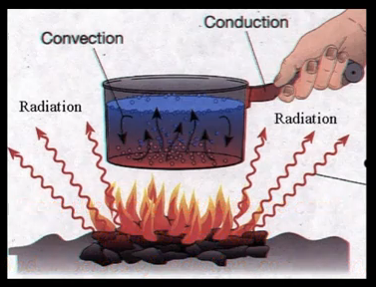 | Light Waves  Reflection and Scattering- light must bounce off an object. Reflection is when the angle of light hitting object is equal to the angle of light leaving the object. Mirror  Absorption- 50% of solar energy that strikes the top atmosphere reaches the Earth’s surface. Longer wave lengths are absorbed by gases in the atmosphere.  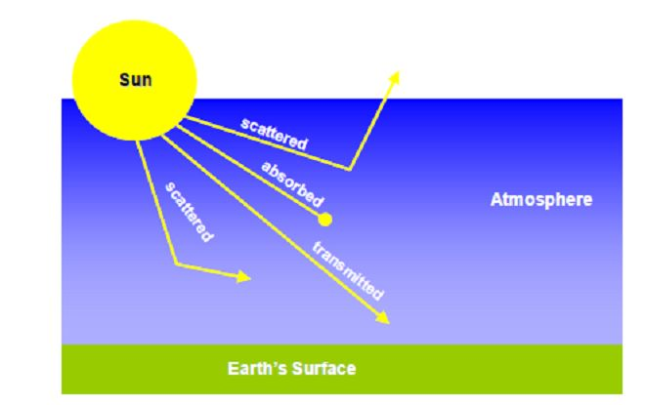  - Scatter  - Absorb  - Transmit  - Scatter | Name  Period  Date  Why would a chemical reaction occur faster in the Thermosphere then in the Troposphere?  The increase in temperature allows for more collisions between the molecules.  What allows the Northern Lights to travel into the Ionosphere and not stop in the Exosphere?  Ions are charged particles that allow magnetic fields to flux through.
13. Unmanned space craft  12. international space station 300km  11. Aurora Borealis  100-250km  10. Radio waves 96-112km  9. Meteors 48-80km  8. Blackbird Sr-70 26km  7. Ozone molecules 20-30km  6. Cumulonimbus up to 16km  5. Cirrus clouds 16km  4. Boeing 12km  3. Flock of geese 6 to 7 km  2. Balloon 5-7km  1. Weather near surface | 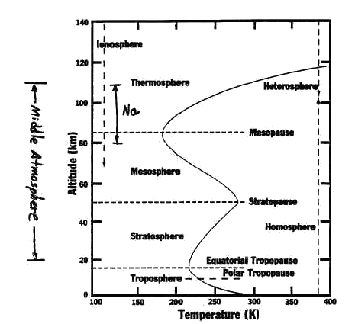 | 1. Magnetosphere  - Earth’s magnetic field  - Causes Aurora Borealis
2. Exosphere
- Upper part of thermosphere
- Satellites orbit here
3. Thermosphere
- increases up to 2k Celsius
- Air molecules are km apart
4. Ionosphere
a) lower part of thermosphere
b) radio waves bounce back to earth
5. Mesosphere
a) temp decrease from -60 to -100 Celsius
b) coldest region
6. Ozonosphere
a) three bonded oxygen
b) protects the surface from UV rays
c) humans are causing it to vanish
7. Stratosphere
a) temp. increases -60 to -20 Celsius
b) where jets and balloons have gone
8. Troposphere
a) temp decreases 25 to -60 Celsius
b) most weather occurs here, convection currents

