Physics Electromagnetism Study Guide

Equations

Coulomb’s Law Ohm’s Law Electrical Power
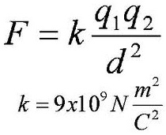
V = I R P = I V = I² R
Resistance in a Parallel Circuit If individual resistances are equal:
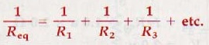
R = R / N

Transformers
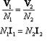

Electrostatics and Electric Fields

Key Facts:
- Like charges repel each other, and opposite charges attract.
- The unit of charge is the Coulomb.
- Conductors have free electrons which allow for current flow.
- The electrons in insulators are tightly bound to the atoms, so current can not flow.
- The charging of objects can occur by friction, contact, and induction.
- The Principle of Conservation of Charge states that charge is never created nor destroyed.
- Electric fields come from charged particles (protons and electrons).
- Electric field lines show the direction of force on a positive test charge.
- The strength of the electric field is governed by Coulomb’s Law.

Sample Questions
1) Find the force between two charges of 1 x 10⁻⁵ C and 3.4 x 10⁻³ C, held 5 m apart.

2) Two charges are held 4 meters apart and exert a force on each other of 10 N. What is the force between the charges if the magnitude of one charge is doubled?

3) What is the force between the two original charges if they are moved to 2 meters apart?

4) Two charges are held near each other and released. As they move, the force between them increases. Do they have the same charge or opposite charges?

5) Two positive charges are held near each other and released. As they move, what happens to the magnitude of the force between them?

6) A positively charged rod is brought near an aluminum can sitting on a rubber mat. You briefly touch the same side of the can. When the rod is removed, what charge is left on the can?

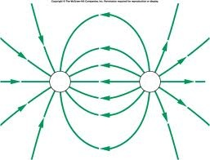
7) Which way will a proton travel if placed in the middle of the following diagram?

8) Which way will an electron travel if placed in the middle of the diagram?

Electric Current and Magnetism and Electric Power
Key Facts:
- Current is the movement of electrons through a conductor.
- Current is driven by a potential difference.
- Potential difference is measured in voltage; current in amperes, and resistance in ohms.
- The relationship between potential difference, current, and resistance is governed by Ohm’s Law: V = I R.
- Individual electrons actually move quite slowly through a conductor – on average 0.01 cm/sec.
- Electric power is the rate at which electrical energy is converted into some other type of energy.
- Electric current creates a magnetic field, the direction of which is governed by the right-hand rule.
- Changing magnetic fields induces electric current, the direction of which is governed by the right-hand rule.
- The typical household outlet has a potential difference of 120 V.

Sample Questions
9) What is the resistance of a hair dryer that uses 10 A of current when connected to a standard 120 V power source?

10) How much power does a computer use that pulls 15 A of current when connected to a standard 120 V power source?

11) How much power does a light bulb use that has a resistance of 5 Ohms when connected to a standard 120-V power source.

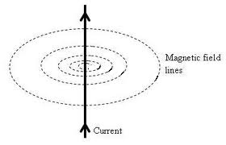
12) Which way will the induced magnetic field lines point (clockwise or counterclockwise)?

Series Circuits
Key Facts:
- Current is the same throughout the circuit.
- The total resistance is the sum of the individual resistances.
- The sum of the voltage drops across resistors equals the voltage supplied by the source.
- Ohm’s Law applies to the total circuit and to the individual resistors (devices) in the circuit.
- A break anywhere in the circuit stops all current flow.

Sample Questions
13) As more lamps are put onto a series circuit, 14) What is the total resistance of a 10-Ohm
what happens to the current in the circuit? resistor and a 5-Ohm resistor in series?

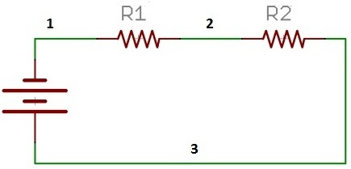

15) In the diagram, R1 is 20 Ohms and R2 is 50 Ohms. If the current through segment 3 of the wire is 5 A, what is the current through segment 1?

16) In the diagram, R1 is 28 Ohms and R2 is 12 Ohms. What is the total resistance in the circuit?

17) In the diagram, the resistance of R1 is 8 Ohms and R2 is 16 Ohms If a multimeter reads the current at segment 3 as 8.2 A, what is the potential difference across the battery?

18) In the diagram, the battery produces 55 V. If the current at segment 2 is 5 A, R1 is 3 Ohms and R2 is 8 Ohms, what is the voltage drop across R1?

Parallel Circuits
Key Facts:
- The voltage is the same across each resistor (device) in the circuit.
- The sum of the individual currents in the branches equals the total current in the circuit.
- Ohm’s law applies to the total circuit and to the individual branches.
- The total resistance is found from the parallel resistance equation.
- A break in one branch will not stop current flow in the other branches.
19) What is the total resistance of a 10-Ohm resistor and a 5-Ohm resistor in series?

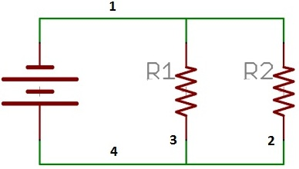
20) In the diagram above, the total voltage across the battery is 6 V. R1 is 2.2 Ohms and R2 is 4.6 Ohms. If the current through segment 1 of the circuit is 3 A, what is the voltage across R1?

21) In the diagram above, the battery is 8 V, R1 is 6 Ohms and R2 is 3 Ohms. What is the total resistance of the circuit?

22) In the diagram above, the battery is 20 V, R1 is 6 Ohms and R2 is 12 Ohms. What is the current through R2?

23) In the diagram above, the battery is 24 V, R1 is 8 Ohms and R2 is 12 Ohms. What is the total current in the circuit?

Induction, Transistors, and Transformers
Key Facts:
- The amount of induced current is directly proportional to the number of loops, the cross-sectional areas of the wire, the strength of the magnet, and the speed of the magnet.
- The work required to move the magnet changes the kinetic energy of the electrons.
- Transistors are made up of semiconductors, which can be insulators or conductors.
- Transistors can be used as switches by varying their electrical conductivity.
- Transistors can be powerful amplifiers in circuits.
- Transformers change the voltage of a circuit through electromagnetic induction.
- The power source connects to the primary coil, and the output connects to the secondary coil.
- Increasing the voltage is called “step-up”; decreasing the voltage is called “step-down”.

Sample Questions
24) Reducing the number of turns in an induction coil would make it (easier / harder) to move a magnet through the coil.

25) The primary coil of a transformer has 50 turns and the secondary coil has 25 turns. This is a (step-up / step-down) transformer.

26) An electronic device needs a 10 V power source, but a household circuit supplies 120 V. If the primary coil of a transformer for the device has 2000 turns, how many turns must the secondary coil have?

27) A transformer converts a 240 V supply into the Voltage required to operate an industrial machine. If the primary coil has 150 turns and the secondary has 1200 turns, what potential difference is required to run the machine?

