Counting the Dead
Chaotic conditions made accurate accounts most difficult. Some victims were vaporized instantly, many survivors were horribly disfigured, and death from radiation was uncertain—it might not claim its victims for days, weeks, months, or even years.
The initial death count in Hiroshima, set at 42,000–93,000, was based solely on the disposal of bodies, and was thus much too low. Later surveys covered body counts, missing persons, and neighborhood surveys during the first months after the bombing, yielding a more reliable estimate of 130,000 dead as of November 1945. A similar survey by officials in Nagasaki set its death toll at 60,000–70,000. (Its plutonium bomb was more powerful, but its destructive range was limited by surrounding hills and mountains).
Additional counts indicated high levels of short-term mortality in both cities:
—Over 90% of persons within 500 meters (1,600 ft.) of ground zero in both cities died.
—At 1.5 km (almost one mile), over 2/3 were casualties, and 1/3 died.
—Of those at a distance of 2 km (1.2 mi.), half were casualties, 10% of whom died.
—Casualties dropped to 10% at distances over 4 km (2.4 mi.).
Most persons close to ground zero who received high radiation dosages died immediately or during the first day. One-third of all fatalities occurred by the 4th day; two-thirds by the 10th day; and 90% by the end of three weeks.
While casualty rates exceeded death rates, they both were highest near ground zero and declined at similar rates by increasing distance from ground zero. But the cumulative death rates (%) in both cities rose dramatically during the first two weeks, then leveled off in subsequent weeks.

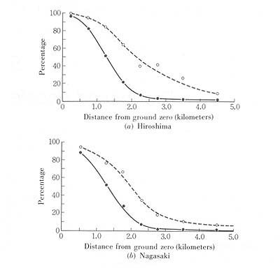
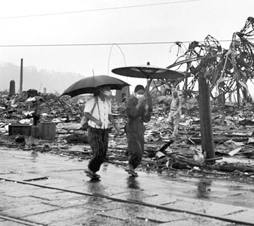

Injury Phases
- First two weeks: mainly burns from rays and flames, and wounds (trauma) from blast and falling structures.
- 3rd week through 8th week: symptoms of damages by radioactive rays, e.g., loss of hair, anemia, loss of white cells, bleeding, diarrhea. Approximately 10% of cases in this group were fatal.
- 3rd and 4th months: “some improvement” in burn, trauma, and even radiation
injuries. But then came “secondary injuries” of disfiguration, severe scar formations (keloids), blood abnormalities, sterility (both sexes), and psychosomatic disorders.
- Even now, after over half a century later, many aftereffects remain: leukemia,
A-bomb cataracts, and cancers of thyroid, breast, lungs, salivary glands, birth defects, including mental retardation, and fears of birth defects in their children, plus, of course, the disfiguring keloid scars.

Stages of A-bomb illness

1. Acute stages
Acute stages ran overall from initial exposure to 4th month, with both primary and secondary thermal burns. Numerous A-bomb casualties (deaths) occurred almost simultaneously with explosion, but both injury and mortality rates fell with increased distanced.
—primary (flash burns)
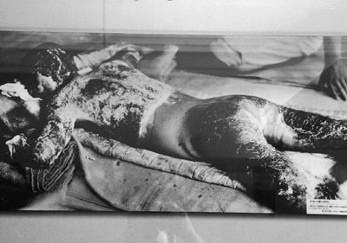
* Marked thermal burns on soldier exposed within 1 km of ground zero. His waist was protected by a thick waist band. (Impact, p. 96, Plate 22)
—secondary (scorch, contact, and flame burns)
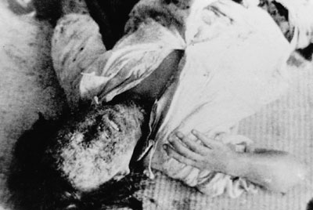
* Exposed skin of a woman seared by intense heat was blown away by fierce wave (but white blouse deflected the intense heat). Most of those suffering severe burns over more than 20% of their bodies died on the spot or a short time later. (HIMAT)

2. Atomic bomb trauma
—primary injury (blast injury)
—secondary injuries sustained from flying debris, burial under rubble, and blast compression

3. A-bomb radiation illness
—Radiation injury penetrates deeply into human body and injures cells, and thus molecules, resulting in cell death, inhibited cell division, abnormalities of intracellular molecules and membranes.
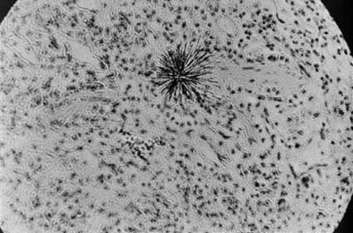
*The black star in the middle shows the tracks of alpha rays emitted by a particle of plutonium 239 in the lung tissue of an ape. These rays do not travel very far, but once in the body, they can penetrate more than 10,000 cells within their range. This set of alpha tracks (magnified 500 times) occurred over a 48-hour period. The plutonium particle that emitted them has a half-life of 24,400 years. (DT, 39)
—Actively regenerating and proliferating cells are most sensitive to radiation, e.g., young blood cells, lymphocytes, spermatogonia (of testicles), follicle cells (of ovaries) are most sensitive; next are mucosal epithelial cells of the mouth, the esophagus, and stomach, and epithelial cells of the eye lens, and cells forming the hair bulb. (Note: epithelial tissues cover surfaces or line cavities, as well as perform various secreting, transporting, or regulatory functions.)

4. Radiation blood injury - lethal dosage
Severe illness occurs with 1,000 rads, causing destruction of bone marrow, marked drop in white cell counts, anemia, bleeding, destruction of stomach and intestinal fluids (mucosa). Most victims died within 30 days. (Note: “rad” indicates a unit of absorbed radiation.)
Immediate disorientation and coma occur with 10,000 rads, and death follows within hours.
*Estimated air dose of gamma rays: Hiroshima: 10,300 rads; Nagasaki: 25,100 rads.
*Estimated neutron dosages: Hiroshima, 14,100 rads; Nagasaki: 3,900 rads.
Degree of shielding can reduce dosage danger.
—acute radiation illness: extensive data show relation of distance to damage.
—three main symptoms are loss of hair, spotty skin discoloration (purpura), and “acute atomic illness,” though there are many other symptoms.

5. Blood injuries
Especially damage to bone marrow and lymphatic tissue. Severe cases subjected to 450–650 rads died within 14 days. Of all blood injuries, severe cases died within 40 days after exposure.
General conditions of blood injury:
—From day of exposure: nausea, vomiting, general malaise.
—From 10th to 14th day: loss of hair, marked malaise, persistent fever, decrease of white blood cells, followed by anemia, decrease of blood platelets, gingivitis (bleeding gums), oropharyngitis, and skin perpura.
---In persons surviving over 20 days: drop of red cell count, but symptoms began to improve with gradual recovery of white cell and platelet counts.

6. Secondary radiation illness:
People beyond the direct effects of primary radiation (near ground zero) suffered effects of radioactivity in fallout. Actual numbers are unknown, but besides local residents, affected persons included relief and first-aid teams. One survey lists 57,839 early entrants and 9,184 engaged in rescue activity for Hiroshima, and respective numbers of 21,315 and 3,035 for Nagasaki.

Unhealed scars
Persons who suffered thermal burns within 1.0 to 2.0 kilometers of ground zero suffered serious flame and contact burns in addition to moderate flash burns, which resulted in marked scar formation.
The majority of thermal injuries within 2.0–3.0 km of ground zero were flash burns that left simple, thin scars at first. But the flash-burn scars altered markedly by thickening to become keloids after 3 to 4 months.

1. Keloids
Keloid is an overgrowth of scar tissue on the wound surface of a thermal burn during the reparative stage. It forms an irregularly shaped protrusion that resembles the shell and legs of a crab, thus the term “keloid” (from Greek for crab), in contrast to a simple heaping up of scar tissue (hypertrophic scar). The latter is usually caused by a secondary burn, and a keloid results from a primary thermal burn. Plastic surgery was performed on many to remove keloid scars, though recurrence of these scars was not uncommon.

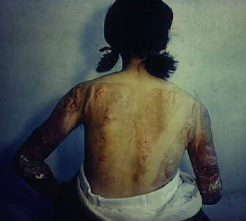
*Keloid scars on a woman’s back. (HPMM)
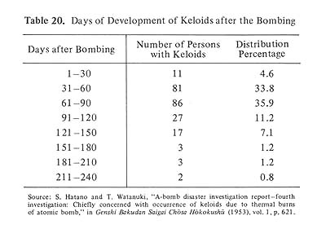
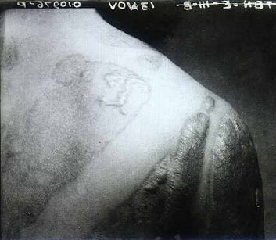
*Close-up of previous photo. (HPMM)
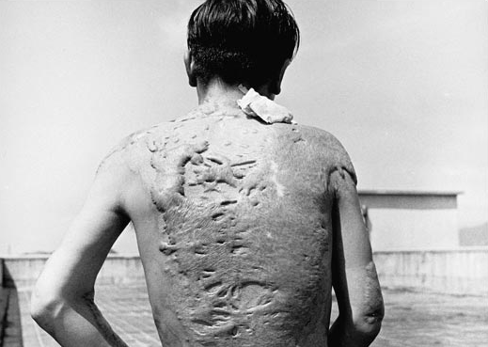

2. A-bomb cataracts
In a cataract the ocular lens becomes opaque. This condition appeared a few years after the atomic bombings; the first was found in 1948 in Hiroshima; and the next, the following year in Nagasaki. Occurrence was related to age at time of exposure and distance from ground zero. Severe cases appeared earlier than mild cases.
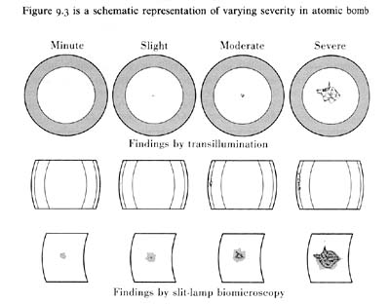
In Hiroshima, 85 of 98 A-bomb cataract cases were discovered in 869 survivors exposed within 1.0 km of ground zero. Between June 1953 and October 1954, some 116 patients with A-bomb cataracts were found among 435 survivors seen at the ophthalmology clinic of Hiroshima Red Cross Hospital. Of these, 87 were exposed within 2.0 km of ground zero; 30 were exposed beyond that distance.
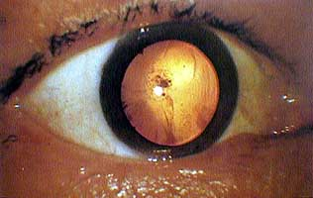

The right photograph shows an eyeball of an A-bomb victim who got an atomic bomb cataract. There is opacity near the center of the eyeball.

3. Leukemia
Leukemia is a malignant tumor or cancer of the blood cells, with an excessive overgrowth of young white cells. Consequently, there is a decrease in red cells and platelets, followed by anemia and a tendency to bleed. Furthermore, white cells lose their normal function, which leads to a decline in the individual’s resistance to infection and death. While it is possible with medication to achieve periods of remission, there is unfortunately no radical treatment or cure.
By 1975 a total of 1,838 cases were diagnosed as leukemia in Hiroshima and Nagasaki. Of these, 512 were exposed within 10 km from ground zero. Incidence peaked in 1951-52 in both cities.
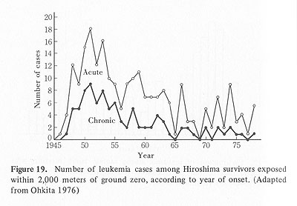
*Frequency of A-bomb cataracts in Hiroshima victims exposed in infancy. (HN, 208)
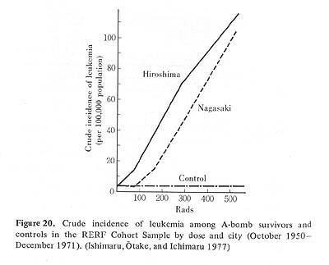

4. Cancers
- Thyroid: first case reported in 1957. High incidence among females. Some cases first discovered by autopsy.
- Breast: cases much higher among those exposed than in non-exposed. Exposure to 100 rads or more made risk 3.3 times that of those unexposed. Peak incidence was found higher among women ages 20-30.
- Lung: First case noted in Hiroshima in 1954, with 37 cases in Nagasaki soon added. A 1972 large-scale survey revealed 3,778 lung cancers in 10,412 deaths, with correlation of high risks to high radiation dosage.

5. Chromosome changes
Chromosomes are present in constant numbers in the nuclei of cells, and can be seen as visible entities during cell division. The count in humans is a constant 46. Chromosome aberrations were first noted in exposed survivors in Hiroshima and Nagasaki in 1960. Subsequent systematic surveys revealed a high frequency of aberrations in blood cells and lymphocytes in fetuses exposed to large radiation doses in utero (in the womb) or soon after birth.
Although chromosome aberrations increased with higher radiation doses, frequency of aberrations was consistently high at all dose ranges. As late as 1985, chromosomal aberrations in somatic (body) cells persisted among exposed survivors.

6. Exposure in utero and microcephaly
A Nagasaki survey of 98 pregnant women exposed at a distance of 2.0 km from ground zero and 113 pregnant women exposed at 4.0 and 5.0 km from ground zero, showed a high percentage of neonatal and infantile deaths for those exposed within a 2.0 km range, as well as signs of acute radiation illness such as loss of hair, bleeding tendency, and inner mouth lesions. Mental retardation was noted in 25% of newborn survivors.
Besides high mortality rates, retarded growth and development was also indicated. Most notable in those exposed within 1.0–5.0 km of ground zero were retarded stature, underweight, and smaller head circumference, a condition called microcephaly, one of the most pathetic aftereffects of the atomic bombings, especially when accompanied by mental retardation.

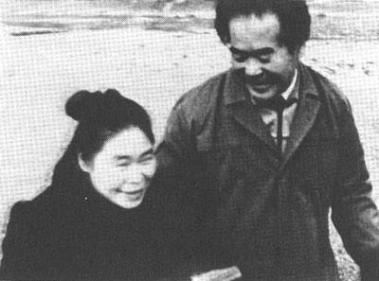
*Microcephaly (small head circumference), retarded stature and weight among those exposed within 1.0–5.0 km of ground zero. (Impact, p. 140)

7. Genetic surveys
Genetic surveys have not yielded positive evidence of genetic hazards due to atomic bomb radiation. Even so, possible A-bomb-induced effects such as spontaneous abortions, stillbirths, congenital malformations, and more, require continued study.
Copyright© 2006 AtomicBombMuseum.org

Major population groupings
- Persons present in Hiroshima or Nagasaki at bombing time. Of the regular resident population, many children and older persons had been previously evacuated, while certain outsiders were working in the cities on their specific bombing days. Overall, the estimated “physically present” population of Hiroshima on August 6 was 340,000–350,000. Nagasaki’s estimated “physically present” population on August 9 was 90,000–120,000.
- Early entrants into both cities following the bombings, mainly soldiers, firefighters, medical workers, and other helping personnel.
- Persons who suffered radiation injuries in the areas surrounding the two bombed cities.
Almost all persons in the above groupings, young or old, also fell into one of the following groups: (1) broken families; (2) A-bomb orphans; (3) orphaned elderly.

Hiroshima
Of the city’s 298 medical doctors, 270 (90%) became A-bomb victims. Casualty rates among pharmacists, nurses, and other medical professionals ranged between 80% and 93%. Eighteen emergency hospitals and 32 first-aid clinics were destroyed, and most of the workers needed to restore these health facilities were killed or injured. Nearby army medical facilities were also mostly destroyed.
In sum, approximately 90% of all medical personnel were dead or disabled, and remaining medical facilities were thrown into great disrepair and confusion.
All citizens faced desperate conditions; the young and old, all the more so.

Nagasaki
In the 2-km zone of total destruction around ground zero in Nagasaki’s Urakami valley, the city’s chief medical facilities were destroyed. These included Nagasaki Medical University and its related hospital, the Urakami branch of Mitsubishi Hospital, Urakami First Hospital, and some other smaller health care institutions.
Of the 70 or so doctors in private practice in the city, twenty were dead and twenty more seriously wounded; only 30 were available to help the mass of A-bomb victims.
As a major port city, Nagasaki was surrounded by various naval installations. Medical personnel from several naval hospitals (Isahaya, Sasebo, Omura, and other places) came with support personnel to give assistance, making the overall situation somewhat better than in Hiroshima.
Even so, food, clothing, medicine, and other relief supplies in Nagasaki were, as in Hiroshima, extremely scarce. Moreover, heavy rains hit both cities in September, making the struggle to survive desperately difficult and miserable.
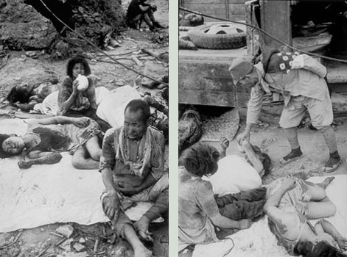
*Desparate survivors in Nagasaki (Yamahata)
Local ability to mobilize health care personnel and restore medical facilities was severely hampered by the overall loss of non-military economic wealth (65 billion yen nationwide). Of this total, Hiroshima (884 million yen) and Nagasaki (380 million yen) together suffered over 2% of the national total.

Political restraints on recovery
On top of the enormous physical, medical, and social damages imposed on Japan by the two atomic bombings, the Supreme Commander of the Allied Occupation (SCAP) imposed another onerous handicap: censorship. Formally termed the Press Code, officially issued by the Occupation GHQ on September 19, 1945, it prohibited the publication of all reports and studies of A-bomb damages, including medical and scientific studies of all injuries and losses suffered by A-bomb victims in both Hiroshima and Nagasaki, whether in newspapers, magazines, scholarly journals, books, or other public means. Thus the A-bombed citizens struggled with ignorance of the many medical and social aspects of the decimated lives.

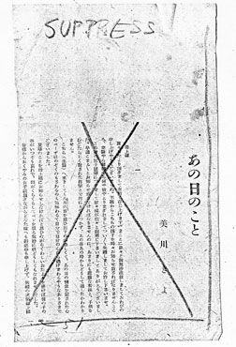
*Sample of censorship under the Occupation Press Code. This article in the July issue of Women’s Journal is a mother’s reaction to her son’s tragic death in the atomic bombing of Hiroshima. The entire article was suppressed so as to not “disturb public tranquility.”

There were minor exceptions. The Hiroshima-based magazine, Chugoku Bunka, devoted its initial issue (March 10, 1946) to A-bomb damages. A Manhattan Project team published its report, The Atomic Bombings of Hiroshima and Nagasaki on June 29, 1946. And the U.S. Strategic Bombing Survey Team completed its report, The Effects of the Air Attack on the Cities of Hiroshima and Nagasaki the following day. These official documents, however, were printed in English and, in any case, did not touch deeply on the sufferings of the two A-bombed cities.
Most importantly, serious research on the extent and gravity of A-bomb damages and injuries could not be publicly printed and distributed by any Japanese persons or organizations, thus handicapping the surviving medical personnel trying to heal and assuage the thousands of A-bomb victims. The most revealing item, perhaps, is that the Japanese characters for “atomic bomb” (genshi bakudan, or the short form, genbaku) could not even be used in public print. This applied to all forms: newspapers, magazines, books, public bulletins, and of course, movies.
Cameramen of the Japanese movie firm Nippon Eiga-sha were arrested by American MPs in Nagasaki on October 17, 1945, and two days later the photographing of A-bomb scenes was prohibited. A formal prohibition was issued by GHQ on December 12. It would be almost seven years later until, after the Occupation ended, the weekly magazine Asahi Gurafu (Asahi Graph) filled an entire issue with heretofore unpublicized photographs of A-bomb damages and victims—the first A-bomb-related photos to be published in the postwar era.

1. How many survived?
A broad accounting of survivors takes into account several groups: (1) directly exposed persons (primary victims), (2) fetuses exposed in their mothers’ wombs,
(3) indirectly exposed persons affected by residual radiation (secondary victims), including (4) early entrants into the two cities and (5) fallout victims in areas where the “black rain” fell. Besides these, “victims” included another large group: (6) “others affected” (tertiary victims) by loss of spouse, close relatives, and housing and household furnishings.
While it is impossible to tally all who fall within these various groupings, a national survey of October 1950 gives a national survivor total of 283,508, with 158,597 for Hiroshima, 124,167 for Nagasaki, and 10 persons who experienced both bombings.
Of Hiroshima’s survivors, 79 percent lived in Hiroshima Prefecture, of whom 98,102 (79%) resided in Hiroshima City. Comparable figures for Nagasaki survivors were 111,294 (89%) in its prefecture, with 96,582 (77%) living in the city.
Another useful accounting of survivors is those treated under the A-bomb Victims Medical Care Law (1957), which showed a gradual increase in those treated.
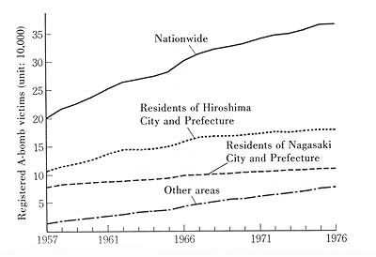
* Registered A-bomb victims: nationwide, Hiroshima, and Nagasaki. (Impact, p.145)

2. Physical and mental suffering
Survivors suffered a wide variety of physical complaints and symptoms, as shown in a chart based on 1953 data.
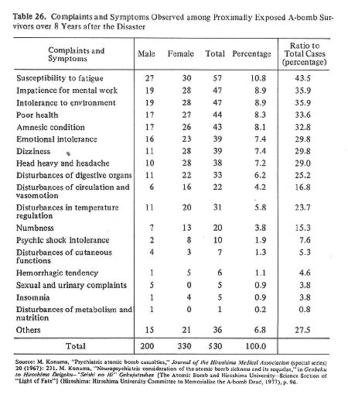
The number of patients with serious diseases hospitalized in Hiroshima A-bomb Hospital in the period 1956–65 was 2,259, and over the years to 1974 the grand total was 5.350 (yearly average: 296). These cases covered a wide range of malignancies and various blood, endocrinological, digestive, cardiovascular, respiratory, neurological and renal diseases, as well as motor dysfunctions and sequelae due to foreign matter.

3. Marked forever
“The fate of all survivors is to live with the stigma that the atomic bomb stamped permanent marks on their minds and bodies.”
It imposed on them an abhorrent lifelong burden, one to live with yet try to overcome. One way of dealing with this burden was to write one’s own personal testimony about trying to get on with life.
I hated for people to stare at me…. Yet, every nerve in my body was attuned to the outside world; and to avoid even the slightest sinister look, I walked with a rigid on-guard posture…. Even so, I secluded myself at home and spent hours before the mirror, looking at my own face. What I saw was ugly hunks of flesh, like lava oozing from a crater wall, covering the left half of my face, with the eyebrow burned off and my eye pulled out of shape. My neck was pulled over to one side, and however much I tried to straighten it out, it wouldn't move back to the normal position. (Nakayama Shiro,Shi no kage [The Shadow of Death])

A boy in my class was burned by the flash;
The hair was gone from half his head,
It was slick as glass.
A younger student in a lower grade
Was called "tempura, tempura"by all;
He covered his face with one hand
As he ran down the hall.
Someday they'll grow up, and . . .
I thought,
What will it be like then? ("Tempura"is deep-fried fish or vegetables)

* Both quotes from Impact, p. 152-53

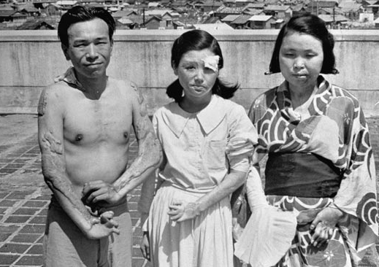

4. Breakdown of families
Life differed somewhat in both Hiroshima and Nagasaki according to one’s residence or physical presence at bombing times, whether city center or surrounding zones.
A main concern for all was the rupture of household bonds due to loss of members, and also whether one’s residence was burned or demolished. Loss of parents or other household heads left both “A-bomb orphans” and “the orphaned elderly.”

5. A-bomb Orphans
It is not clear how many A-bomb orphans were in either city. People involved in helping some of them in Hiroshima reported “6,500 orphans” following the bombing. Estimates based on evacuation data (most children had been sent to the countryside during wartime) indicate between 4,000 and 5,000 orphans in Hiroshima. Records for Nagasaki are especially scarce. Some schools reported registered pupils without known living parents, yet many cried and called for their mothers.

*Two boys looking for their father soon after Nagasaki bombing. (Yamahata Yosuke)
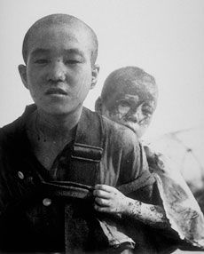

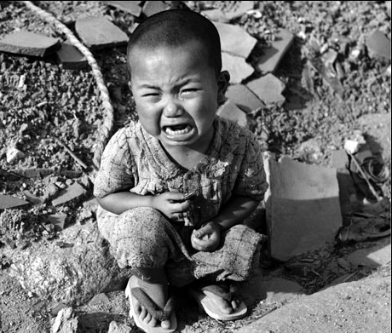
Orphaned baby
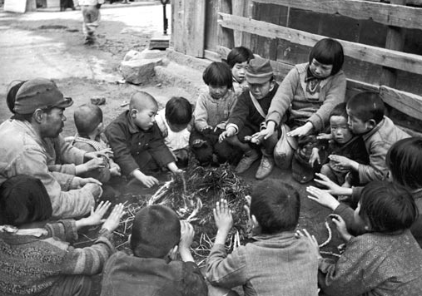
A group of homeless children warm their hands over a fire on the outskirts of Hiroshima

6. The orphaned elderlys
Thousands of older persons, whether they suffered the atomic bombings or escaped them by being evacuated to the countryside, lost spouses and children and thus had no one to depend upon. Their numbers increased with the passage of postwar years.
An October 1960 survey of A-bomb victims in Hiroshima and Nagasaki showed that victims age 70 and over were 6.6% of Hiroshima’s population and 5.8% of Nagasaki’s. The aged groups as a whole were only 1.4% in Hiroshima and 1.3% in Nagasaki. Some had employment or were self-employed; but many were without income sources. And many suffered illness or disability.
Of 31 suicides by A-bomb survivors nationwide in the five-year period 1970–75, Hiroshima Prefecture claimed 25, of whom 8 were orphaned elderly victims, for whom illness was the major motive.

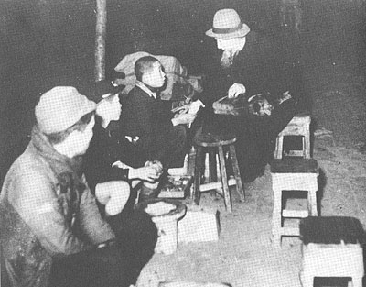

*A-bomb orphans with elderly Catholic priest at Hiroshima Railroad Station, Jan. 10, 1946. (Impact, 158)

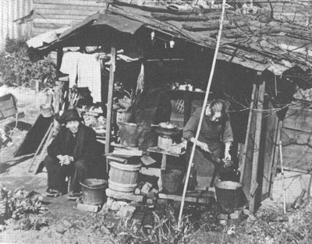

*An elderly couple living in a makeshift shack, November 1952. (Photo by Yuichiro Sasaki, in Impact, 159)

Testimony: Hiroshi Morishita
President of Japan Association of Secondary School Teacher Survivors
I was a 14-year old high school boy at the time of the atomic bombing. Students at that time were mobilized to tear down certain houses to make firebreaks in the city. I was 1.7 kilometer (1 mile) from ground zero on the morning of August 6, 1945, so I suffered many serious burns on my face and hands, which left large scars known as keloids. On the same day, my mother was killed by the bomb as were many of my friends and teachers. All these sorrows came to me all at once. I was suffering and ashamed of my keloid burns all the time, and I did not know how to make a living. I felt like shouting at the top of my voice in despair. But I could only murmur, “If only the A-bomb had not been dropped!” I was completely overwhelmed with grief, which resulted in the autism from which I suffered for a long time after the war.

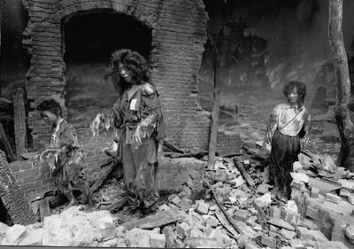

*Wax models in the Hiroshima Peace Memorial Museum portray a common scene on August 6 and thereafter the ghostly appearance of burn victims holding their hands away from their bodies, stumbling along in a painful daze [and] with little sense of direction.

Thinking of this sudden change of fate at the moment of the bombing, as if we were thrown into a smelting furnace — lots of people wandering with their skin hanging, piles of dead. Swollen and burnt bodies, and my relatives and friends dying while vomiting blood or something like black foam – I strongly felt that we who survived the atomic bombing should do something for those suffering so much, and should appeal to the people everywhere to understand the disaster that befell Hiroshima so that it might not ever be repeated. It was my earnest desire to do something for peace, but I was suffering from tuberculosis. At the same time, what with the Korean War breaking out and with nuclear bombs still being developed, I became very fearful.
I wrote about my A-bomb experiences, composed poems about the A-bomb, and wrote to newspapers to request help for the victims. When I had almost recovered from my injuries, I went to school again so that I could become a school teacher. After becoming a teacher, I often felt gloomy because of the students’ gaze at my ugly keloid scars, while I was consciously trying to forget about the A-bomb. Thus I was at a complete loss when asked, “What do your students who had no experience of bombing think of the A-bomb?” After all, just ten years after the bombing, there were many students who had had no experience of war.
I was awfully ashamed to acknowledge the fact that I had not had any objective talks with the students about the atomic bombing. I personally felt peaceful only when I forgot about the ugly keloid scars on my face, and the misery of the bombing. I began to realize that I was always trying to avoid any talk of the A-bomb.
Since I was often asked about the bombing, I decide to conduct a survey of the high school student’s knowledge and consciousness regarding the A-bomb disaster. In the survey results I was surprised to find many replies such as: “A-bomb matters don’t matter to me, because I’ve had no experience of them.” “I’m too busy with daily life to know how to bring about peace.” “I feel so sorry for the victims, but I can’t afford to do anything for them.”
Should that misery be forgotten? Should we not foster in young people a will toward peace that can help avoid the same blunder again? If we have another nuclear war, even those inexperienced youths will not escape it. There is no guarantee that these youths would survive it. Therefore they also have some responsibility to prevent war.
Even now countless A-bomb victims are suffering from various diseases and, moreover, they are subjected to great anxiety over whether radiation affects the second generation, as is indicated by experiments with animals. Accordingly, the youths, second-generation survivors, are apt to be discriminated against in employment and marriage. These problems should be solved by youths with their own understanding and sense of public responsibility.
I have tried to inform students about the terror of the A-bomb. For example, I wrote a drama titled “Hiroshima” based on the A-bomb disaster, involving death and suffering among mobilized students and children. I have exhibited A-bomb pictures and panels on loan from the A-bomb museum. I had students read articles and poems about A-bomb experiences. We have discussed nuclear weapons in our school club. I have joined a peace mission group traveling throughout the world, appealing to people everywhere for understanding of the A-bomb experiences.
However hard I tried, statistics show that the number of young people who do not know about Hiroshima, or are forgetting, is increasing. This is only natural, for as the saying goes, “Out of sight, out of mind.” But I am most surprised by current school textbooks. Only a few lines are given to the A-bomb experience: “On August 6, 1945, an atomic bomb fell on Hiroshima and the war ended with Japan’s acceptance of the Potsdam Declaration.” As the years have passed, school text treatment of the atomic bombing has been persistently pared down and simplified. It is well known that the Ministry of Education has imposed these limitations on school textbooks.
I have felt helpless when realizing that there is little use in trying to bring about peace only by individuals or voluntary groups. Since the abolition of war and of nuclear weapons has much to do with international affairs, I believe peace education must be promoted and carried out internationally.
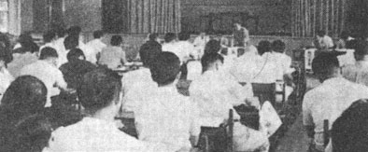
*Departmental conference on peace education in schools. (HIMAT, 226)

Kenzo Nagoya
Kaitaichi High School Teacher
Even with his bones, blood and internal organs all undermined, my son still asked, “When am I going to get better?”

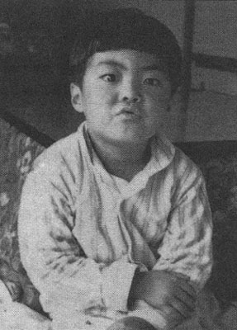

Kenzo Nagoya’s son Fumiki

Fumiki, my second boy, 7 years and 6 months old, died of the terrible disease, leukemia. His ordeal began one day when suddenly he experienced pains in his joints. His gums became swollen. His face became distorted. My wife wondere if it was leukemia. An ominous premonition came across our minds. The shock of July 29, 1965, is unforgettable for me. It was on this day, when Hiroshima was sizzling with summer heat and the memorial day of August 6th was at hand, that we learned that our 4-year-old boy had leukemia.
My wife is an A-bomb victim. There is widespread anxiety as to whether a victim’s child might somehow be affected, and every victim cannot help but feel insecure. Unfortunately, my wife’s foreboding came true. At the Hiroshima University Hospital, Fumiki was diagnosed as having terminal leukemia. I could hardly believe that my beloved 4-year-old boy was thus sentenced to death. The doctor said that he could live only a year at most, and that in some cases death had come in less than a week following the confirmation of the disease. Thus did Fumiki’s fight against the disease begin. It was an indescribable struggle. My diary at that time reports as follows: “One year and nine months have passed since he became ill. Our joy and sorrow always go with him. Confronting his death every day, we have passed three autumns, three winters and now spring has come round again. This spring Fumiki graduates from kindergarten and will be promoted to primary school. Even though suffering from the illness, to my surprise, Fumiki is growing steadily.”
On graduation day he brought home a scrapbook of his kindergarten art work entitled “Ayumi,” which means “Walking” [used in the sense of following a course]. I found in it a picture of a big sea-bream with its mouth wide open, seeming to enjoy the delicious seaweed it was eating. A sea-bream in Japan means good luck. I put the picture on the wall, hoping that somehow it would bring him good luck.
His grandmother bought him the biggest school bag available in order to celebrate his going to primary school. Since Fumiki was fat and tall for his age, the school bag looked very good on him, strapped on his back just like every other Japanese boy and girl preparing to enter first grade. I covered it with a piece of yellow cloth, as is our custom, so that he could be easily seen on the street and protected against traffic accidents.
My wife was working as well as taking care of the family. Her diary from this period records: “Now I understand what it means to fold one thousand paper cranes. It makes me feel that somehow my sick boy will surely be alive today, too. Whenever I fold another crane I feel that Fumiki is safe for another day.”
In spite of his parents’ strong wish and prayers, death finally took Fumiki away. He suffered from leukemia for two years and six months, which seemed to me both a short and at the same time a very long period for one small life to be consumed by a terrible disease. Fumiki’s only wish was to get better and to live. At 2:45 AM on February 22, 1968, Fumiki breathed his last breath. It was a snowy night in Hiroshima.
Four years have passed since his death. Our grief has become deeper and deeper. Every time we hear about the death of a second-generation victim (child of an A-bomb victim), we recall our son’s death, and I never fail to visit his death bed. On their dead faces, again I see Fumiki’s face. I shall never forget him. I’m afraid that acute leukemia is always trying to attack not only victims themselves but even their children as well.
Unless we bring about peace in the world, unless we prohibit the production of all atomic and hydrogen bombs, we shall eternally have to face and suffer many deaths like Fumiki’s.

