Philosophers Chart
The Ideal Form of Government
Philosopher | Ideal Form of Government | Important Ideas & Beliefs About Government & Politics | Could People be Trusted to Govern?
Thomas Hobbes
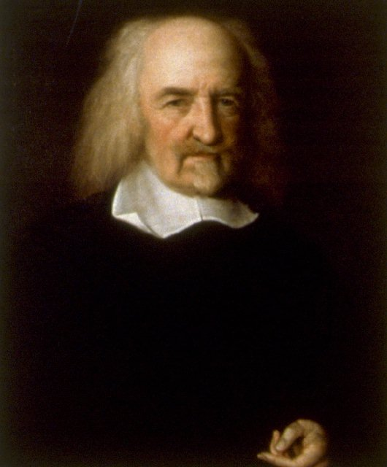

John Locke
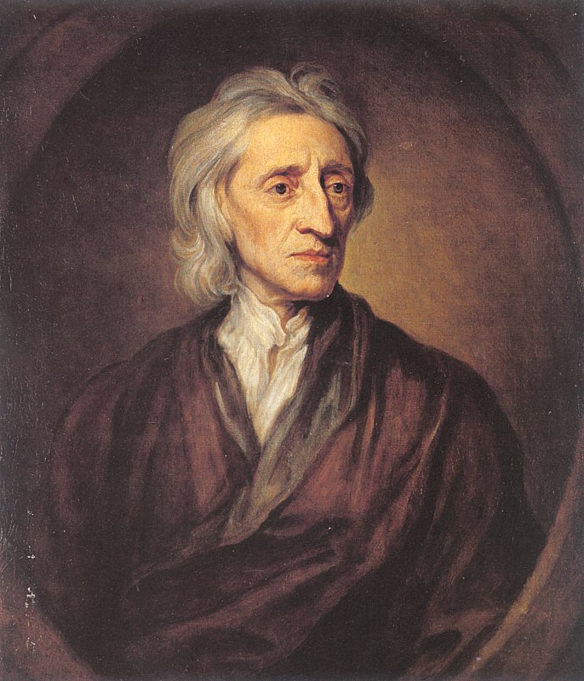

Baron de Montesquieu
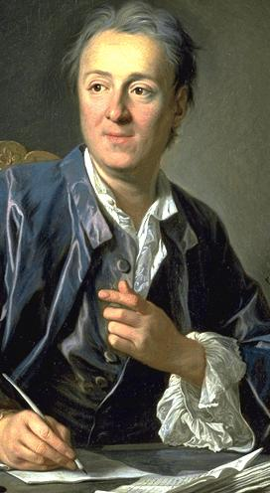

Jean-Jacques Rousseau
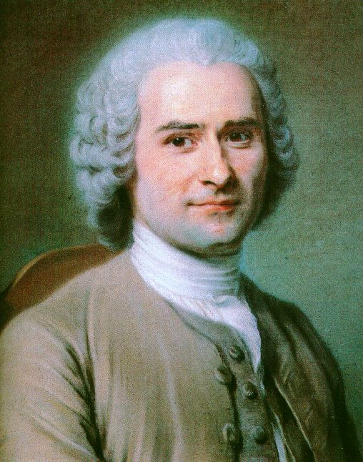

Philosopher | Ideal Form of Government | Important Ideas & Beliefs About Government & Politics | Could People be Trusted to Govern?
Mary Wollstonecraft
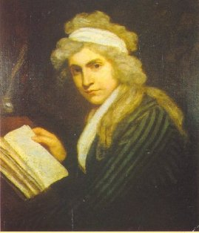
Thomas Jefferson
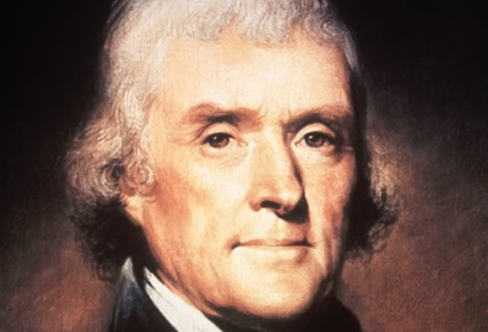
James Madison
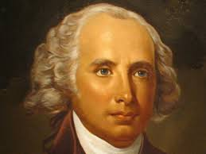
Simón Bolívar
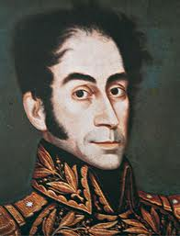
Plato
