Name : _____________________
Date: __________
Period: _____
Lorde or Lana Del Ray? _______________

Weigh too Easy Mass Worksheet

- The standard metric unit for mass is _____ and the standard metric unit for weight is _____.

- An object's mass refers to ________________________________________________ ____________________________________________________________________ and an object's weight refers to ____________________________________________ ______________________________________________________________________________________________________.

- Complete the following table showing the relationship between mass and weight. Different masses are hung on a spring scale calibrated in Newtons.
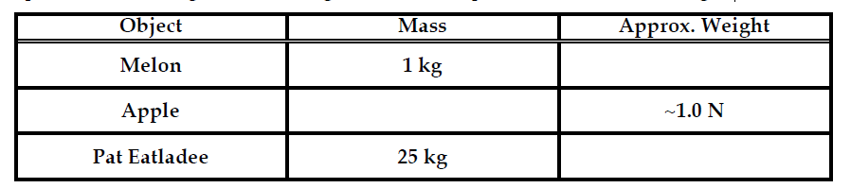

- Different masses are hung on a spring scale calibrated in Newtons.

The force exerted by gravity on 1 kg = ~10 N.
The force exerted by gravity on 5 kg = ~______ N.
The force exerted by gravity on 70 kg = ~________ N.
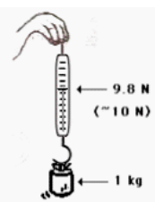

- The value of “g” in the British system is 32 ft/s². The unit of force is pounds. The unit of mass is the slug. Use your weight in pounds to calculate your mass in units of slugs.

- You might be wondering about your metric weight. Using conversion factors, convert your weight in pounds to units of N. (Use 1 N = 0.22 pounds)

- What is the mass and weight of a 10-kg object on earth?

- What is the mass and weight of a 10-kg object on the moon where the force of gravity is 1/6th that of the Earth's?

- Which is most preferable to use as a measurable quantity, mass or weight? Justify your answers.

