DNA Replication, RNA, and Protein Synthesis Review Sheet
Answer in complete sentences in your notebooks! This is part of your notes due on test day.
1. DNA and RNA are named by their __________.
2. What three things make up a nucleotide?
3. Describe the structure of RNA.
4. What happens to tRNA anticodons during translation?
5. What is a codon & where are they found?
6. What is the function of rRNA?
7. What bases pair with each other on: a) DNA? b) RNA?
8. Name the 3 types of RNA & tell the function of each.
9. What is the function of DNA polymerase?
10. If the code on DNA is TTAGCCTGA, what will be the code on the complementary section of DNA when it's copied during replication?
11. Where does mRNA go for proteins to be made in a cell?
12. What is transcription?
13. What is translation?
14. Which RNA carries instructions for making proteins?
15. What is the function of DNA helicases?
16. What is the job of RNA polymerase?
18. List the steps of DNA replication and explain what happens in each step.
19. Name the three differences between DNA and RNA
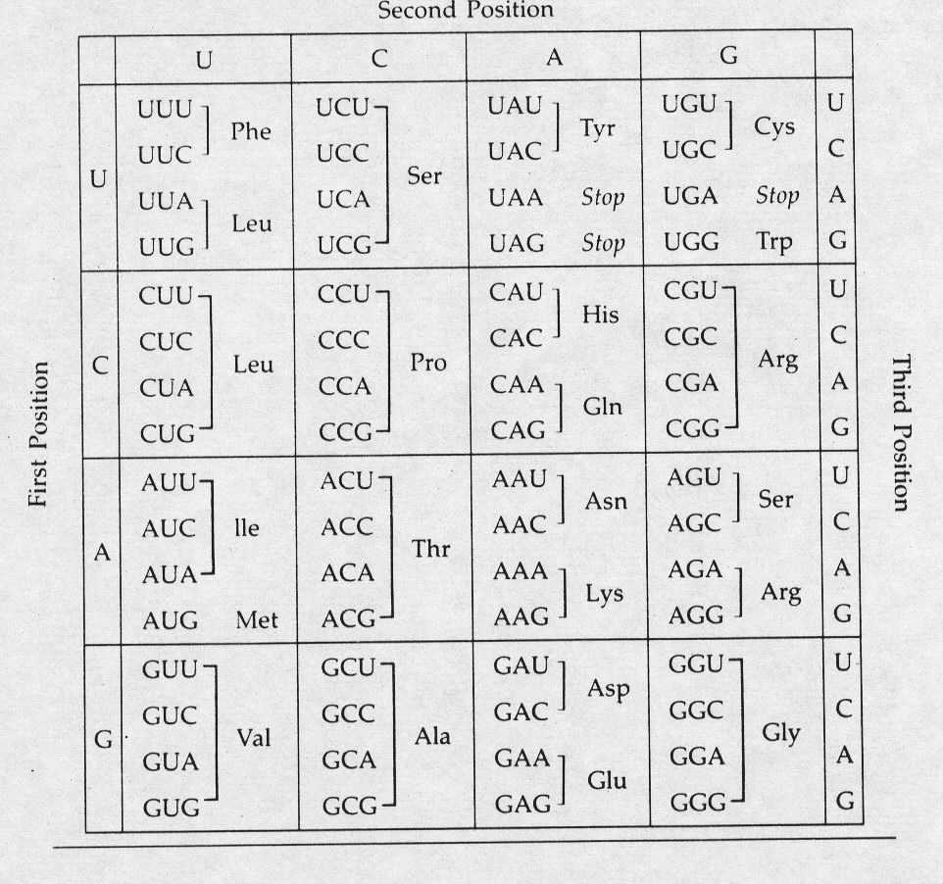
19. Use the above Genetic code table to answer the questions below.
Transcribe the following DNA sentences to mRNA. Then use the table above to translate the mRNA into an amino acid sequence.
TACGAGTGGTTATTTCTACCGATT
TACGAAGGAGTAGCATCACCAATC
TACACCGTAGTTGTCTTTCTTCGCACT

