Midterm
Science - Review Guide
The following is an overview that cover specific terminology, unit topics, and practice that you will need to know in order to be successful on your midterm exam. Please review and ask your parents to sign.

Signature Date

Bring this study guide on a day of test for extra credit.

Classification of Matter
- All pure substances have their own unique set of properties, or characteristics
- All mixtures contain two or more pure substances, which have their own distinct properties (some of which may be hidden)
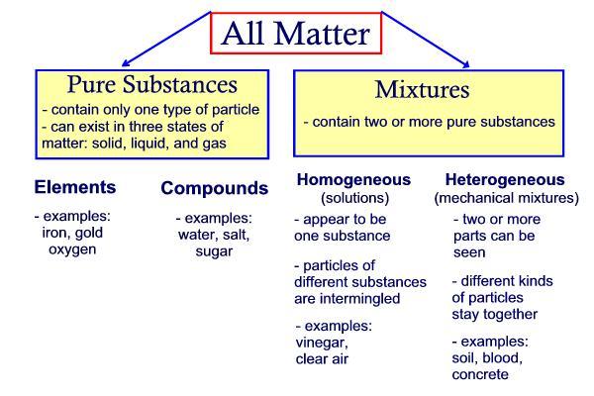
Homogenous Mixtures
- are mixtures which look as though they have only one set of properties.
- the blended mixture has equal amounts of both substances (all parts of the mixture are the same)
- if the homogenous mixture does not have any settling of any of the substances it is made of, then it is called a solution
- solutions occur because each particle slips between each other particle and is evenly distributed throughout the entire mixture
Homogenous Mixtures
- the properties of the pure substances, in a heterogeneous mixture, are not hidden
- if there are two or more materials that are visible within a mixture, then it is called a heterogeneous mixture
In-Between Mixtures
- a heterogeneous mixture, in which the particles settle slowly after mixing, is called a suspension (eg. orange juice)
- a heterogeneous mixture, in which the particles do not settle at all, is called a colloid (eg. fog)
- to disperse the particles for a longer period of time, an emulsifying agent (like a protein) is used to form an emulsion (eg. mayonnaise)
- mixtures that are obviously two or more substances are called mechanical mixtures
the separate parts of the mechanical mixture are called phases
MIXING and DISSOLVING
What Makes Materials Dissolve?
- forming a solution by mixing two or more materials together is called dissolving
- dissolving occurs because of the attracting between the particles (there may be a stronger attraction to the particles of another substance, than to the particles of the same substance)
Solutes and Solvents
The solute is the substance that dissolves in a solvent. The solvent is the substance that dissolves the solute to form a solution.
Soluble means to be able to be dissolved in a particular solvent. Solutes and solvents can be gases or liquids.
Water - the Universal Solvent
- it is called the 'universal solvent' because it can dissolve so many materials
- 97% of the water on Earth is Ocean water, 2% is frozen and only about 0.5% is 'usable' (and even this has materials already dissolved in it that can be harmful
The Rate of Dissolving
- the speed at which the solute dissolves in a solvent is called the rate of dissolving and can be affected by:
- agitation (stirring or shaking)
- temperature
- pressure
How Much Can Be Dissolved?
- the limit to concentration is called solubility
- a saturated solution is one in which no more solute will dissolve in a specific amount of solvent at a specific temperature
- an unsaturated solution is one in which more solute can be dissolved in a specific solvent at the same specific temperature
- using the particle theory, the attractive forces between the particles becomes balanced and no more particles of the solute can be attracted by the particles of the solvent
Beyond the Limit: Supersaturated Solutions
- a solution that contains more solute than would normally dissolve at a certain temperature is called a super-saturated solution.
Cleaning Up with Solvents
- Not all solute will dissolve in solvents. Insoluble means not able to be dissolved in a particular solvent.
- certain solvents are used for special circumstances because they will dissolve some solutes that water and other solvents cannot (rubbing alcohol is use to dissolve chlorophyll - grass stains, because the particles have strong attractions)
Fluid Properties & The Particle Model (Theory)
The particle model helps to explain why gases and liquids flow, while solids do not.
- All substances are made of tiny particles
- All particles in a pure substance are the same (Different pure substances are made of different particles)
- All the particles have spaces between them
- All the particles are always in motion (the speed of the particles increases/decreases when the temperature increases/decreases)
- The particles in a substance are attracted to one another (the strength of the attraction depends on the type of particle)
 | 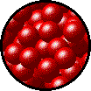 | 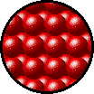
gas | liquid | solid
assumes the shape and volume of its container | takes the shape of the part of the container which it occupies | retains a fixed volume and shape
particles can move past one another | particles can move/slide past one another | rigid - particles vibrating in place
compressible | not easily compressible | not easily compressible
lots of free space between particles | little free space between particles | little free space between particles
flow easily past each other, move in all directions, do not flow to the lowest possible level | can be poured (always flowing to the lowest possible level) and form a level (flat) surface at rest | form a pile when they are poured (the particles do not continue to flow apart from each other)
Changes of State
A change of state occurs when the particles of a substance gain or lose energy. The diagram below indicated the terminology used.

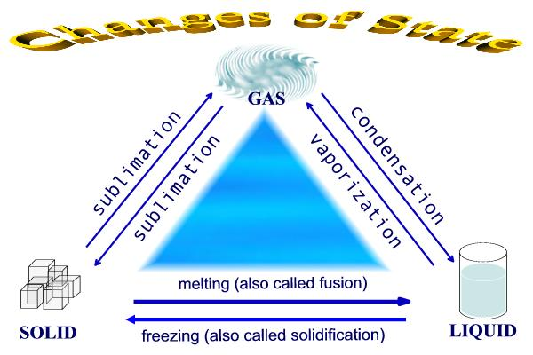
Applications
- The most common form of matter in our universe exists in a fluid state called plasma, which is a gaslike mixture of positively and negatively charged particles. (It is often considered to be the fourth state of matter) - Plasma, if controlled could be used as rocket fuel.

No new substances are formed. The change is not permanent.
Dissolving is also a physical change.
A chemical change occurs when two or more substances react and create one or more new substances. It is often permanent, although not always. Combustion is an example.
Can You Ever Be Sure About Changes?
It is often difficult to decide if a change is physical or chemical, so certain clues will help you decide if a chemical change has occurred.
• Change in color
• Change in odor
• Formation of a gas (bubbles) in a liquid
• Formation of a solid (precipitate) in a liquid
• Release or absorption of energy (heat)
• Materials you started with are used up
• A new material is formed
• The change is difficult to reverse

The only evidence that will guarantee a chemical change has occurred is that a new substance has been formed.
Properties: Chemical or Physical?
Any property that can be observed without forming a new substance is a physical property.
These can include: color, texture, luster, smell, state, melting point, boiling point, hardness, malleability, ductility, crystal shape, viscosity, solubility, density and conductivity (electrical and heat). Any property that describes how a substance reacts with another substance when forming a new substance is a chemical property. Chemical properties include: reaction with acids, ability to burn (combustibility), reaction with water, behavior in air and reaction to heat, toxicity, stability.

Dalton’s Atomic Theory
John Dalton developed a theory that helped explain what happened in the electrolysis of water and was a new way to explain chemical facts and laws. His Atomic Theory was widely accepted.
• All matter is made up of tiny particles called atoms
• Atoms cannot be created, destroyed, or divided into smaller particles.
• All atoms of the same element are identical in mass and size. Atoms of one element are different in mass and size from the atoms of other elements.
• Compounds are created when atoms of different elements link together in definite proportions

An element is a pure substance made up of only one type of particle, or atom. Each element has its own unique set of distinguishing properties and cannot be broken down into simpler substances by means of a chemical change.
A compound is a pure substance made up of 2 or more elements chemically combined together. Compounds can be broken down into the elements that they are composed of.

Safety First
A good science lab is a safe one. All of the procedures, equipment and chemicals you use have been designed to help you understand the science principles you are investigating.
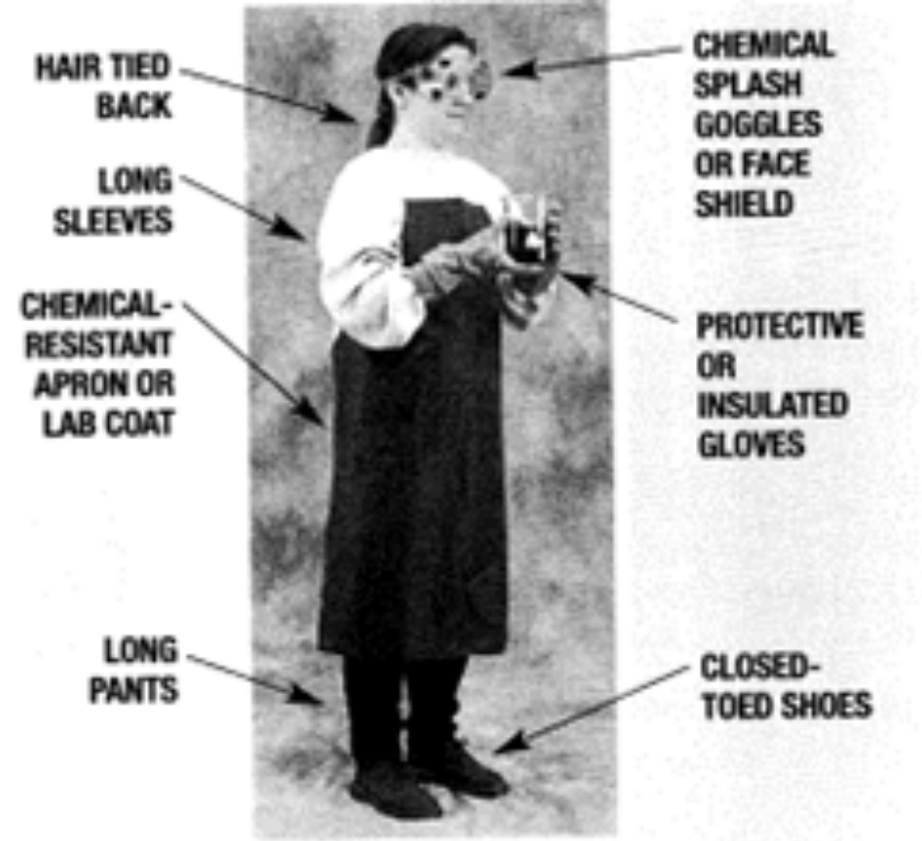
Before beginning any activity
- Know what is expected
- Prepare a clear work environment
- Wait for permission to start
- Whenever special attention is needed in a Lab activity you will see the word Caution (This means that special care must be taken when proceeding with this activity)
General Safety Precautions
- Work quietly and carefully
- Never work alone
- Wear appropriate clothing
- Wear safety equipment
- Inform your supervisor of health-related problems, allergies
- Never eat or drink In the Lab area
- Do not attempt Lab activities at home unless told to do so by your teacher, and only under the direct supervision of an adult
- Touch substances only when told to do so
- Smell substances using the proper technique (wafting fumes toward you)
- Pour substances properly and safely
- Rinse off substances immediately that come into contact with skin or clothing
- Wash hands after handling substances and before leaving the Lab
- Clean up all spills Immediately
- Dispose of harmful substances by following teacher's directions
Handling a Heat Source
Use hot plates that have thermostatic controls. Use a beaker of water on a hot plate to heat substances In test tubes. Use heat-resistant glass - never use cracked glass. Always keep the open end of the test tube pointed away from everyone. Never allow any container to boil dry. Use tongs or gloves to pick up hot objects. Turn off hot plate when not In use. Unplug cords by pulling on the plug, not the cord. Report and replace equipment that has frayed or damaged cords. Make sure electrical cords are placed properly where no one will trip over them. Treat burns using cold water or ice
Handling an Open Flame
- Locate fire safety equipment before using any open flame (fire blanket, fire extinguishers, fire alarm, first-aid kit)
- Know the proper procedures for using a Bunsen burner In the Lab
- Remove all flammable substances from the room before lighting a flame
- Use a test tube holder if the test tube Is being heated in an open flame
- Point the open end away from yourself and others
- Gently move the test tube back and forth over the flame so that it is heated evenly
Other Recommendations
- Dispose of broken glassware as instructed by your teacher
- Report broken or damaged equipment immediately (DO NOT USE IT)
- Clean up work area completely when you are finished
- Wash all glassware thoroughly and place in drying racks
- Report all accidents to the teacher immediately (no matter how minor)
SAFETY RULES
- Do not perform unauthorized experiments.
- Never work in the lab alone.
- Report all accidents immediately to your teacher.
- If vapors generated are toxic, use a fume hood.
- Wear chemical splash goggles.
- Wear a chemical resistant apron.
- Wear chemical resistant gloves.
- Tie back long hair.
- Do not wear loose sleeves.
- Do not wear shorts.
- Do not wear sandals.
- Do not wear contact lenses.
- No food or beverages.
- No gum chewing.
- Do not leave experiments unattended.
- Know the location of all of the science lab safety equipment, exits and telephone.
- (safety showers, eye wash, fire blankets, fire extinguishers)
- No running.
- Keep aisles clear.
- Extinguish burners when away from desk.
Workplace Hazardous Materials Information System (WHMIS)
 | Compressed Gas  This symbol is in class A and is used to inform people of compressed gas. This category includes such things such as propane bottles, butane bottles, and acetylene bottles.
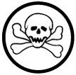 | Poisonous and Infectious  This symbol belongs to class D-l and is one of the most commonly found symbols in homes across North America. This symbol represents materials that are toxic when ingested. This category includes such common products as bleach, Mr. Clean, and Tide. Most household chemicals and cleaners contain this symbol and has become known as the symbol for poison.
 | Oxidizing  This symbol informs people that this substance produces oxygen when burned. This specific reaction creates a high problem for combustion and has to be stored in special containers and must be transported with extreme care.
 | Dangerously Reactive  This symbol is found on some household products and on a large number of lab chemicals. Itl means that when certain chemicals are mixed they will react and produce a harmful side effect. Some chemicals that should not be mixed are bleach, drain cleaner, and ammonia because, when combined, they will form a toxic gas.
 | Flammable and Combustible  This symbol is the Flammable and combustible material, which is in class B and tells a person that certain substances will react with a flame and burn. Some materials that fit into this category are gas and oil. These substances are highly flammable and ignite with little effort.
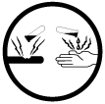 | Corrosive  This symbol is the second most common symbol found in homes across North America. This symbol is most commonly found on products such as bleach and battery acid, which are highly corrosive and are able to burn organic matter.
 | Toxic / Infectious  This symbol belongs to class D-2 and is one of the less common symbols found in homes. It is more commonly found in Chemistry Labs. This symbol is somewhat similar to the fourth symbol, but chemicals that fit into this category cause slower effects to the body. Some examples of this are arsenic and nicotine.
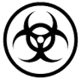 | Biohazardous  This symbol is often found in hospitals and is put on products that have materials that are harmful, such as viruses or bacteria.  Examples of bacteria that fall into this category are ebola and the flesh eating disease.
In science, laws do not explain anything. They simply describe and summarize what happens.
Theories are imaginative ways to explain why something happens the way it does.
Theories are developed over the course of many observations and hundreds of experiments before other scientists will accept it.
Observations -Hypothesis -Experiments -Theory –Time- Revised Theory
as many
times revised
as needed Hypothesis
Scientific ideas may change over time as more evidence is gathered. Most of Dalton’s atomic theory has stood the test of time, however, smaller particles (subatomic) have been discovered and Dalton’s Theory needed to be revised.
Scientific models help others to visualize structures or processes that cannot be seen directly.
Different Kinds of Elements
One way of classifying elements is to sort them into categories, based on their distinct properties.
Long before anyone knew any detail about the atoms or any of the periodic properties the elements were divided into two broad categories → metals and non-metals. Distinct properties of metals were malleability and ductility, shiny luster and were solid at room temperature (except mercury).
Non-metals: some were gases, solids or liquids; solid non-metals are brittle; they are flexible, dull and non-conductors of electricity or heat.
In-between elements were called ‘metalloids’, having properties of both metals and non-metals.

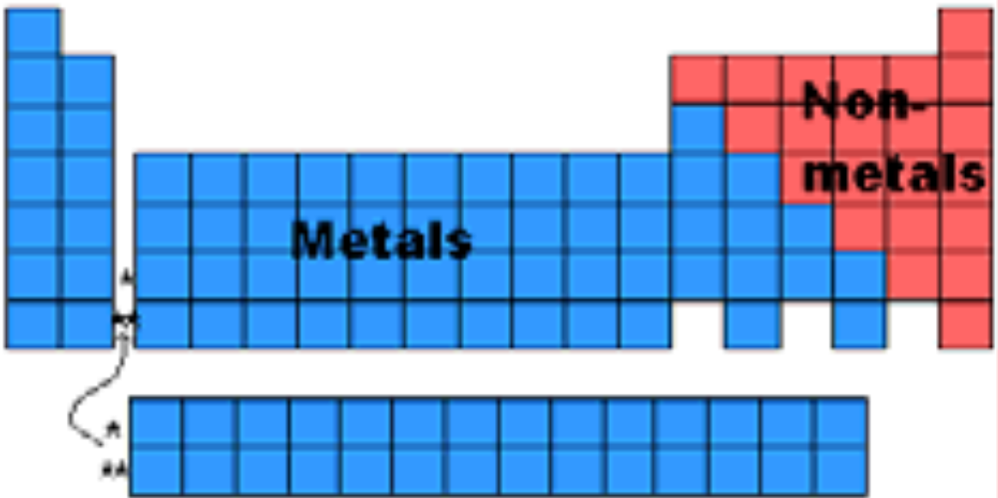

Transition Metals - | The 38 elements in groups 3 to 12 are called transition metals. The only elements in this group known to produce a magnetic field are iron, cobalt and nickel.
Other Metals - | There are 7 elements considered "other metals" in groups 13 to 15. All these elements are solid with a high density. Examples are tin, aluminum and lead.
Metalloids - | These elements have both metal and non-metal properties. Some of them are semi-conductors, which means, they can carry an electrical charge under special conditions. Metalloids are great for computers and calculators.
Non-Metals - | These fall into groups 14 to 16 in the periodic table. They can't conduct heat or electricity very well and are brittle. They also can't be made into wire or sheets. At room temperature, non-metals turn into gasses and solids.
Rare Earth Elements - | There are 30 rare earth elements. Many of them are synthetic or man-made. They're found in group three of the periodic table and the sixth and seventh groups.
Alkali Metals - | These are group 1 in the periodic table. They don't occur freely in nature and are softer than most metals. Like all metals, they are great heat conductors and can even explode if exposed to water – they are very reactive and need special storage. They easily give off an unpaired electron by forming a compound.
Alkaline Earth Metals - | These are group 2 in the periodic table. Because they're extremely reactive, they aren't found freely in nature. An example of an alkaline earth metal is radium.
Noble Gases - | The 6 noble gases are in group 18. All of them have the maximum number of electrons possible in their outer shell which makes them stable. Examples of noble gases are helium, neon and krypton.
Halogens - | All 5 halogens are non-metallic elements. Compounds that contain halogen are called ‘salts’. At room temperature, they are in three states of matter: solid, liquid and gas.

Mendeleev Builds a Table The system of using atomic mass to classify and organize all the elements known and undiscovered was created based on Dalton’s Theory, by Dmitiri Mendeleev (1834-1907)

Atomic Number –  The number of protons an atom has is called the atomic number. | An element is defined by the number of protons it has. Carbon atoms have six protons, hydrogen atoms have one proton and oxygen atoms have eight protons. The chemical behavior of an element depends on the number of protons in an atom.
Mass Number - | The atomic mass number of an element is simply the sum of the protons and neutrons in the nucleus of 1 atom of the element.
Atomic Symbol - | These are almost always one or two letters that represent an element. They're used worldwide and usually relate to the name of the element or the Latin name of the element. An example of this is "O" for Oxygen and "Ca" for Calcium.
Atomic Mass –  To find the average number of neutrons for an element, simply subtract the number of protons (atomic number) from that atomic mass. | The average mass of an element in atomic mass units (amu.) The mass in an atom is roughly the mass of one proton or neutron. The atomic mass is a decimal number on the Periodic Table because it's an average of the various isotopes (one or more atoms that have the same atomic number but different mass numbers) of an element.
Periodic Table Models
About 112 elements are known today.
When any of the 112 elements combine into groups of 2 or more they form compounds. If an atom of an element transfers electrons to another atom of a different element, an ionic compound is formed. If atoms of elements are shared, a molecular compound is formed.
Understanding Formulas for Compounds
The combination of elements to form compounds has a chemical formula and a chemical name. The chemical formula uses symbols and numerals to identify which elements and how many atoms of each element are present in the compound.
For example: ethanol ( C₂ H₆ O ) has 2 carbon atoms, 6 hydrogen atoms and 1 oxygen atom
To determine a chemical name, a standardized chemical naming system, or nomenclature, is used.
If you know the formula for a compound you can determine its chemical name .If you know its name, you can determine its formula.
Write the chemical formula as determined by the name of the compound. (If a poly atomic ion is part of the formula, keep the poly-atomic ion intact) Aluminum oxide | 2 - Al | 3 - O | Al₂O₃
Calcium nitrite | 1 - Ca | 2 - NO₂ | Ca(NO₂)₂
Sodium Chloride | 1 - Na | 2 – Cl₂ | NaCl

A chemical reaction takes place when two or more substances combine to form new substances. Different types of chemical reactions can occur, including combination, decomposition, displacement and exchange reactions. The substances at the beginning of the reaction are called reactants. The new materials produced by the reaction are called products. The properties of the products differ from those of the reactants, thus a chemical change has occurred. A chemical change results from a chemical reaction. Evidence that a chemical change has occurred include:
• A change in color
• The formation of an odor
• The formation of a solid (precipitate) or a gas (bubbles)
• The release or absorption of energy
􀂾 A chemical change, which releases energy, is called EXOTHERMIC.
􀂾 A chemical change, which absorbs energy, is called ENDOTHERMIC

Chemical Equations
Chemical reactions can be written as word equations which gives the names of all the reactants (separated by a "plus' sign + ) followed by an arrow which points to the names of all the products (separated by a 'plus' sign +)
eg. ( iron + oxygen + water 􀃆 rust )
(Iron plus oxygen plus water produces rust)
Reactants -> Products
Combustion is a chemical reaction that occurs when oxygen reacts with a substance to form a new substance and gives off energy.
Identification Tests:
􀂾 for OXYGEN
Light a wooden splint. Blow out the flame, allowing the splint to continue glowing. Hold the glowing splint in a small amount of the unknown gas. If the splint bursts into flame, then the gas being tested is oxygen.
􀂾 for HYDROGEN
Light a wooden splint. Hold the glowing splint in a small amount of the unknown gas. If you hear a "pop", then the gas being tested is Hydrogen.
􀂾 for CARBON DIOXIDE
If you put a burning splint into Carbon Dioxide, the flame will go out and you will know the gas is not oxygen or hydrogen, but you will not know for sure that it is Carbon Dioxide. The test for Carbon Dioxide is not a combustion test, but rather uses a liquid called limewater (a clear colorless solution of calcium hydroxide, or slaked lime). Bubble the unknown gas through the limewater solution, or add a few drops of the limewater solution to the gas and swirl it around. If the limewater turns milky, the gas is Carbon Dioxide.
Although a chemical equation may look complicated, by knowing what you know now, it should be much easier to understand.
HC₂H₃O_{2(l)} + NaHCO_{3(g)} -> NaC₂H₃O_{2(aq)} + H₂O_{(l)} + CO_{2(g)}
(vinegar) (baking soda) (sodium acetate) (water) (carbon dioxide)
Breaking Chemical Bonds
Chemical bonds are forces that cause a group of atoms to behave as a unit. Energy is stored in these bonds. To break the bonds energy must be added. When bonds form, energy is released. All chemical reactions involve energy being absorbed ENDOTHERMIC, or released EXOTHERMIC. Photosynthesis is an endothermic reaction, because it needs light energy to occur, whereas combustion is an exothermic reaction, because it gives off light and heat.

Spectral Lines
Isaac Newton passed a beam of light through a prism to produce a spectrum of colors. If you pass the light through a narrow slit before sending it through a prism (a spectroscope is a device that does this) the spectrum will be in more detail. Joseph von Fraunhofer used a spectroscope to observe the spectrum produced by the Sun. He noticed dark lines, called spectral lines, but didn’t know what they meant. He found these spectral lines throughout the solar system.
Spectroscopy: The Science of Colour
The significance of the spectral lines was discovered about 50 years later when Kirschoff and Bunsen, two chemists used a spectroscope to observe various chemicals when they were heated. They found some of the lines missing in some of the chemicals. Each particular element had its own unique spectral lines. This led to the science of spectroscopy – the study of spectra, as a part of chemistry. They found that there were three types of spectra.

Spectroscopy for Astronomers
Astronomers refract the light from distant stars to determine what the star is made of. Stars have dark bands in distinct sequences and thicknesses on their spectra. Each element that is present in the star creates its own black-line ‘fingerprint’.
The spectra of the star are then compared to known spectra of elements to determine the star’s composition. This is called spectral analysis. A spectrometer is used to do this.
By attaching spectroscopes to their telescopes, astronomers are able to observe a star’s spectra, but because the distant stars are much dimmer than our Sun, only some of the elements in the spectra can be identified. Those that cannot be identified remain as inferences, based on what astronomers know about certain types of stars.
The spectrum of an approaching star shows the dark bands shifting to the blue end of the spectrum, whereas, the shift is to the red part of the spectrum if a star is moving away from the Earth.
The amount of shift indicates the speed at which the star is approaching or moving away.
There are also practical applications that use the Doppler effect.
Law enforcement officers detect the speed of an approaching vehicle by using a radar gun, which sends out a radio signal and receives one back from the vehicle. To determine the speed of the vehicle, the hand-held device records the difference in the outgoing wavelength and incoming wavelength.

The Sun is made up of mostly hydrogen gas. It is 1.4 million km in diameter. Its temperature is about 15 million degrees Celsius. 600t of hydrogen are converted, by nuclear fusion, into helium per second. This is the energy released from the Sun. The Sun emits charged particles in all directions. This solar wind bombards the Earth at 400km/s, but the magnetic field of the Earth protects us.
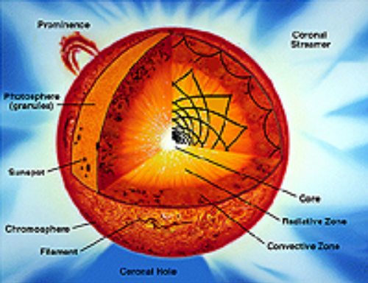

The formation of our solar system is based on the ‘hypothesis’, which follows three steps:
1. A cloud of gas & dust in space begin swirling
2. Most of the matter (more than 90% of it) accumulates in the center – forming the Sun
3. The remaining materials accumulate (forming planets) and circle the Sun

The Moon
The first other world to see up close was the Moon. On July 17, 1969 Neil Armstrong and Edwin Aldrin landed on the moon for a firsthand look.
The Inner Planets - Mercury, Venus, Mars and the Earth - are considered the terrestrial planets because of their composition. The Outer Planets – Jupiter, Saturn, Uranus, Neptune, and Pluto – are similar because of their gaseous composition.

Exploring the Outer Planets
Observation equipment is sent out into space to explore distant areas of our solar system. Space probes are unmanned satellites or remote-controlled ‘lenders’ that put equipment on or close to planets where no human has gone before. Probes have done remote sensing on Mercury and Jupiter, taken soil samples on Mars, landed on Venus, and studied Saturn’s rings up close. The most recent probes to explore Mars are still there.
They are Spirit and Opportunity.
They are looking for evidence of water to determine if Mars at one time could have sustained life.

The astronomical unit is used for measuring ‘local’ distances in the solar system. It is equal to the distance from the center of the Sun to the center of the Earth (approximately 149,599,000 kms). A light year is equal to the distance light travels in 1 year (approximately 9.5 trillion kms). It is used for longer distances – to stars and galaxies. The distance to our nearest star, Proxima Centauri is a little over 4 light years. A parsec is a basic unit of length for measuring distances to stars and galaxies, equal to 206,265 times the distance from the earth to the sun, or 3.26 light-years, The nearest star, Proxima Centauri is about 1.31 parsecs from the Earth.
When you view an object in the sky you are seeing it as it was in the past. It has taken the light a very long time to reach the Earth. Light from the Sun takes about 5 minutes to reach the Earth, whereas light from Pluto takes about 5 hours. The farther away, the longer light takes to reach the Earth. Light from the stars in the center of the universe takes about 25,000 years to reach the Earth. The Hubble telescope is capturing light from 12 billion years ago. A star is a hot, glowing ball of gas (mainly hydrogen) that gives off light energy. Stars vary in their characteristics. Very hot stars look blue, while cooler stars look red. In the 1920’s, Ejnar Hertzsprung and Henry Norris Russell compared the surface temperature of stars with its brightness (luminosity). They graphed their data to show the relationship between brightness and temperature of stars was not random.
The process of ‘star-building’ is known as fusion, which releases great amounts of energy and radiation.
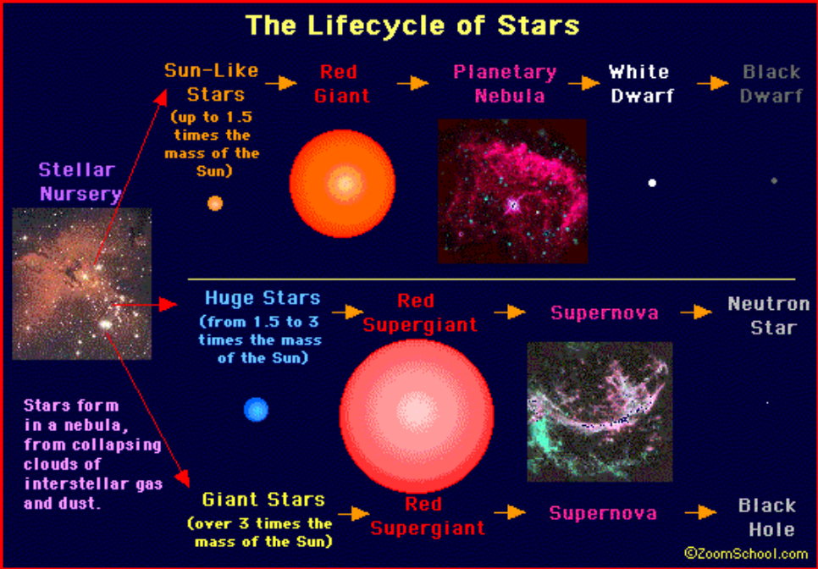

The race for space supremacy began just over 50 years ago. As a result many technologies were fast-tracked to make sure whoever developed them first, would make it into space first.
Space travel can have its dangers. A launch can be affected by many dangers, including highly explosive fuel, poor weather, malfunctioning equipment, human error and even birds. Once in flight, the spacecraft can be affected by floating debris, meteoroids and electromagnetic radiation (coronal mass ejections – or, solar flares). Over 4000 missions have been sent into space. Micrometeorites are constantly bombarding spacecraft and the International Space Station. They travel at extremely high velocity and can cause great damage. Once they enter the atmosphere, they usually burn up.

The Space Suit

Space junk refers to all the pieces of debris that have fallen off rockets, satellites, space shuttles and space stations that remain in space. This can include specks of paint, screws, bolts, nonworking satellites, antennas, tools and equipment that is discarded or lost. Some debris in space will enter the atmosphere and will not totally burn up. When this occurs, it may land in populated areas and cause loss of life or damage to property.  Some satellites, or decommissioned space stations, that re-enter the atmosphere have radioactive parts and can contaminate a very large area, costing a lot of money and hours to clean it up. Some burn up in the atmosphere and those parts that don’t fall into the ocean, making recovery and clean-up less costly. | 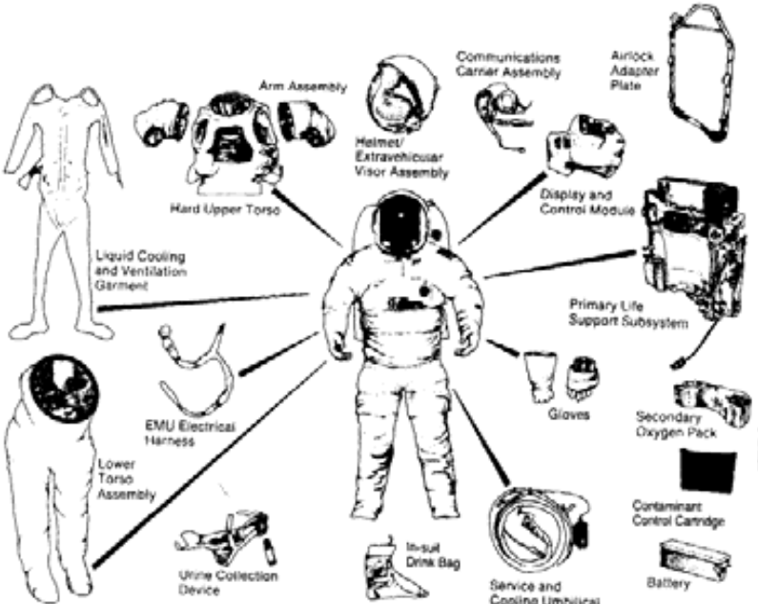
The space suit is a mobile chamber that houses and protects the astronaut from the hostile environment of space. It provides atmosphere for breathing and pressurization, protects from heat, cold, and micrometeoroids, and contains a communications link.
The suit is worn by the astronauts during all critical phases of the mission, during periods when the command module is not pressurized, and during all operations outside the command and lunar modules whether in space, in the International Space Station, or on the moon. Living in microgravity can cause problems because of the effects of weightlessness on the human body. Bones have less pressure on them and so they expand. They also lose calcium and become more brittle.The heart doesn’t have to pump as hard to circulate blood. Muscles weaken and shrink. Depth perception is also affected.

