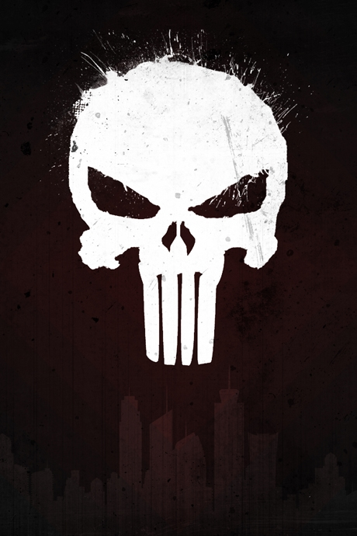

CREATE A PUNISHER POSTER PT 2
STEP 1
Start by creating a new document where the ratio of the dimensions are 900 by 600 PIXELS.

STEP 2. Fill it #050505 black, and add a Layer » Layer Style » Gradient Overlay, ranging from #050505 black to #330000 red with 15% Opacity in the Style of Diamond.
It's okay if the red is dark.



Brushing The 2D Punisher Skull
STEP 3. Next, we need to creatively brush our Punisher skull with the Chalk 60 brush (Part of the original Photoshop brushes – if you cannot find it, raise your hand), with a color of #777777 (on a new layer of course).
It doesn't have to be perfect.
In fact, that's the look we're trying to achieve! Messy, artistic, creative, rough – within reason! STEP 4. Once you have your initial brushwork done, Load the wg_mixed_media_brushes brushes that have been provided for you.
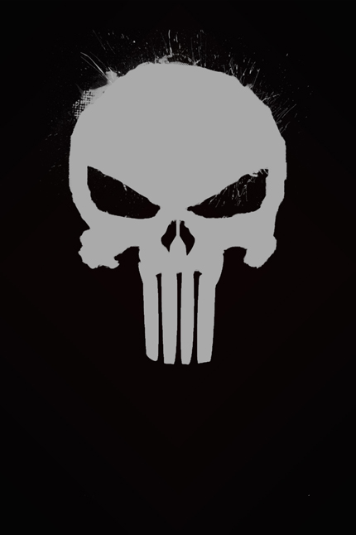

Adding The Urban Cityscape
STEP 5. After that, we need to create the skyline. Use the provided silhouette, OR the one you just created (Punisher pt 1) at the bottom of the Photoshop document (this is why the height of the PSD is so long). After using Edit » Transform » Scale to make it smaller (optional – so you can see more of the city), position it however you see fit.
STEP 6. You may have noticed that it's a GIF image, and the white background will need to be removed. Well, we need the buildings to be white, so instead, press CTRL + I to invert the image, and then make the Opacity of the skyline 15%.

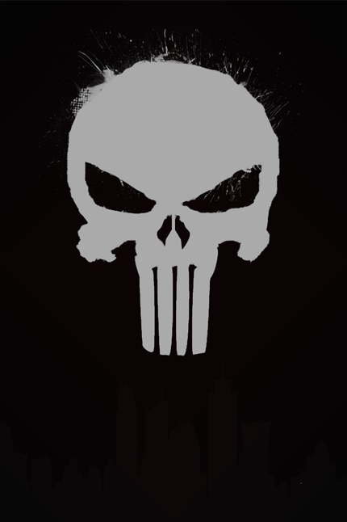

Photoshop Grunge Textures
STEP 7. Literally, this will spring to life once we've added some urban-themed texture. Use the provided Grunge Texture 2 by Shadowhouse Creations.
STEP 8. Make sure that, once you've aligned the texture where you want it, that the Blending Mode is set to Overlay. Duplicate (CTRL + J) the texture layer for a more intense effect.
You should be complete!

