How Alcohol Affects Body Parts¹:
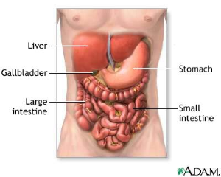

The Liver:

Some of the most serious effects of drinking alcohol on the body are damage done to the liver.

If alcohol is frequently in the blood in large amounts, it causes the liver cells to die and prevents the liver from working efficiently.

This disease is called Cirrhosis.

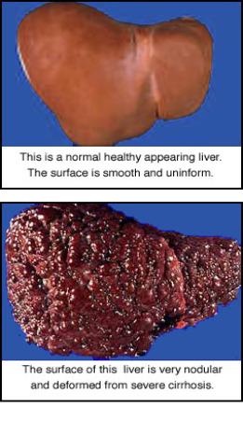
The liver is like a car with one gear - it can only work at one rate. On average, it takes one hour for the liver to burn up one drink of alcohol.

If it has to deal with too much over a number of years, it suffers damage.
Chromic heavy drinking may cause alcoholic Hepatitis (inflammation and destruction of the liver cells) and then
Cirrhoses (irreversible lesions, scarring and destruction of liver cells). These diseases also cause:

-skin appears yellow (Jaundice)
-Fluid to build in extremities (Edema)
-uncontrolled bleeding
-liver failure
-coma
-death

The Brain and Central Nervous System:
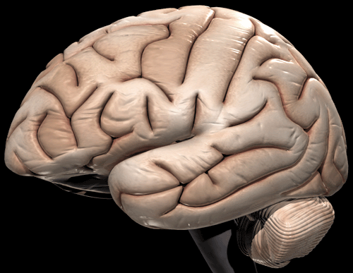

Large amounts of alcohol cause:

- permanent brain damage
- addiction
- vitamin deficiencies leading to serious mental disturbance
- impaired behavior, judgment, memory, concentration and coordination
- depression and other psychiatric and emotional disorders
- extreme mood swings and emotional outbursts
- dulling, altering and damaging the brain’s nerve cells ability to respond
- respiratory failure
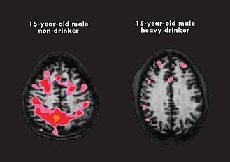
- coma
- death

Other effects on the central nervous system:

*Impaired visual ability
*Altered sense of time and
space
*Dulled smell and taste
*Slows reactions
This brain images shows how alcohol can affect a teen's
developing brain. Compared with a young non-drinker, a
15-year-old with an alcohol problem (one right) showed
poor brain activity during a memory task. This finding is
noted by the lack of pink and red coloring

*Impaired fine motor skills
*Loss of pain perception
*Unclear hearing
*Impaired sexual
performance

Alcohol Damage to the Heart:

-weak pumping action of the heart causing heart failure

-Weakened heart muscle and ability to pump (Cardiomyopathy)
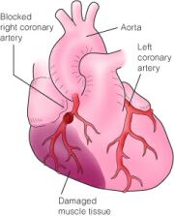
-Heart enlargement

-abnormal heart signs and irregular heartbeat

-Increased blood pressure

-risk of heart attack and strokes

-Inhibits production of white and red blood cells

-death

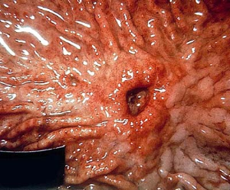

The Stomach:

*irritation of stomach lining *peptic ulcers
*inflammation
*bleeding lesions
*cancer

The Skin:

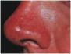
Alcohol causes small blood vessels in the skin to widen, allowing more blood to flow close to the skin's surface. This produces a flushed, red or purple skin color and a feeling of warmth. This causes the red appearance of an alcoholic’s nose

The Reproductive Organs: (Males and Females)

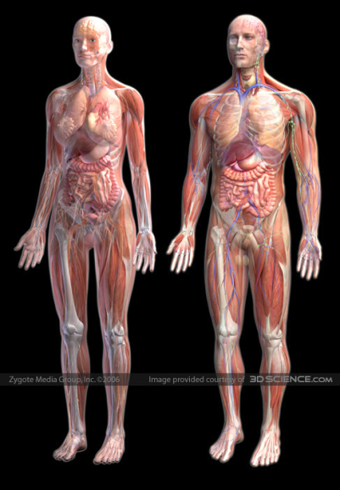
Alcohol is commonly believed to be an aphrodisiac (increase sexual desire) but as Shakespeare said it “provokes the desire, but takes away the performance.” The sobering physical fact is that problem drinkers are more likely to express dissatisfaction with their sex lives.

Persistent heavy drinking can lead to:

*loss of desire and potency
*shrinking of the testicles
*reduction of the size of the penis
*diminished sperm production
*Females also have high risk of developing breast cancer
*Fetal Alcohol Syndrome (The baby, when it is born, may be very small and could have reduced intelligence and facial deformities)

Pregnancy and Unborn Babies:
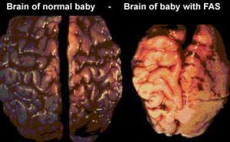
Drinking during pregnancy significantly increases the chance of delivering a baby with Fetal Alcohol Syndrome: a small head, possible brain damage, abnormal facial features, poor muscle tone, speech and sleep disorders and retarded growth and development.


Weight:

Alcohol contains sugar and other carbohydrates. Heavy drinking can cause a serious weight problem due to alcohol's high carbohydrate content. Men especially develop “beer bellies.”

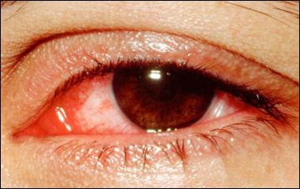
Eyes:
Distorted vision and ability to adjust to lights. Causes pinpoint pupils and red eyes.

Ears:

Diminished ability to distinguish between sounds and perceive their direction.
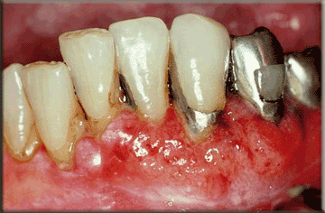

Mouth:
Slurred speech, dulls taste and smell, reduces desire to eat, and causes cancer of the mouth and throat.

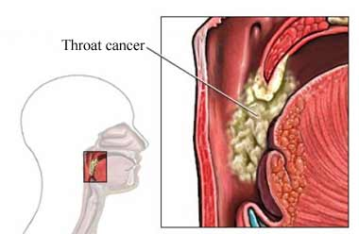

Throat:

-Irritation and damage of lining of esophagus
-induces severe vomiting, hemorrhaging, pain and difficulty swallowing.
-Causes throat cancer.

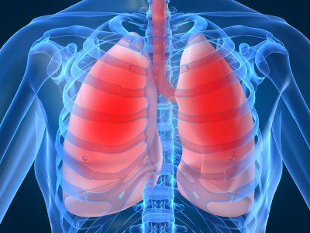

Lungs: High amounts of alcohol may cause breathing to stop, and lead to death. The lungs also have a lowered resistance to infection.

Intestines:
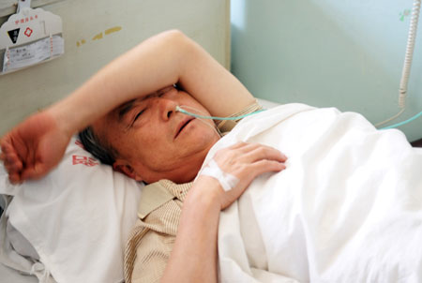
-Irritation of the lining of the intestinal tract and colon.
-Chronic drinking may result in inflammation, ulcers and cancer of the intestines and colon.
-Nausea, diarrhea, vomiting, sweating and loss of appetite are common. Alcohol impairs small intestine's ability to process nutrients and vitamins.

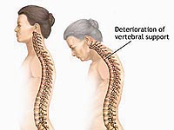
Bones:
Alcohol interferes with the body's ability to absorb calcium resulting in bones being weak, soft, brittle and thinner- called Osteoporosis.
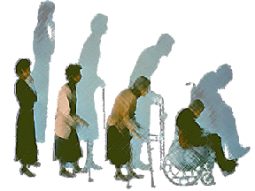

1 http://www.hknet.org.nz/AlcoholEffects.html

http://www.shesinrecovery.com/addiction/harmfuleffects.html

