- Complete the table below to outline four main types of receptors and the stimuli they detect:
Receptor | Stimulus | Examples
Mechanoreceptor
Thermoreceptor
Chemoreceptor
Photoreceptor

- TOK link – To what extent is our perception of the world limited by our receptors?
Research some examples of animals with different ranges of stimuli – or even completely different stimuli altogether!

- Label the structures of the human eye with their names and functions: 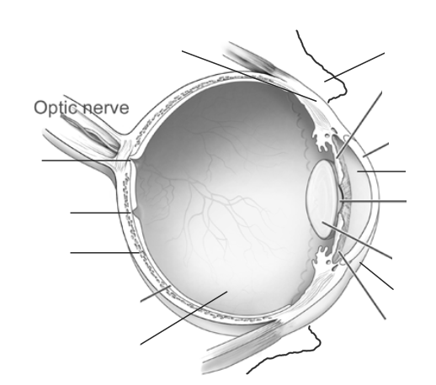

- Label the section of the retina below:

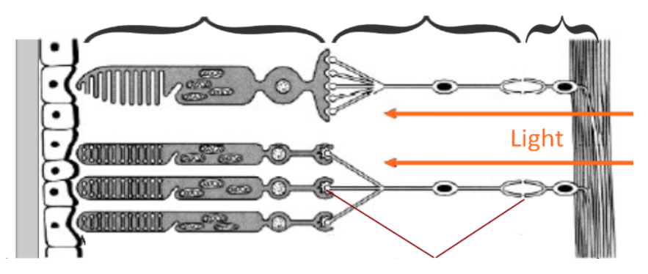
- Annotate the diagram below to outline how light stimulus is received by the photoreceptor and converted to an action potential:
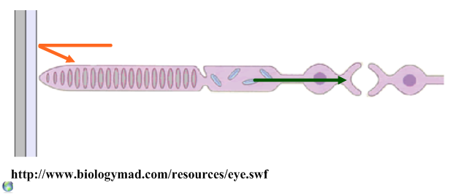
- Compare rod and cone cells:
 | Rod cells | Cone cells
Light brightness
Diversity of cells
Wavelength sensitivity
Impulse: neuron ratio
distribution
- Explain how visual stimuli are processed in the eye and brain, with reference to the following stages (you can draw or find images to help, if you wish):

- Image focusing and inversion in the cornea and retina

- Visual fields

- Contralateral processing and the role of the chiasma

- The role and location of the visual cortex in the brain

- Edge enhancement and ‘filling in’ of the blind spot

- Label the diagram with the structures of the ear, and use the diagram to explain how sound is perceived by the ear.
