Assg: ALL Name
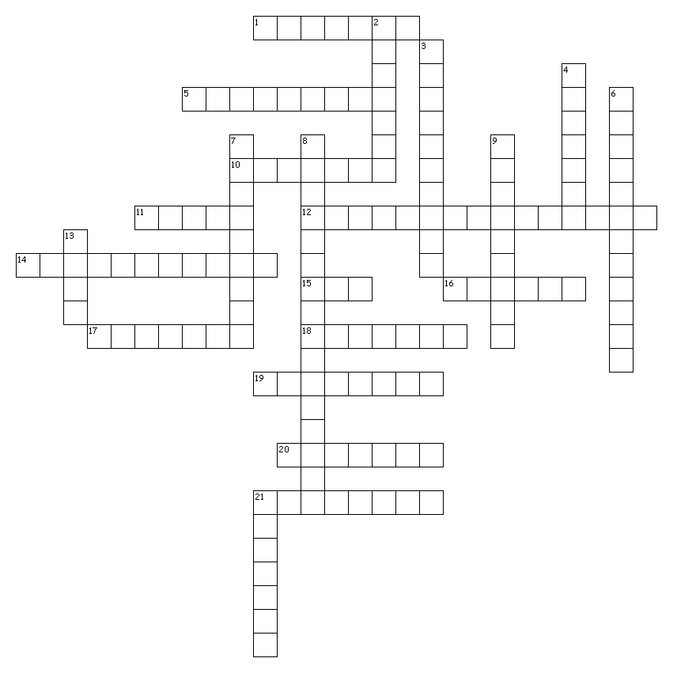
Down
2. Different forms of a gene.
3. Organisms that have two identical alleles for a particular trait.
4. The effects of a recessive allele are seen when the dominant allele is not…
6. Organisms that have two different alleles for a particular trait.
7. The physical traits of an organism, for example height, hair color, blood type, etc.
8. The offspring of two different parents results from this process.
9. The theory that states some alleles are dominant while others are recessive.
13. The gender pea flowers have.
21. Alleles segregate when these are formed.

Across
1. The type of letter used to represent a dominant allele.
5. The type of letter used to represent a recessive allele.
10. The offspring created by crossing parents of different traits (exp. tall and short)
11. The number of traits Mendel studied.
12. When the male part of the pea flower fertilizes the female part of the pea flower.
14. The likelihood that a particular event will occur.
15. Each gamete carries this many copies of each gene.
16. Used pea plant to study inheritance.
17. Probability can be used to predict this of genetic crosses.
18. alleles are represented using these in a punnett square.
19. The scientific study of heredity.
20. When a living thing inherits a dominant allele the trait is…
21. The letters used to represent the genetic makeup of an organism like HH or hh for height, BB or bb for hair color, etc.

Ch. 11 Introduction
to Genetics Summary

