NYOS AP Biology Name _________________________________ Kingdom Animalia Dissection Pre-Lab Date __________________________________
SEA STAR Pre-Lab
Introduction
Echinoderms are radially symmetrical animals that are only found in the sea (there are none on land or in fresh water). Echinoderms mean "spiny skin" in Greek. Many, but not all, echinoderms have spiny skin. There are over 6,000 species. Echinoderms usually have five appendages (arms or rays), but there are some exceptions.
Radial symmetry means that the body is a hub, like a bicycle wheel, and tentacles are spokes coming out of it (think of a starfish). As larvae, echinoderms are bilaterally symmetrical. As they mature, they become radially symmetrical. Most adult echinoderms live on the bottom of the ocean floor. Many echinoderms have suckers on the ends of their feet that are used to capture and hold prey, and to hold onto rocks in a swift current.
Sea stars (group name Stelleroidea) are sometimes called starfish, though they are not real fish (they lack both vertebrae and fins). There are two sub-types of sea stars:
Asteroidea are the true sea stars and sun stars.
Ophiuroideas are brittle stars and basket stars.
The differences between the two sub-types lies in how the arms connect to the central disk. Ophiuroids have arms that do not connect with each other. There is a distinct boundary between arm and central disk. Asteroids have arms that are connected to each other. Also, it is harder to tell with asteroids where the central disk ends and the arms begin. The sea star's top surface (or skin) looks spiny if you examine it. If you look very closely you will notice that there are different types of growths on the surface. Some bumps are used to absorb oxygen, they are called dermal branchiae. Pedicellaria are pincher-like organs used to clean the surface of the skin. Barnacle larvae could land on a sea star and start growing if it were not for these organs.
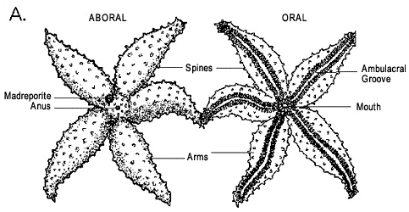 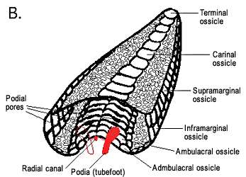 Fig. 1 - Morphology of asteroids. A, aboral and oral surfaces of a generalized asteroid. Image © BIODIDAC. B, transverse section and perspective view of a generalized arm (soft tissues and spines removed); note the arched ambulacral ossicles forming the ambulacral groove and the dorsal podial pores between ambulacral ossicles. One podium (tubefoot) on the left is drawn in outline only to illustrate how the podia descend through the podial pores. Image © 2004 Emily Knott.

Fossil Record
The earliest asteroids appeared in the Ordovician (Figure 2). However, at least two major faunal transitions have occurred within the Asteroidea concomitantly with large extinction events: in the Late Devonian and in the Late Permian. The asteroid orders as described here contain all extant and some extinct species which have a morphology distinct from Paleozoic forms. The asteroid orders are thought to have appeared and diversified very rapidly (within approximately 60 million years) during the Lower and early Middle Jurassic, frustrating our understanding of ordinal relationships.
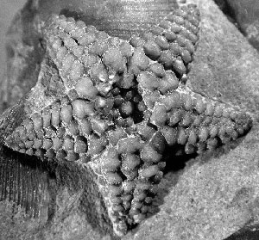 Figure 4: Hudsonaster sp. (USNM 40882), an early asteroid from the Ordovician. Image copyright © Daniel B. Blake

How Do Sea Stars Move?
Each sea star has hundreds of tiny feet on the bottom of each ray. These are tube feet, or podia. These tiny feet can be filled with sea water. The vascular system of the sea star is also filled with sea water. By moving water from the vascular system into the tiny feet, the sea star can make a foot move by expanding it. This is how sea stars move around. Muscles within the feet are used to retract them. Each ray of a sea star has a light sensitive organ called an eyespot. Though it cannot see nearly as well as we do, sea stars can detect light and its general direction. They have some idea of where they are going.

PRE-LAB QUESTIONS
1. In what phylum are starfish found?

2. What is the habitat for sea stars? Describe as specifically as possible, while generalizing for the whole group.

3. On what do sea stars feed?

4. What system in their body helps them catch & hold their food? Describe how this process occurs.

5. What does echinoderm mean, in Greek? Why is this a good name for this group?

6. Name 2 Classes of echinoderms, & a member of each class.

7. Where does water enter a starfish? Where does it leave?

8. Morphologically, what type of a) symmetry do sea stars display?
b) What term describes their tissue layers? c) Their body cavities?
For each, describe what the term indicates about the organism’s morphology.

9. Embryonically, are sea stars classified as protostomes, or deuterostomes?
What does this classification signify?

GRASSHOPPER Pre-Lab
Introduction & Background (see provided Flinn Scientific Dissection Guide)
Fossil Record
Insect Order Orthoptera, which includes grasshoppers, crickets and locusts, first appeared during the middle of the Carboniferous period, well over 300 million years ago. The name Orthoptera, derived from the Greek "ortho" meaning straight and "ptera" meaning wing, refers to the parallel-sided structure of the front wings (tegmina). In many species of Orthoptera, the males use sound signals (chirping or whirring) in order to attract a mate. The sound is produced by stridulation -- rubbing the upper surface of one wing against the lower surface of another wing, or the inner surface of the hind leg against the outer surface of the front wing. Most living members of this order are terrestrial herbivores with modified hind legs that are adapted for jumping. There are some 20,000 extant species.


Family ROMALEIDAE: LUBBER GRASSHOPPERS
Containing some of the most boldly-marked and eyecatching of Paraguayan grasshoppers, the Romaleids are a diverse group ranging in size from small to enormous - the Chaco species Tropidacris collaris is the size of a small bird! They are likely of South American origin. The diagnostic character of this family is the presence of an immovable spine on the inner and outer surface of the tip of the hind tibia. The two basal lobes of the hind femur are approximately equal in size and there is a spine between the front legs. Both the forewings and the hindwings are often brightly coloured, though the wings are commonly short. The head is typically broadly rounded.
PRE-LAB QUESTIONS
1. In what phylum are grasshoppers found?

2. What is the habitat for grasshoppers? Describe as specifically as possible, while generalizing for the whole group.

3. On what do grasshoppers feed?

4. What system in their body helps them attract mates? Describe how this process occurs.

5. What does Orthoptera mean, in Greek? Why is this a good name for this group?

6. Name 2 Classes of Orthoptera, & a member of each class.

7. Describe the life stages and metamorphic processes that grasshoppers experience.

8. Morphologically, what type of a) symmetry do grasshoppers display?
b) What term describes their tissue layers? c) Their body cavities?
For each, describe what the term indicates about the organism’s morphology.

9. Embryonically, are grasshoppers classified as protostomes, or deuterostomes?
What does this classification signify?

10. List the equipment and materials that will be needed to perform these two dissections.
At least TEN items must be listed.

