1. HENRY DAVID THOREAU  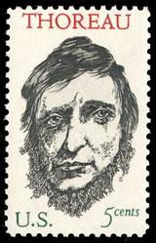 | 2. JOHN MUIR  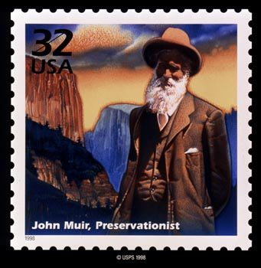 | 3. THEODORE ROOSEVELT  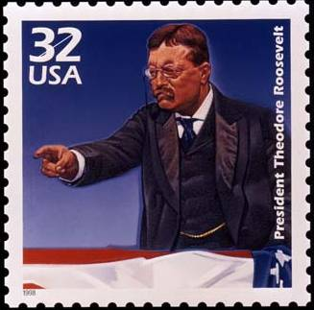
4. ALICE HAMILTON  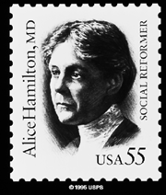 | 5. ALDO LEOPOLD  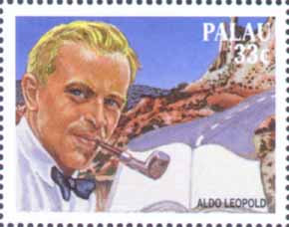 | 6. RACHEL CARSON  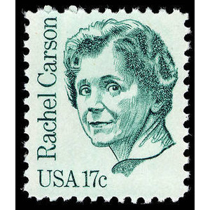
7. GARRETT HARDIN  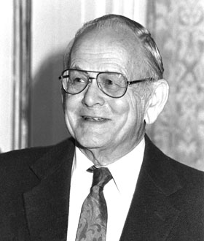 | 8. DAVID ATTENBOROUGH  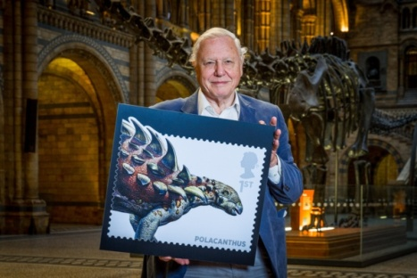 | 9. MARION STODART  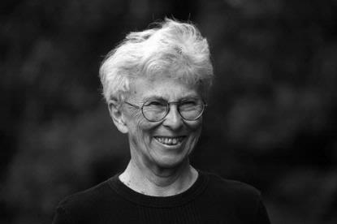
10. PAUL EHRLICH  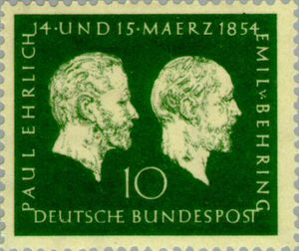 | 11. JANE GOODALL  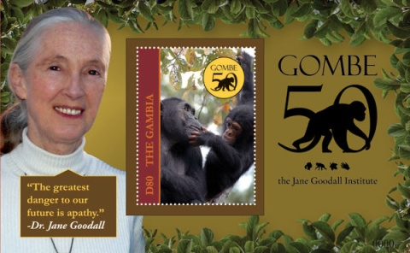 | 12. SYLVIA EARL  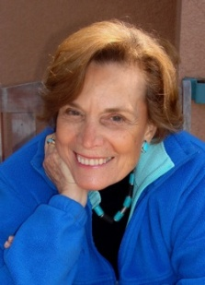
13. WANGARI MAATHAI  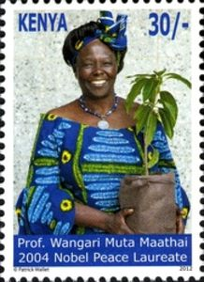 | 14. JOHN CRONIN  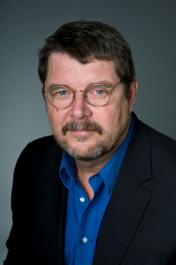 | PEOPLE WHO HAVE INFLUENCED  ENVIRONMENTAL THINKING  SECTION 21-3 PAGE 544  NAME: _______________________  PERIOD: ___ DATE: ____________

