AP Statistics Ann Hsiao
Room #106 Email: ahsiao@smusd.us

AP Statistics is comparable to an introductory college statistics course, which covers four major themes: exploratory analysis, planning and conducting a study, probability, and statistical inference. Basically, you will learn how to collect data and analyze data.

A major component to statistics is the ability to communicate results both verbally and in writing. Communication of the results is just as important as performing the calculations accurately. As such, there will be a great deal of writing and presenting in this course using the vocabulary of statistics.

Grade Breakdown
A standard grading scale is used: 90% - A, 80% - B, 70% - C, 60% - D. Earning less than 60% of possible points will result in the grade of F. Grades will be available online through PowerSchool. The teacher reserves the right to curve student grades.

10% | Homework
15% | Quizzes
15% | Projects
60% | Tests and Final

*A student who earns below 80% for the 1st Semester will be placed in Regular Statistics for the 2nd Semester.
___________________________________________________________________________________

AP Stats Binder
It is recommended that you maintain a binder for this course to keep yourself organized with all the handouts and papers you will collect for this class. I would recommend you organize your binder by chapter where in each of the 13 chapters, you will have the following:

- Chapter Reading Notes: From the advice of successful previous AP Stats students, they said to read the lessons before class and take notes to better understand the vocabulary and language used in Statistics.
- Class Notes
- Class Handouts and Exercises
- HW Practice Problems
- Quizzes and Tests
_______________________________________________________________________________________

Recommended Materials
If there is any trouble getting materials, please let me know ASAP!

Barron’s AP Statistics Prep Book
Pencils, Pens, Erasers, Highlighters, Ruler
3-Ring Binder and Dividers (13 dividors for each chapter)
Notebook Paper
Graphing Calculator – TI-84 Plus Silver Edition (*Need by next week)
*please note that the TI-83 and TI-89 are specifically NOT recommended
Please see me if cost is preventing you from getting a graphing calculator
_______________________________________________________________________________________
Homework
The emphasis in the course is on the understanding of the concepts; you will be doing more reading and writing and less traditional math problems. All required steps must be shown and written in complete sentences, as applicable.
No work, No Credit.

- Take it seriously. This is your chance to figure things out for yourself!
- Unexcused late work will be accepted at half credit up until the Chapter Test
- If you miss a class, it is your responsibility to find out what you’ve missed (homework, lesson, important announcements) and/or to schedule a make-up quiz/test with the teacher immediately upon return.
_______________________________________________________________________________________

Citizenship
The classroom is a place where learning must take priority. Your behavior and effort in class determines your citizenship grade.

• Tardies and truancies will lower your citizenship grade.
• Going off task during class will lower your citizenship grade.
• CELLPHONES are to be on silent and in your backpack during class…in your backpack means, not on your desk! Your citizenship grade will be lowered every time I take away your phone. If a cellphone is visible during a quiz or test, that will be considered cheating.

• Cheating will result in the following: a zero on the test/assignment, a call to your parents, citizenship grade of F for the semester, counselor notification, assistant principal notification, and immediate removal from AP and placement into a regular math course. Counselors are required to notify colleges about cheating during the college application process.

AP Exam
- A mock AP exam is a required part of this class, so save the date: Sat. May 2nd, 2015, 9am-12:30pm.
- You must take the AP exam or your college will be notified and the AP designation will be dropped from your transcript.
_______________________________________________________________________________________
Advice from Previous AP Stats Students…Word for Word!

“Pay attention in class bc Stats is harder to learn through textbooks. Don’t fall behind in a chapter/section, bc if you do then you will be doomed for future sections.”

“Study. Listen to Lectures. Ask for help.”

“Study in and out of class. Participating in class activities benefits you greatly, even if you don’t notice at first.”

“Pay attention to abstract stuff or it will bite you on the AP.”

“Love your TIs – come in after school to learn if you’re having trouble. Don’t be afraid to ask for help. Do your homework!”

“Pay attention during the lecture, do your homework and you’ll be fine.”
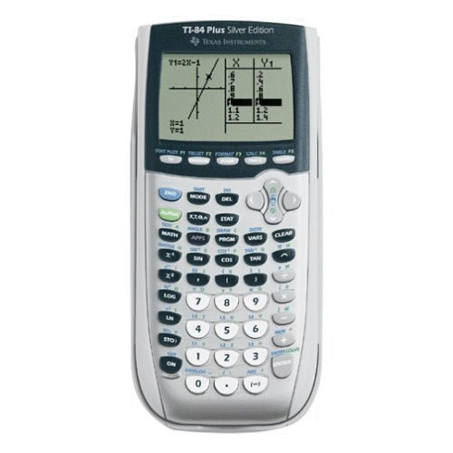

Please sign and return this sheet.

I have read, understood, and agree to abide by the preceding Course Syllabus for Ms. Hsiao’s AP Statistics class. I also understand that Ms. Hsiao reserves the right to make changes in the Syllabus.
I also commit to taking the mock AP Statistics Exam on Sat. May 2nd, 2015, 9am-12:30pm. If I do not take the mock exam during this scheduled time, I will accept a failing grade for my 2nd semester final.

___________________________________ ______________________________
Student Name and Period (print) Student Signature

___________________________________ ______________________________
Parent/Guardian Name (print) Parent/Guardian Signature

______________________
Date

Best way to reach parent/guardian:

______________________________ _________________________________________
Phone Email address

Is there anything else you would like me to know (either student or parent/guardian)?

