Treasure Island
Study Guide, Part VI:
Short Answer: Use complete sentences to answer each of the following questions.
- How did Silver get possession of the blockhouse?
- What was Jim’s deal with Silver?
- Why did the council give Silver the black spot?
- Why did the council decide to invalidate the black spot and keep Silver as captain?
- What scared the treasure-hunting pirates?
- What surprise did Silver and the pirates find at the treasure site?
- Who saved Silver and Jim?
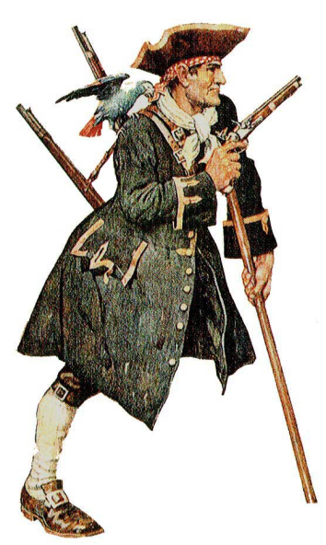
- Who got the treasure?
- What happened to Silver?
- What happened to the others?

