Create Batman Logo in Photoshop Posted on July 19, 2010 by David_E
In this tutorial, we’ll be creating the iconic Bat logo of the superhero, Batman. Here, we’ll be using the Pen Tool to sketch out the ‘bat’ and a set of Heavy Scratches brushes to add a great amount of detail to the bat logo.

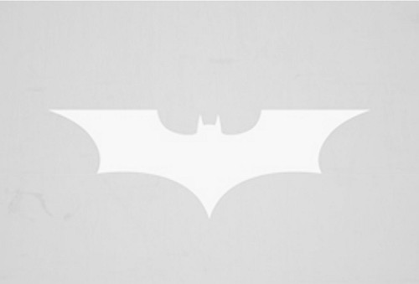
Step 1
With a document size of 800 by 600 px, resolution of 140 dpi and a white background, I started with an outline of the original bat logo which I desaturated and; the contrast increased thus, leaving nothing but the shape of the logo. We’ll be using this shape as guides for our actual bat logo.

Step 2
For greater accuracy, we’ll have to enable grid lines for our document by going to View>Show>Grid.
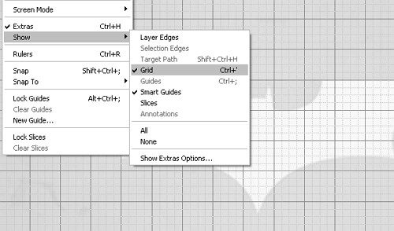

The document enabled with Grids.
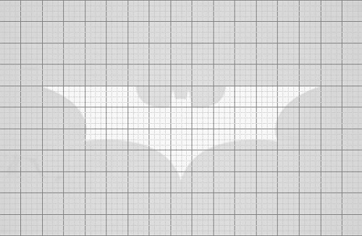
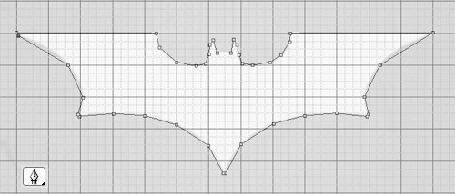

Step 3
Create a new layer ‘bat’ and on the Tools bar, select the Pen Tool and map out the shape of the bat logo as shown below:

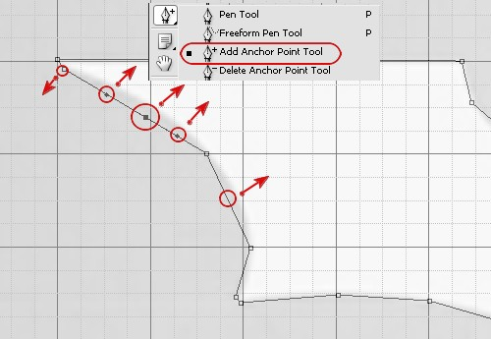
Step 4
Now for the intricate part. For other tools options under the Pen Tool, select the Add Anchor Point Tool and add a number of points to the straight lines of the logo. With your mouse or the directional keys on the keyboard, move the Anchor points steadily upwards or diagonally to create a curve(s).

Step 5
For more smoother curves, drag the handles of the Anchor Points in the direction most appropriate.
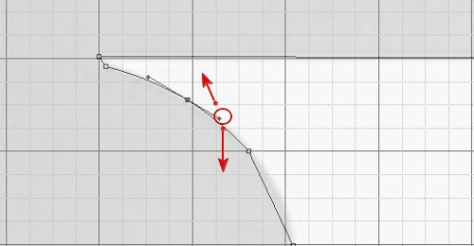
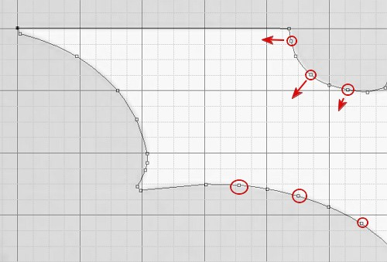

Step 6
Add more Anchor Points and repeat the previous steps to create more curves.

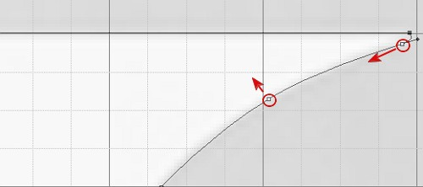
Step 7
For the edges of the logo, more specifically points of the wings, ensure that they’re rounded and not sharp.

To the Right is the final result: 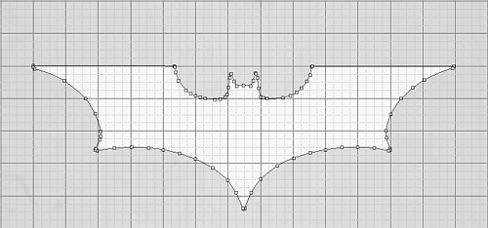
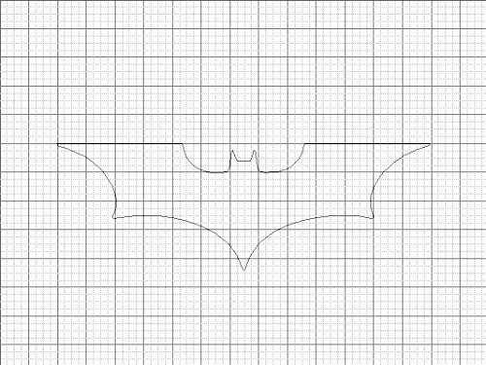

Step 8
I deleted the layer that I used as my guides and pressing Ctrl+-, the Grids were removed.

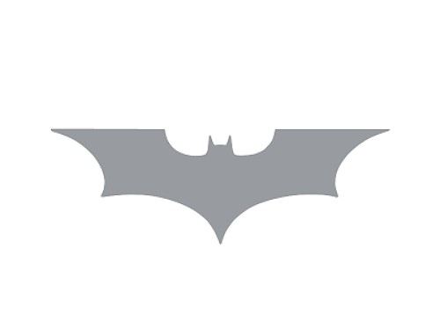
Step 9
Fill the bat logo with a grey color.

Step 10
Open the Metal Texture brushed metal texture. Now position the top most part of the metal texture over the bat logo.

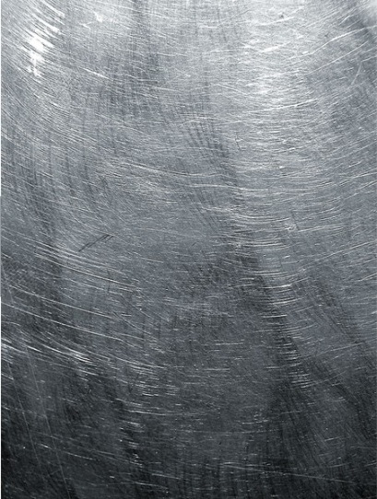
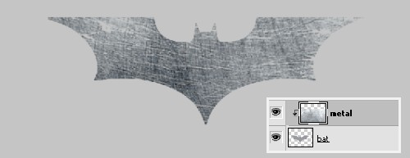
Holding down the ALT key, click in between the ‘bat’ and ‘metal’ layers for a Layer Clipping Mask.

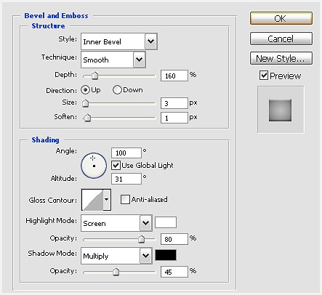
Step 11
Double-click on the ‘bat’ layer and select a Bevel and Emboss Layer style. Set its parameters as shown below:

Step 12
Follow up with a Gradient Overlay style and set and adjust the Gradient Color Stops:

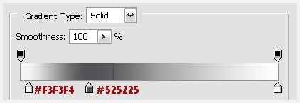
B. Reduce the Gradient’s Opacity to 60%or lower set its Style to Radial and Angle at 0 degrees.
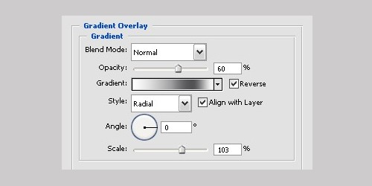

Step 13
Also select a Drop Shadow Layer Style and set its parameters as shown below:
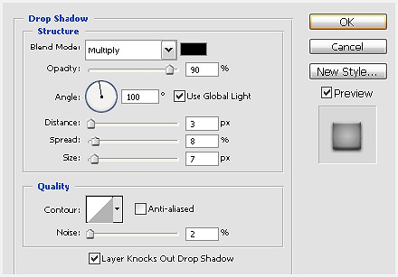

Step 14
Now to create some scratches and dents on the metallic bat logo. We’ll be using two sets of Scratch brushes. The Heavy Scratches brushes can be downloaded from Dawghousestudio.com and another Scratches brush by can be downloaded from Brushstock.com.Load these brushes into Photoshop and select the brush of choice from the Brushes Palette and change the foreground color to black. These brushes have huge pixels larger than our working document and so we’ll must reduce the size of the brush(es) on application (painting that is). Do create a new layer for this.
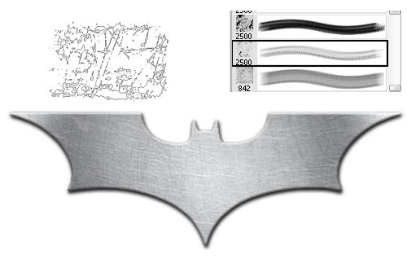

Step 15
Hit Ctrl+T to enter the Free Transform mode and, with the mouse position close to the corner of the selection, rotate it slightly diagonal. This is to ensure some of the brush strokes don’t appear too linear.
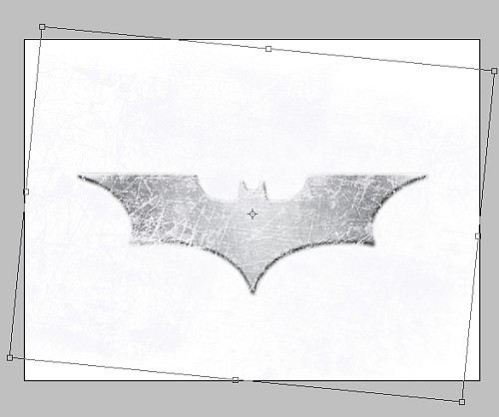

Step 16
Select the Eraser Tool (E), and clear the brushes marks that might be left outside the logo. Also erase just slightly the inner edges of the logo. Reduce brush opacity to 90%.

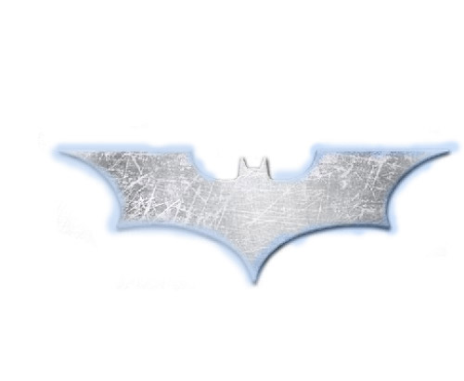
The result:
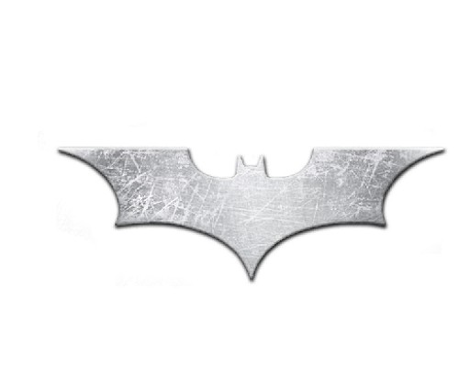

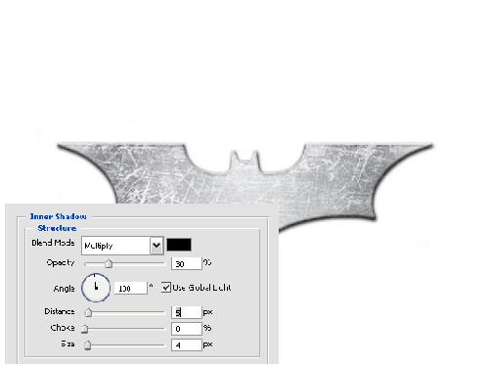
Step 17
With the ‘bat’ logo selected, create an Inner Shadow Layer style. Set the Blend Mode to Multiply, Reduce the Shadow’s Opacity to 30%, its Angle to a 100degrees, Distance at 5 px and Size at 4 px. Leave the Choke at 0%.

Step 18
We now use another metal texture for the background. You can download this or any other metal texture you might fancy from http://www.3dmd.net/gallery/large-free-brushed-metal-texture-fs125.html.
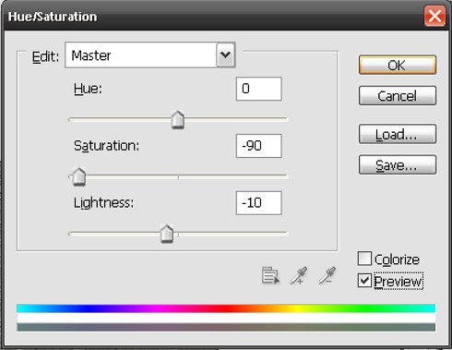
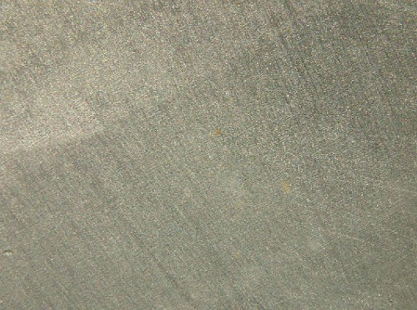

Step 19
Press Ctrl+U for the Hue/Saturation Dialog box and make the adjusts as shown below. This sort of, to a degree desaturate the texture. (A full desaturation would have left the texture with a faint bluish tint).

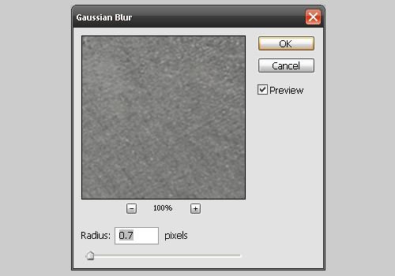
Step 20
Go to Filter>Blur>Gaussian Blur and set the Blur Radius to 0.7 pixels.

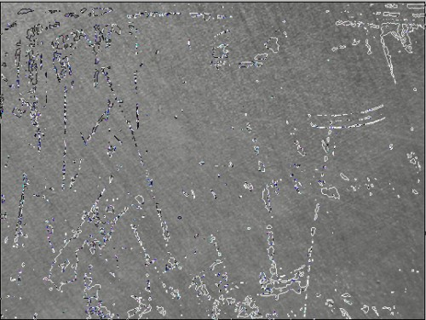

Step 21
Still on the ‘background’ layer, select the Heavy Scratches brush once again and increase the brush size just large enough to cover the entire background texture.

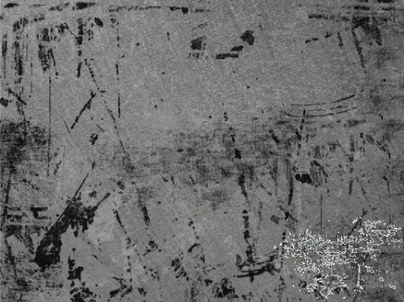
Step 22
Select a couple of other Heavy Scratch brushes from the Brushes Palette and reduce their sizes and then paint away.

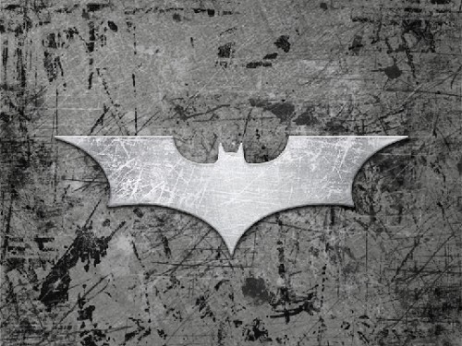
Step 23
Change the brush color to white and reduce its opacity to 80% and add some more scratch markings around the bat logo.

Step 24
Go to Filter>Render>Lighting Effects and set the Light Type as Omni and Intensity to 9.
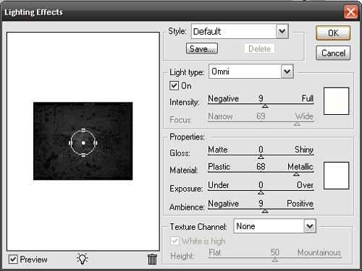

Step 25
Have the background image sharpen by going to Filter>Sharpen>Sharpen. Press Ctrl+F to Sharpen again.
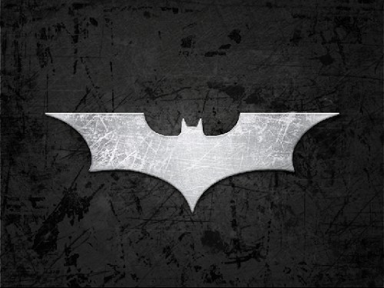

Step 26
Select the Burn Tool (O), set the Burn Range to Highlight and Exposure to 45%. Burn around the edges of the texture background.
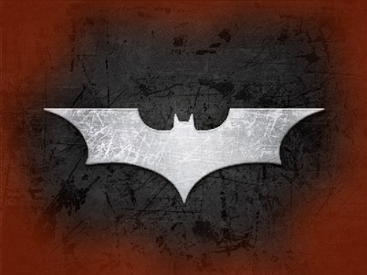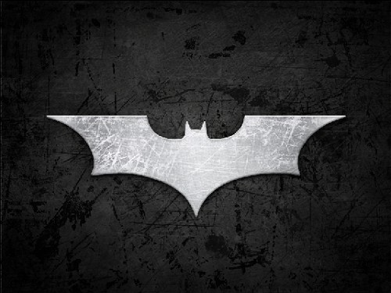

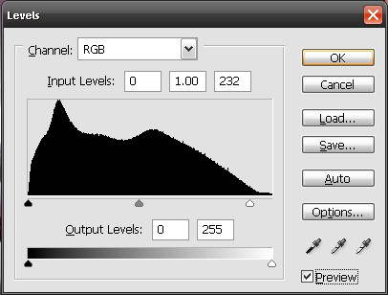
Step 27
Select the ‘bat’ layer and press Ctrl+L for the Levels Dialog box. Increase the light for the bat logo with the parameters below:

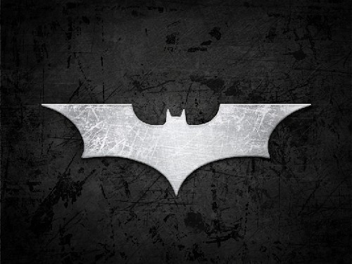
The result:

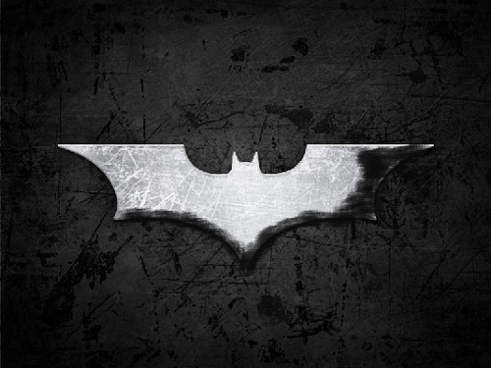

Step 28
Create a new layer and select a black Spatter brush. Paint sparingly one part of the bat logo.

Step 29
Go to Filter>Blur>Gaussian Blur and set the Radius to about 35 px. And we’re done.
