CHAPTER 19 SUMMARY – PAGE 502
SECTION 19-1 SOLID WASTE  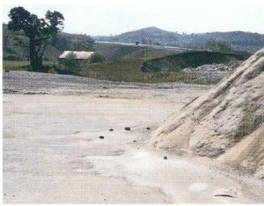 | SECTION 19-2 REDUCING SOLID WASTE  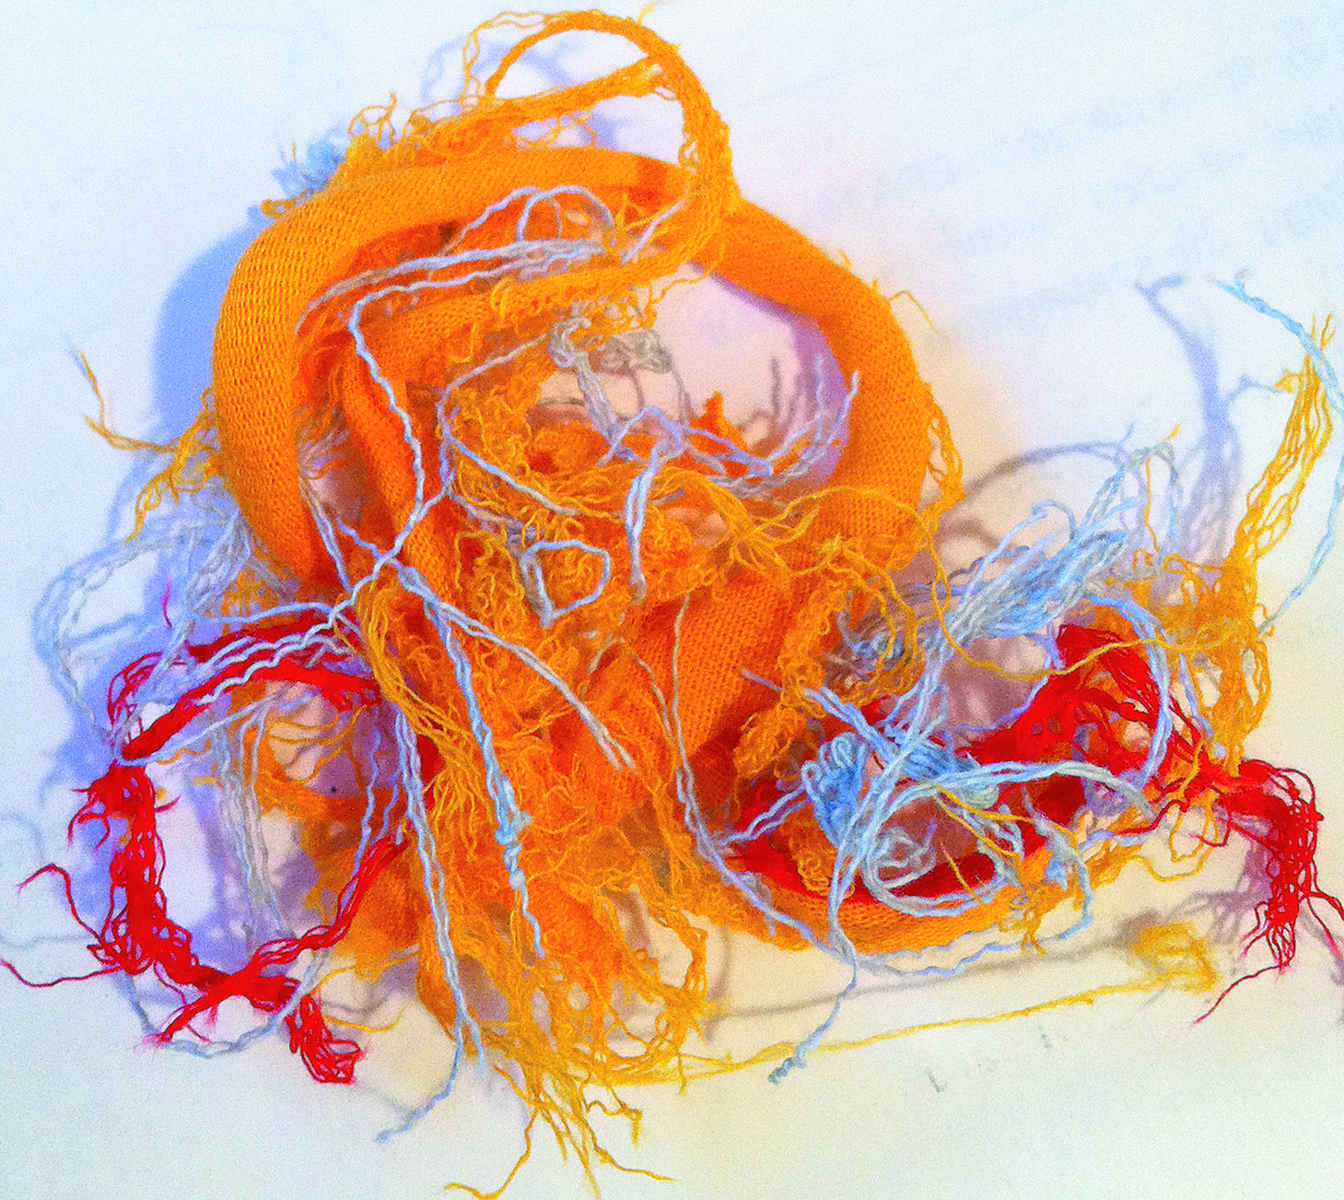 | SECTION 19-3 HAZARDOUS WASTE  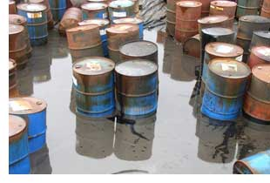

CHAPTER 19 SUMMARY – PAGE 502
SECTION 19-1 SOLID WASTE | SECTION 19-2 REDUCING SOLID WASTE | SECTION 19-3 HAZARDOUS WASTE

CHAPTER 19 SUMMARY – PAGE 502
SECTION 19-1 SOLID WASTE | SECTION 19-2 REDUCING SOLID WASTE | SECTION 19-3 HAZARDOUS WASTE

