Ri$e of Big Bu$iness Oct. 10, 2012
p. 241-243
 | Industry Facts | Tycoon (leader) of the Industry | Management and Business Strategies
Steel Industry  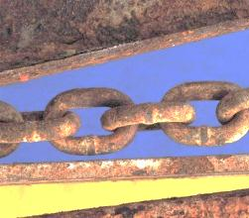 | -1899 Carnegie’s co. made more steel than all of Great Britain  -derived from iron  -1859 Bessemer Process: refined iron into steel  -1870 77,000 tons of steel  -Pittsburgh- steel capital | -Andrew Carnegie: poor Scottish immigrant that worked his way up to success “rags to riches” | -vertical and horizontal integration: buys out all of the suppliers, buys out the competition (mines, factories, railroads to transport iron/ steel)  -1901 sold business to JP Morgan for $480 million  -Carnegie retires $1 million/ month
Oil Industry | -Edwin Drake: uses steam engine to drill for oil  -3 forms of oil: gasoline, kerosene, distillate | -John D. Rockefeller established Standard Oil Co.  - no formal education, starts working at 16 yrs. old- his dad cheats his kids to teach them a lesson | -vertical integration: merges with oil drilling, processing and transportation  -sells oil at lower prices than the cost to produce= drives out competition, then rise the price up  -very low wages to workers  -used trust contracts with competitors  -Std. Oil Co is broken up by the Supreme Court as a monopoly

Horizontal integration: (p. 242):

Vertical integration: (p. 242)

