Know:
Unit 2- The Expansion of American Industry 1850-1900
Know and Be Able To:
*Heading West
1. Native Americans:
2. Colonel George Custer:
3. Vaquero:
4. Cowboy:
5. Gold Miner:
6.Settler:
7. Exoduster:
8. Farmer/ Bonanza Farms:
*Technological Revolution
9. Transcontinental Railroad:
10. Peter Cooper and Tom Thumb:
11. Bessemer Process:
12. The Great Train Robbery:
13. Edwin L. Drake:
14. Interstate Commerce Act1887:
15. Workers that built the railroads:

*The Growth of Big Business
16. Andrew Carnegie:
17. Social Darwinism:
18. Horizontal Integration:
19. Vertical Integration:
20. Socialism:
21. Monopoly:
22. John D. Rockefeller:
23. JP Morgan:
24. “Robber Barons”:
25. “Captains of Industry”:
*Industrialization
26.Ellis Island:
27. Health Exam for new Immigrants:
28. Angel Island, S.F.:
29. Nativism:
30. Chinese Anti-Exclusion Act:

*The Rise in Labor Unions
31. Eugene V. Debs:
32. Industrial Workers of the World (Wobblies):
33. Samuel Gompers:
34. American Federation of Labor:
35. Great Strike of 1877:
36. The Haymarket Affair:
37. Homestead Strike:
38. Pullman Company Strike:
39. Mary Harris Jones:
40. Triangle Shirtwaist Company fire:
*The Gilded Age
41. Urbanization:
42.Americanization Movement:
43. Tenements:
44. Jacob Riis, How the Other Half Lives:
45. List the urban problems:
46. Social Gospel Movement:
47. Settlement Houses:
48. Political Machine:
49. Political Boss:
50. Mike Kelly in Far and Away:
51. Graft:
52. Boss Tweed and the Tweed Ring Scandal:
53. Spoils System:
54. Populism:
*Segregation
55. Poll tax:
56. Ida Wells:
57. Grandfather Clause:
58. Jim Crow Laws:
59. Plessy v. Ferguson:
60. Debt peonage:
61. Mexican workers in the Southwest:
62.Booker T. Washington:
63. W.E.B. Du Bois:
*Progressivism
64. Bob La Follette:
65. Ida Tarbell:
66. Florence Kelly:
67. Muckrakers:
68. Meat Inspection Act of 1906:
69. Pure Food and Drug Act of 1905:
61. Upton Sinclair, The Jungle:
62. Suffrage Movement:
63. NAWSA:
64. T. Roosevelt’s “Square Deal”:
65. William Taft’s reforms:
66. Woodrow Wilson’s “New Freedom”:
67. Clayton AntiTrust Act:
68. Federal Trade Commission:
69. Nineteenth Amendment:
70. Trustbusting:

Be Able To: (complete in full sentences)
- What economic possibilities drew large numbers of people to the Great Plains and the West in the mid-1800s?
2) Do you think the government and citizens could have done more to stop the corruption and power of the railroads? Give support to your opinion with examples.

3) Do you think that the tycoons of the late 19th century are best described as ruthless robber barons or as effective captains of industry? Explain.

4) Of the different groups of immigrants that came to America from 1850-1920, which group do you think faced the greatest challenges in the U.S.? Explain why.

5) Why did immigrants tend to group together in cities?

6) How did the challenges and opportunities for Mexicans in the U.S. differ from the challenges African Americans faced? (Think about: types of work available, effects of government policies, effects of the legal system)

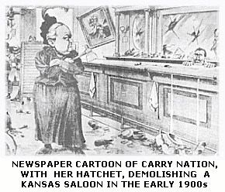

7) This cartoon shows Carry Nation inside a saloon that she has attacked. Do you think the cartoonist had a favorable or unfavorable opinion of her as a prohibitionist? Explain.

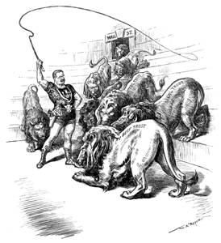

8) (See also on p. 319 in your textbook)

1)What do the lions stand for?

2)Why are all the lions coming out of the door labeled “Wall St.”?

- 3)What do you think the cartoonist thinks about trustbusting? Use the cartoon to cite your explanation.

Total KBAT points: ______
156

