Slide | Notes | Critical Thinking Question
A: American Interest in Cuba  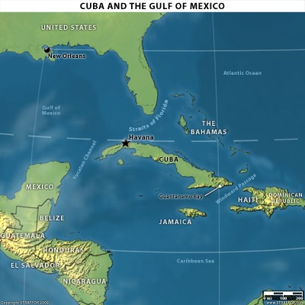 |  | Why were the U.S. owned sugar plantations in Cuba?
B. Jose Marti  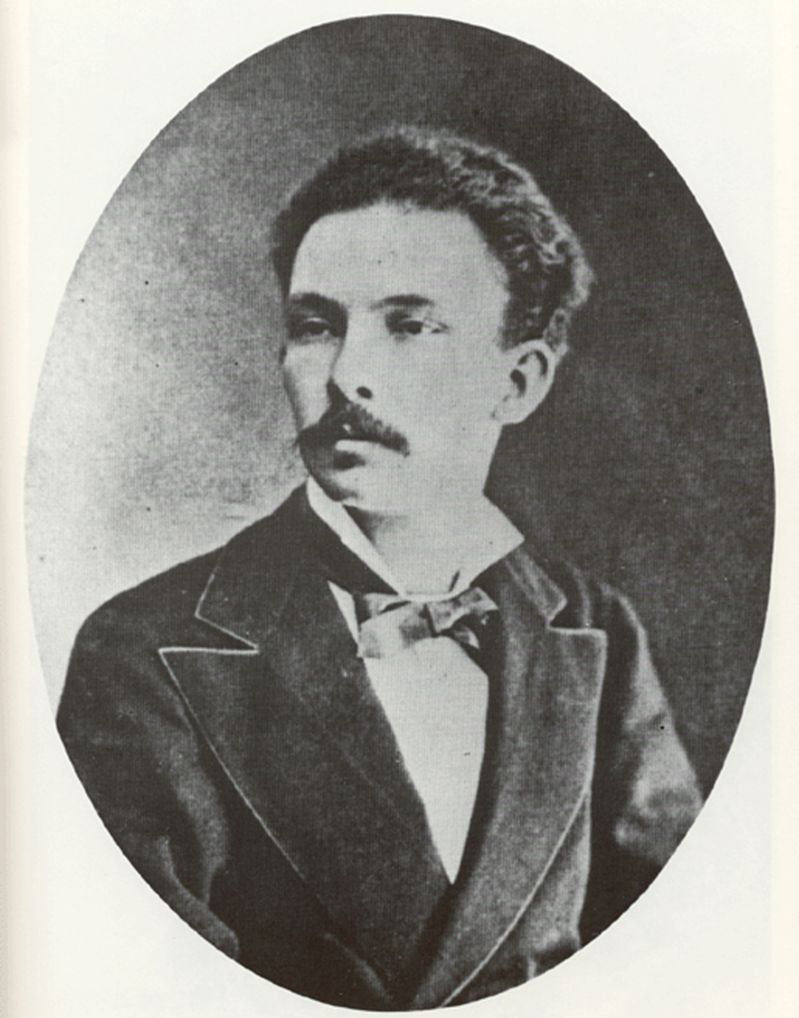 |  | How did Martí influence the U.S. to help with the Cuban effort for independence?
C. General Valeriano Weyler  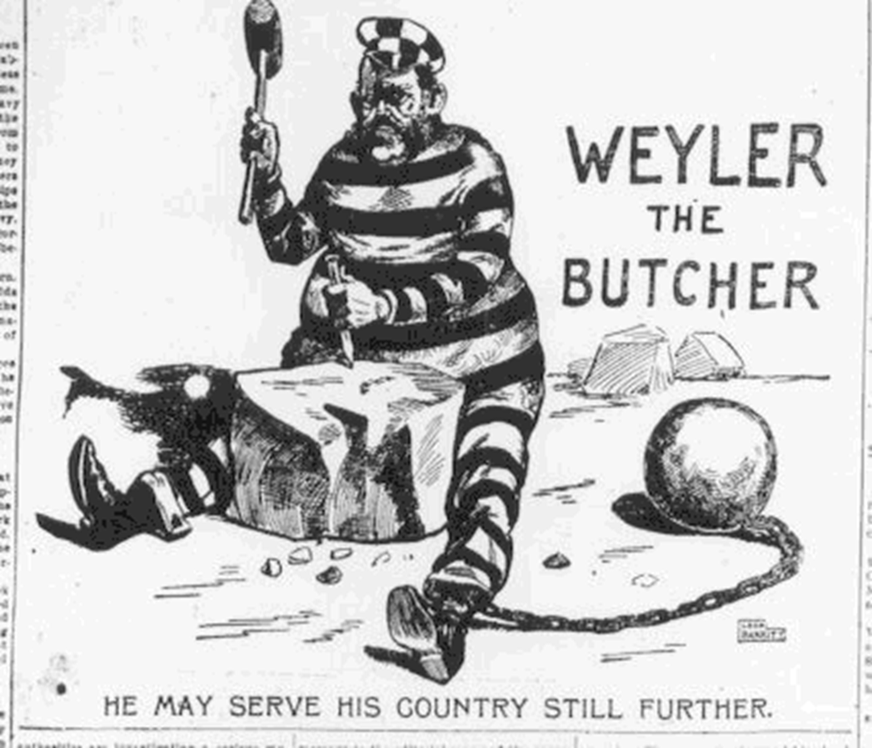 |  | Why was General Weyler nicknamed “the Butcher?”
C: Yellow Journalism  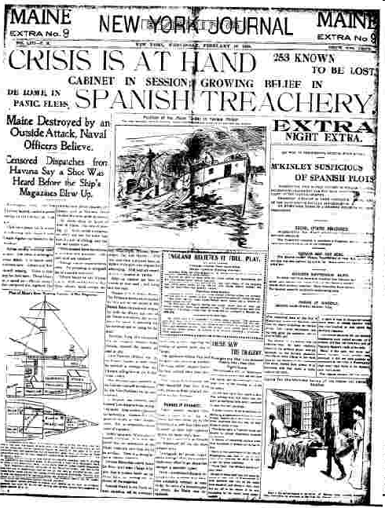 |  | How did publishers Hearst and Pulitzer influence the U.S. to declare war on Spain?
D. De Lome Letter  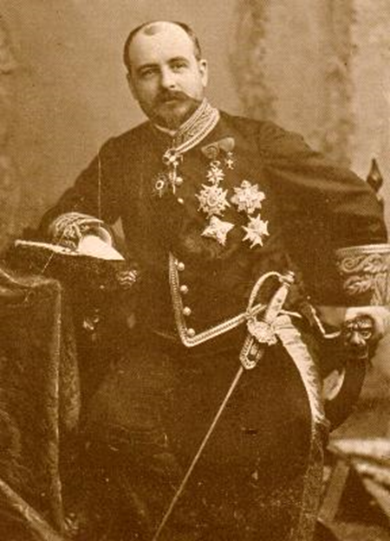 |  | How did the de Lomé letter help fuel U.S. anger towards the Spanish?
E: U.S.S. Maine  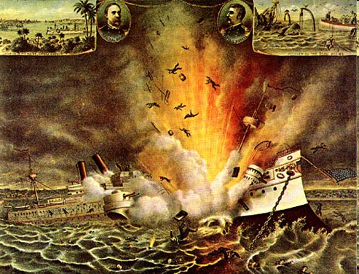 |  | Why do you think the ship was destroyed? Who did it?
E: Outbreak of war  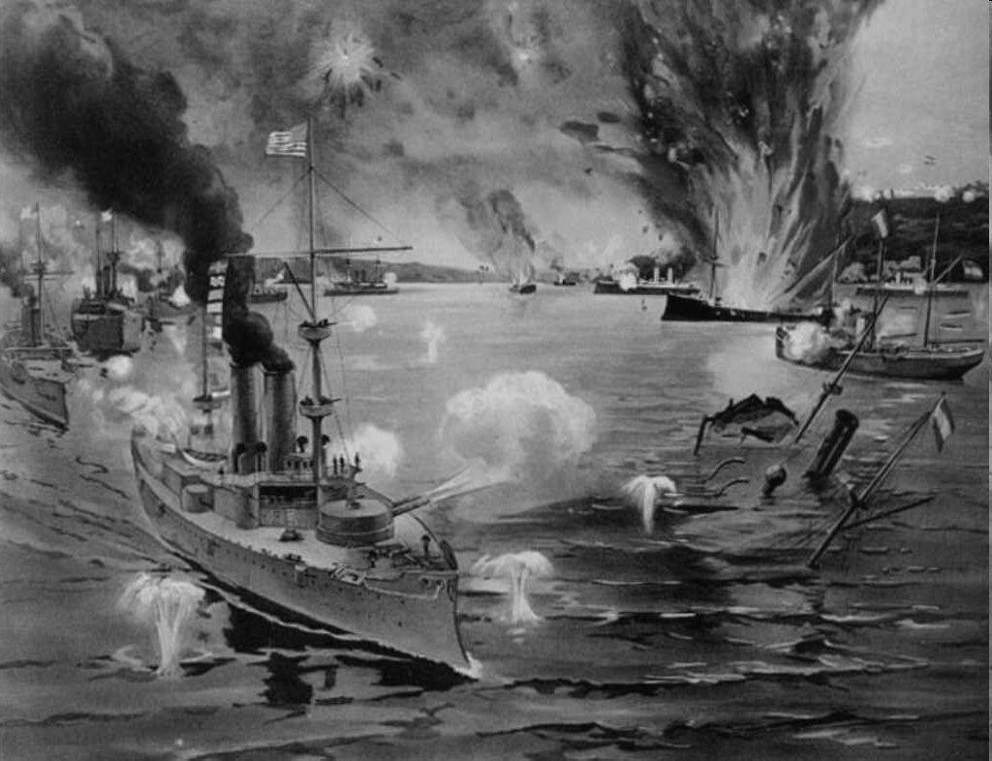 |  | Who appears to be winning in this image? Explain.
E. George Dewey  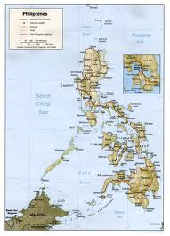 |  | In order to capture the city of Manila from the Spanish, who did Dewey get support from? How is it important to get the help of the locals?
F: Rough Riders  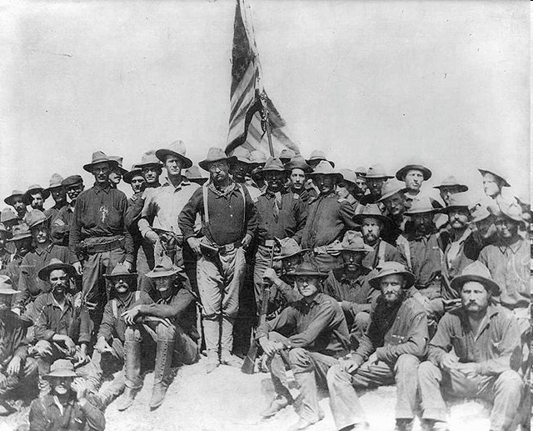 |  | Why are they carrying a flag? What do you think they have just done?
H: Treaty of Paris  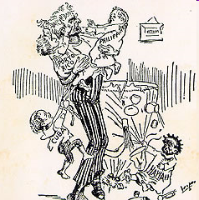 |  | What is happening in this cartoon? What was the artist’s message?

