Chemistry – Unit 2 Study Guide
Use your Mastery Checklist/Content Map to help you study. If you lost yours, there is a limited number of extra copies in the Extra Copies box in the back of the classroom.
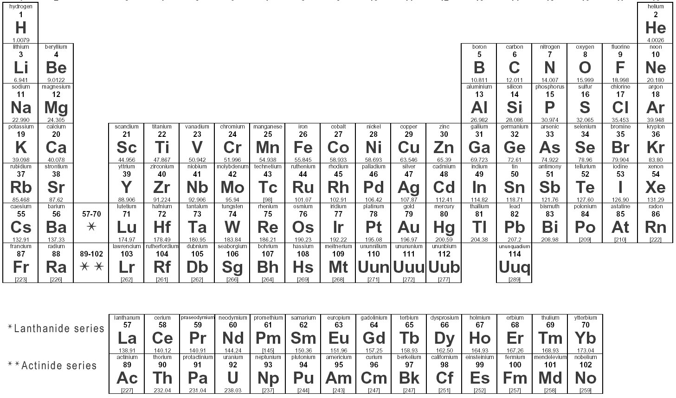
You will have this periodic table on your test, so make sure you are familiar with it/can read it.
You will need to create your own Aufbau diagram up through the seventh energy level. Use the one below as a guide and create your own next to it.
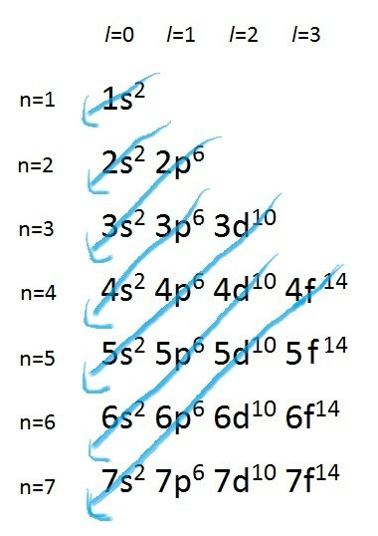
What you need to know about models of the atom:
Know the biggest contributions made by outdated models of the atom, including Bohr’s planetary model and the idea of energy levels for electrons; what Rutherford’s gold foil experiment taught us; how a cathode ray was used to detect electrons and later protons. Write notes about these ideas here:

Draw a model of the atom showing protons, neutrons, the nucleus and the electron cloud.

What role do neutrons play in the nucleus? Think about the charge of protons.

The electron dorm analogy again! Oh no! What does it mean?!? State which principle of quantum mechanics these analogies represent, then write the principle or rule using chemistry terms from your amazing book.
Electrons are lazy and prefer to live on the lowest floor available.

Electrons are super special and they don’t like each other, so they need their own room with its own special address.

Electrons will share a bathroom if they have to, but would prefer to have their own dorm suite if it’s available.

When electrons get excited, they go to a party upstairs and turn on all the lights.

Two electrons will share a dorm suite, but need their own room. What does the suite represent? The rooms?
In the dorm analogy, we use quantum numbers to find the electron’s address. Let’s connect those concepts again. Remember, you’re not responsible for knowing this on your test. You are only responsible for knowing how many electrons each orbital and each energy level will hold.
Energy level – n=1, 2, 3, … These are the energy levels Bohr found in his planetary model. In the dorm analogy, they are the floors of the building. Bohr was correct, electrons do have energy levels, but they are more complex than the circles we see in his model.
Orbital Shape – possible L values = n-1 (note that the letter we are using is a lowercase L, but I’m going to use an uppercase L so we can tell what letter it is when typed.) L values match an orbital shape – see table below.
Since L = n-1, this tells us what orbitals shapes are possible at each energy level. Looking at the aufbau diagram, we know that only an S orbital is possible at the first energy level, n=1. At the second energy level, we can have an S and a P orbital, etc…
L | Orbital shape | M_{L}  Directions this orbital is oriented | # at each energy level | M_{S}  Electron Spin within orbitals
0 | S | 0 | 1 | 1/2, -1/2
1 | P | -1, 0, 1 | 3 | 1/2, -1/2
2 | D | -2, -1, 0, 1, 2 | 5 | 1/2, -1/2
3 | F | -3, -2, -1, 0, 1, 2, 3 | 7 | 1/2, -1/2

M_{L} tells us the number of axis/directions the orbital is oriented. You don’t need to know the numbers, but you need to understand that the numbers tells us how many of each type of orbital is present at each energy level. So, at each energy level where a D orbital is present, there are 5 D orbitals all turned in different directions. There are 3 P orbitals, 7 F orbitals and 1 S orbital at EACH ENERGY LEVEL. See why it’s more complicated than Bohr’s planetary model? This is why the electron cloud takes up SO MUCH SPACE compared to the nucleus. It has to fit a lot of electron orbitals in there.
Finally, M_{S} tells us which way the electron is spinning. Since they repel each other, they need to spin in 2 different directions when they share an orbital. (The orbital is the suite they share and the spin is the different rooms in the suite… oops, I just gave away an answer…)
What you actually have to know for the test:
Energy Level | Orbitals at that Level
1 | S
2 | S, P
3 | S, P, D
4 | S, P, D, F
5 | S, P, D, F
6 | S, P, D, F
7 | S, P, D, F
At each energy level, the S orbital will hold 2 electrons
At each energy level, the P orbital will hold 6 electrons
At each energy level, the D orbital will hold 10 electrons
At each energy level, the F orbital will hold 14 electrons
The aufbau diagram shows us which order the orbital levels will fill in.
That’s it. Like I said, you won’t be responsible for quantum numbers in high school, I just want you to know WHY the orbitals work the way they do.
Write the COMPLETE electron configurations for these elements. That means, do it the LONG WAY. You’ll be asked to do both on your test, so make sure you know how to read directions before then. ;)
I did the first one for you
Phosphorous
P - 15e⁻ 1s²2s²2p⁶3s²3p³
Silver

Strontium

Krypton

Iron

Thorium

Bismuth

Sulfur

Magnesium

Review – abbreviated electron configurations. Look at the complete electron configurations you did above for Strontium and Krypton. But brackets [ ] around the parts in Strontium that are the same as Krypton. This is where you can use noble gases (they’re special because each electron level is full) to abbreviate.
Abbreviated electron configurations
Look to the Noble gas(far right) one row ABOVE the element you’re using to start you abbreviated configuration. This takes care of a bunch of electrons because it sums up all the previous energy levels using one symbol. Subtract those electrons from the total you need to use in your configuration.
Now, you need to figure out the next energy level so you can pick up where the noble gas left off. Go back to your original element and find what period(row) it is in – use the numbers on the right of the periodic table or count down from Hydrogen to find out.
Whatever period you are in, you will start with that energy level’s S orbital.
Now write the ABBREVIATED electron configurations for the following elements.
Arsenic

Zirconium

Tungsten

Rubidium

Abbreviated configurations for Actinide and Lanthanide series elements – remember, these elements still belong in period (rows) 6 & 7. Imagine they are sticking out the back of the periodic table, connected by Lanthanum and Actinium. Find which row they connect to so you can find the correct noble gas and energy level.
Europium

Neptunium

Abbreviated configurations for Noble Gases – you can’t just write the noble gas and be done, that’s sorta cheating. You need to start your abbreviated using the noble gas one row above it, just like you would for any other element.
Neon

Xenon
About Atoms…
What does the atomic number of an element represent?

What does the atomic mass of an element represent?

Assuming an atom is neutrally charged, the number of electrons are equal to _________________ and _____________.

Draw an atom, label the subatomic particles.

What part of the atom is different and therefore changes the atomic mass when isotopes are present?

Finding average atomic mass when there are isotopes
When talking about average atomic mass, we can’t just average the mass numbers for each isotope, because some of them are rarer than others. If we added them up and divided by the number of masses, we would have skewed results.
So, we use this formula to find the relative mass of an isotope: Abundance x Isotope Mass = Relative Mass
Then, we add all the relative masses to get the average atomic mass for the element.
The easiest way to do this, is to use a table.
Isotope Name | Abundance (as a decimal) | Isotope mass | Relative Mass
Number of rows will depend on number of isotopes
 |  | Average Atomic Mass

Calculate the Average Atomic Isotope for the following elements:
Naturally occurring europium (Eu) consists of two isotopes was a mass of 151 and 153. Europium-151 has an abundance of 48.03% and Europium-153 has an abundance of 51.97%. What is the atomic mass of europium?

Strontium consists of four isotopes with masses of 84 (abundance 0.50%), 86 (abundance of 9.9%), 87 (abundance of 7.0%), and 88 (abundance of 82.6%). Calculate the atomic mass of strontium.

Properties of Matter
What’s the difference between an element, a compound and a mixture?

What’s the difference between a homogenous mixture and a heterogeneous mixture?

What is the formula for density?
You have a 15 mL sample of liquid that weighs 19 g and a mysterious rock that displaces 18 mL of water and weighs 5 g. Find the density of the water and the rock. If you put the rock in the liquid, will it float or sink? Why?

The density of oil is .94 g/mL. The density of vinegar is 1.23 g/mL. You attempt to mix these to make a salad dressing, but they won’t stay mixed for long because they don’t like each other. When they separate, which will be on top?

Intensive Properties of matter DO NOT depend on the amount of a substance, whereas Extensive properties do. Think about Minestrone Soup and its properties. Which are intensive/extensive? Mark each one with INT or EXT.
It’s HOT
It’s a heterogeneous mixture
It has pasta in it
There is a one gallon pot of soup
There are 7 carrots in it
The broth is brownish-red
NOW – Add one intensive and one extensive property of your own
Physical and Chemical Changes
A chemical change occurs when the molecules of a substance rearrange to form different molecules. Everything else, including making or separating a mixture and state changes, is a physical change.
What are the four signs a chemical change has happened?

