- What is a vascular plant?

- Differentiate between angiospermophytes and gymnospermophytes.

- Complete the table below to differentiate between monocotyledons and dicotyledons.
You may use labeled diagrams if you wish.
 | Monocotyledon | Dicotyledon
Examples
Number of cotyledons
(first leaves)
Roots
Stem tissue distribution
Leaves
Flowers

For much of the remainder of the unit we focus on dicotyledons (dicots), which are examples of angiosperms. Be sure to use dicot examples in any research you carry out.
- In the space below, draw and label a tissue plan (low power) diagram of a dicot stem.

- Draw and label a tissue plan diagram of a dicot leaf.

- What are the functions of the following leaf structures?
How does their position/ distribution in the leaf relate to their function?
Structure | Function | Distribution/ function relationship
Waxy cuticle

Palisade mesophyll

Spongy mesophyll

Vascular bundle i. xylem

ii. phloem

Guard cells and stomata

- Give named examples of the following modified leaf, root and stem structures:
Example: | How is it modified? | Image:
Leaf: tendril
e.g. Bignonia
Leaf: bulb
Stem tuber
Root tuber
- Define meristem.

- Why is one more likely to find cells in mitosis in a meristem than in other plant tissues?

- Differentiate between apical and lateral meristems in terms of location and function in the stem.

- Compare the functions of apical and lateral growth.

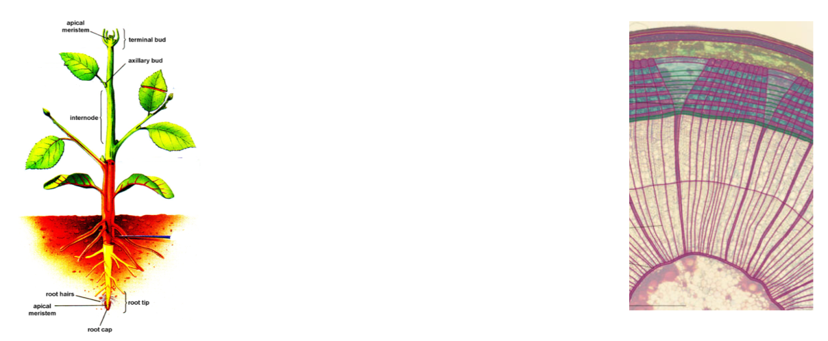
- Compare methods of growth due to apical and lateral meristems.

- What is the function of the axillary bud?
What is the trigger to growth of a new shoot or branch?

- Define tropism.

- Compare these types of tropism:

 | Response to: | Positive or negative?
Phototropism
Geotropism
(radicle)
Geotropism (plumule)
Hydrotropism
- What is auxin?

- Explain, with the aid of a diagram, the role of auxins in phototropism.

- Outline how the following structures of the roots are beneficial to the plant:

- Branching roots

- Root hairs

- Tap roots

- Wide-reaching roots

- Match up the following mineral ions with their functions in plants:

Nitrates (NO₃⁻) |  | Stimulate root growth and flowering
Phosphates (HPO₄⁻) |  | Regulation of water use/ loss
Potassium (K⁺) |  | Amino acid/ protein production

- Describe these three methods of mineral ion movement through the soil to the roots:

- Diffusion

- Mass flow

- Via fungal hyphae (how is this relationship mutualistic?)

- Why do mineral ions need to be taken up by active transport in the roots?
(Go all the way back to membrane transport!)

- Differentiate between anions and cations.

- What is the source of energy used in active transport at the root hairs?

- Annotate the diagram below to explain the uptake of cations by mineral exchange.

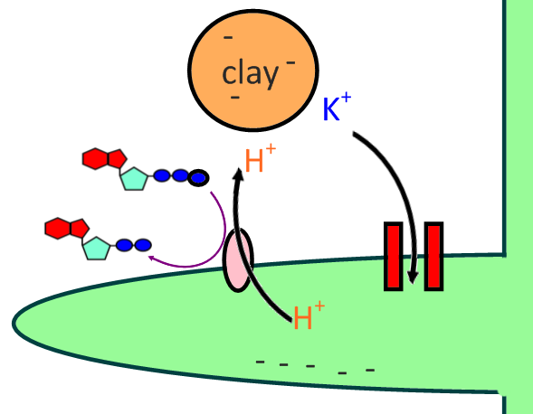

- Annotate the diagram below to explain the uptake of anions by symport.
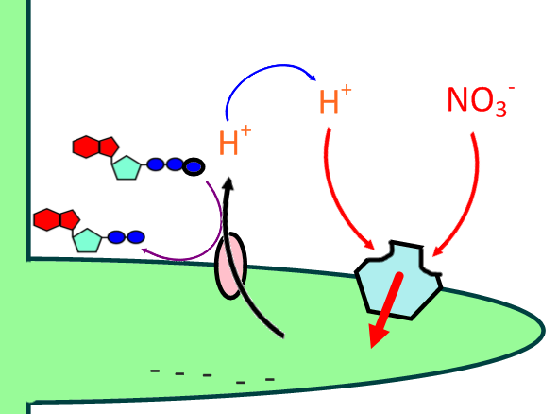

- Which one step in the methods outlined above is common to both symport and ion exchange?

- Describe how the following methods help support a plant:

- Thickened cellulose

- Lignified xylem
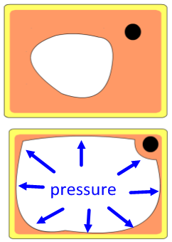
- Cell turgor

- Define transpiration.

- Annotate the diagram to explain how the structure of primary xylem facilitates transpiration.
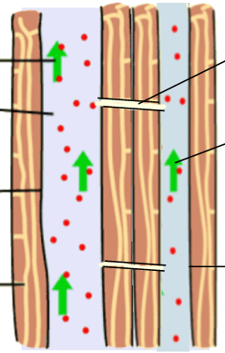

- How does water leave the leaves?

- Which property of water allows a transpiration pull to be generated?

- How does the action of guard cells allow the plant to balance CO₂ uptake with control over water loss?

- Which factors cause the opening of the stoma?

- Which hormone and other factors cause the closing of the stoma?

- Draw and label a simple diagram to show the open and closed stomata.
Include cell turgor, water pressure.

- What is a boundary layer?

- How does the presence of a boundary layer decrease the rate of evaporation from the leaf?

- Complete the table to explain how the following abiotic factors affect the rate of transpiration:

 | Effect | Reason
Temperature
Light
Wind
Humidity
- What is a xerophyte?

- What is a hydrophyte?

- Describe three physical adaptations of xerophytes to minimise water loss.

- Describe two life cycle adaptations of xerophytes to minimize water loss.

- Describe how the CAM plants metabolism is an adaptation to preventing water loss.

- Which three types of macromolecule are transported by active translocation?

- What is the function of phloem?

- Differentiate between source and sink.

- Complete the table below to show the sources and sinks of sugars and amino acids in plants.

 | Sugars | Amino Acids
Sources
Sinks

- Draw and label a simple line drawing of an animal-pollinated dicot.
Include all reproductive structures.

- Outline the steps involved in insect-pollination of a flower.
Begin with attraction of the insect to the flower.

- Describe the process of fertilization in a flowering plant.
Begin with the pollen grain on the stigma.

- Where does the seed develop?

- Give two advantages of dispersing seeds over a wide area.

- Outline some examples of these methods of seed dispersal:

- By wind

- By water

- By animal vector

- In the space below, draw a simple line drawing to show the structure of a green bean seed.
Label and include functions of: testa, micropyle, scar, radical and plumule

- What is germination?

- What are the functions of the following in the germination of a seed?

- Water

- Ideal temperature/ pH

- Oxygen

- Annotate the diagram below to outline the metabolic processes during the germination of a starchy seed:
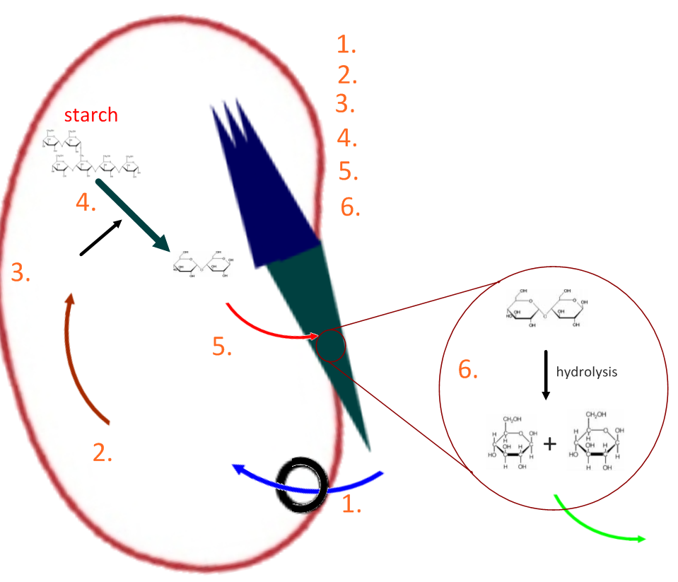

- Distinguish between long-day and short-day plants in terms of conditions needed for flowering.

- What is a phytochrome?

- Distinguish between red light and far-red light.

- Use the diagram below to help explain the interconversion of phytochromes during daylight and darkness.

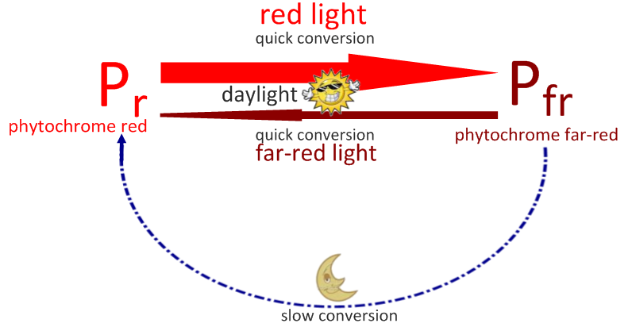

- Explain how phytochrome levels control flowering.

- In short-day plants.

- In long-day plants.

- Describe the results of one experiment to show that it is in fact night-length that is critical in triggering flowering.

