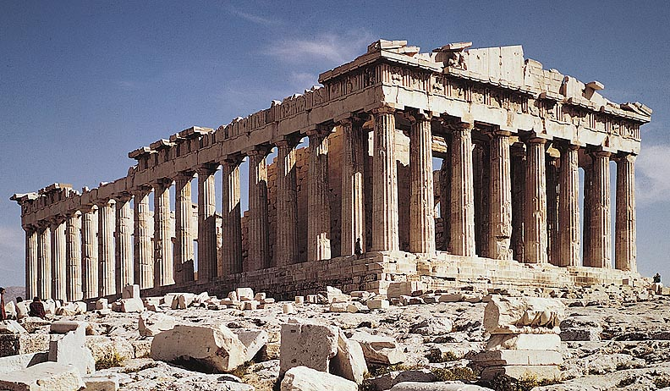

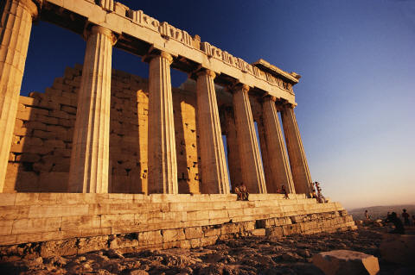

TABLE OF CONTENTS
- COVER PAGE
- TABLE OF CONTENTS
- GREEK ALPHABET HANDOUT
- ANCIENT GREECE PACKET
- KWL

