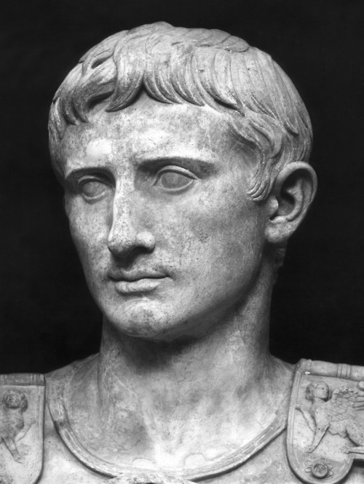
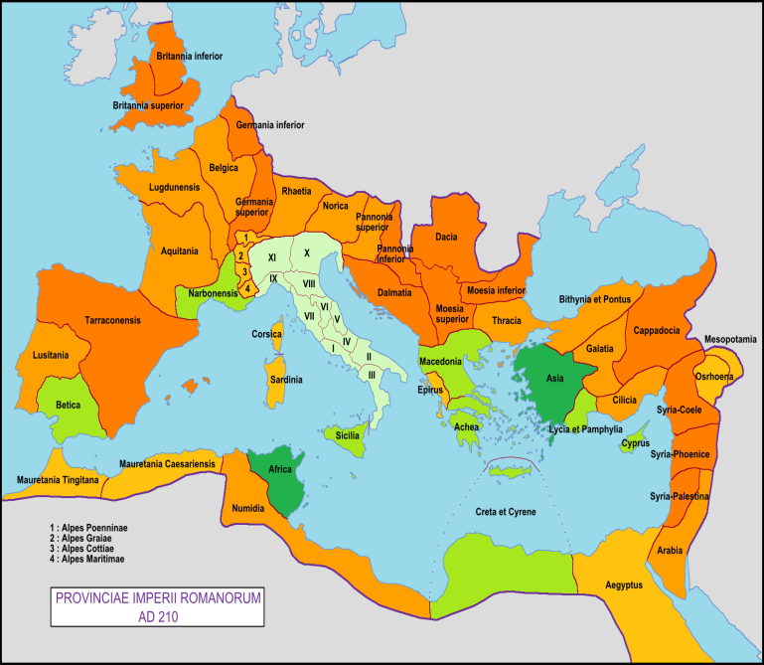

TABLE OF CONTENTS
- COVER PAGE
- TABLE OF CONTENTS
- PPT ON ROMAN EMPIRE

