Project: HON Name
The Phase of Meiosis Date pd.

The project – you and/or another person (1 or 2 people per group) will create that show the different stages of meiosis I. In addition to your models there are ___ additional parts that must be completed along with your models. Read on for more information.

Part 1, Option 1 – The
With this option you will create 3 dimensional models of an cell going through the stages of . Your models should depict each phase of meiosis I as realistically as possible. Your models must include all the directly involved in each stage of meiosis I. In this option, your models must be ! That’s right, we should be able to eat your phases of meiosis I! You can build your models out of cakes, brownies, jello, pizza, pancakes, candies, pasta, bread, fruits, vegetables, rice, etc. The list goes on and on! Just be sure that after the presentation of your model, we can eat it!

Part 1, Option 2 – The Model
With this option, you will create 3 dimensional of an animal going through the of meiosis I. Your models should depict each phase of meiosis I as realistically as possible. Your models must include all the organelles involved in each stage of meiosis I. In this option, your models will be made of out non-perishable items.

Part 2, the for each stage of meiosis I

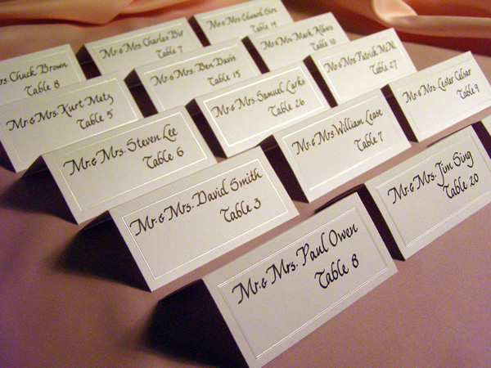 | In this part of your project you will have description cards. There is no size limit on your description cards. The cards have to be able to ______________ upright and must large enough to include the following requirements.  - ___________________of the stage.  - ___________________(hand drawn or from internet) of the stage  - The main ____________________ that take place in the stage.

Part 3, a description card with the – in this section you will create a description card that describes “what” represents each ______________ during the different stages of _________________.  For example if my models were cakes:  - Cytoplasm – vanilla frosting  - Nucleus – blue frosting  - Centrioles – red liquorish  - Spindle fibers – twizzlers  - Cell membrane – cake  - Chromosomes - twix | Part 4, Put it on the website!  - Take a picture of each model with its description card.  - In an organized manner, place the picture of each stage of meiosis I. For each picture you must have the following  - Title of the stage  - Events that take space during that stage (same information you wrote on the description card)  - Write a reflection on this project .  - What is your overall reaction to this project?  - Did this project help you learn the phases of meiosis I? Why or why not?  - If you had to complete this project again, what would you do differently?

Turn in this rubric to me the day of presentation.
My models are location at station # _____

Category  60 pts. possible | Excellent  10-9 pts. |  | Good  8 pts. |  | Satisfactory  7 pts. |  | Need Improvement  6-0 pts.
Display  _______pts. received | The models are attractive & well organized. The items are neatly & securely attached to the display. It is obvious extra effort was put into this model. |  | The models are attractive & well organized. The items are neatly & securely attached to the display. |  | The models are somewhat organized. The items are attached to the display. |  | The models are not attractive nor is it organized. The items are not neatly nor securely attached to the display. It is obvious that no effort was put into this model.
Accuracy  Weight X 2!  _______pts. received | The models accurate display the stages of mitosis! All organelles are structurally & proportionally correct to the size of the cell. The items chosen resemble the organelle accurately! |  | Most of models accurate display the stages of mitosis. Most organelles are structurally & proportionally correct to the size of the cell. Most items chosen resemble the organelle accurately. |  | Some models accurately display the stages of mitosis. Some organelles are structurally & proportionally correct to the size of the cell while others are not. Some items chosen resemble the organelle accurately. |  | The models and or organelles are not accurate.
Creativity  _______pts. received | A lot of thought & effort was put into making the model interesting and fun to look at. Creative materials were used to represent the organelles. |  | The group put some thought & little effort was put into making the model interesting and fun to look at. Some creative materials were used to represent the organelles. |  | The group tried to make the model interesting and fun to look at. Some of the materials used made it harder to distinguish the organelles from each other. |  | Little thought was put into making the model. No effort whatsoever was put into this project.
Required Elements  Organelles  _______pts. received | The model includes all organelles directly involved plus extra-added structures. It is obvious this model went beyond what was required. |  | The models include the organelles directly involved in mitosis. |  | Some models include the organelles directly involved in mitosis while others are missing organelles. |  | Some models are missing organelles directly involved in mitosis.
Required Elements  Stages  _______pts. received | All stages of mitosis that were required have a model. |  | One of the required stages of mitosis is missing a model. |  | X |  | Two or more of the required stages of mitosis are missing models.
Required Elements  Description  Cards  _______pts. received | All models have a description card (3x2) that accurately describes the events taking place during that stage of mitosis and an illustration. |  | One of the models are missing a description card (3x2) that accurately describes the events taking place during that stage of mitosis and an illustration OR one of the description cards is not accurate. |  | X |  | Two or more of the models are missing a description card (3x2) that accurately describes the events taking place during that stage of mitosis and an illustration OR two or more of the description cards is not accurate.
Is it on the website?  _______pts. received | Yes it is! |  |  |  |  |  | No it isn’t
Class grade on models  _______pts.received | A+ | 10 | B+ | 8.8 | C+ | 7.8 | D | 6.5
Class grade on models  _______pts.received | A | 9.5 | B | 8.5 | C | 7.5 | D- | 6.0
Class grade on models  _______pts.received | A- | 9 | B- | 8.0 | C- | 7.0 | F | 5.0
 | TOTAL POINTS RECEIVED OUT OF _____pts FOR MITOSIS PROJECT

