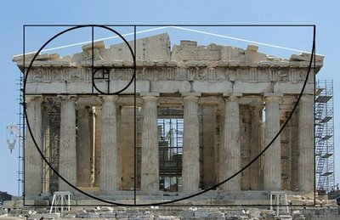



= 1.618

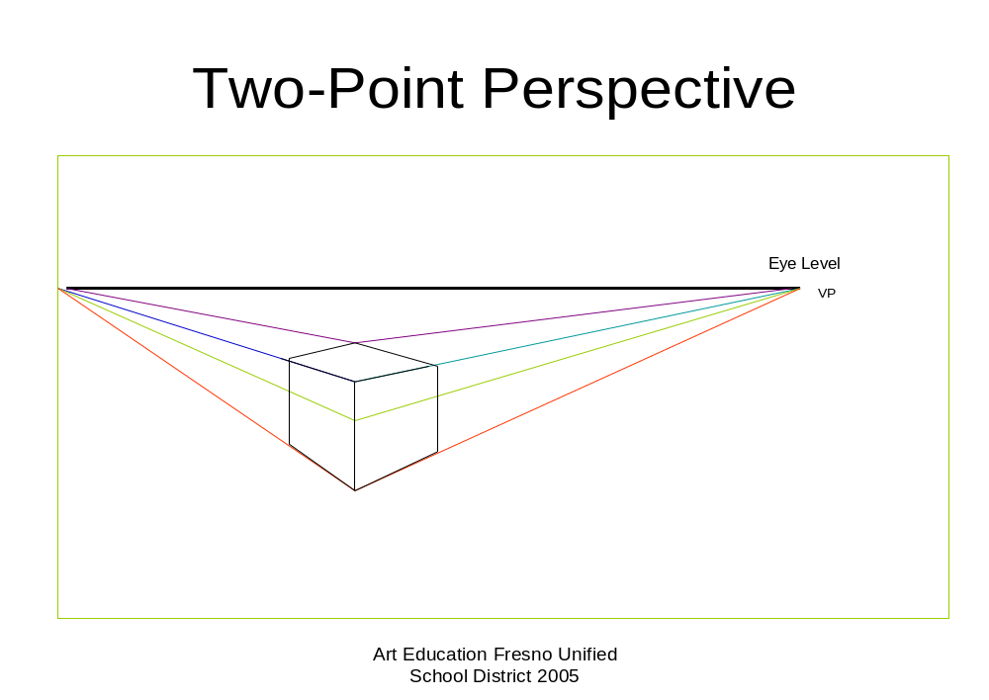

- First, draw a horizon line across the top of the page. Mark two vanishing points, as far apart as possible.

- Draw a short vertical line for the front corner of a box and then draw a construction line (orthogonal) from the top and bottom of the line, to each vanishing point.



- Next draw a vertical line to the left of the 'front corner', between the top and bottom construction lines). From the top and bottom points of this line, draw construction lines back to the RIGHT vanishing point (VP2). Next, draw a similar vertical line to the right of the 'front corner', and from the top and bottom points of this line, draw construction lines back to the LEFT vanishing point (VP1).

