A. Winter and summer  Closest, farthest from the sun. Winter tilt Away, summer tilt toward from the sun. | D. Vernal and Autumn, Spring and Fall. Tilt toward the same side of the sun. | G. Rotation is on the axis running through the poles, day. Revolution around the sun, year.
B.  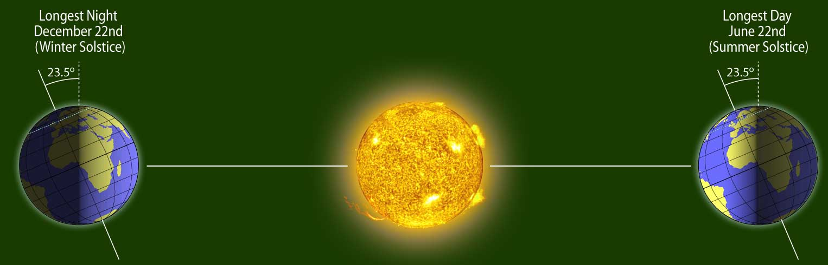 | E  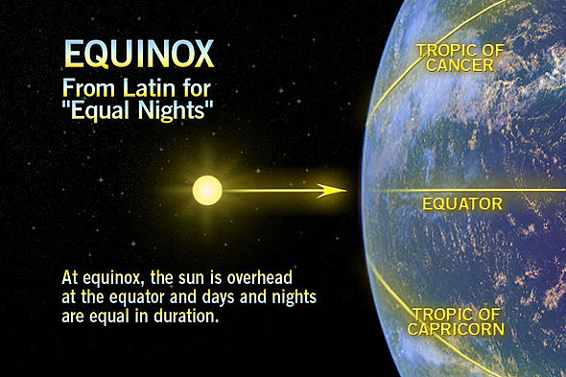 | H  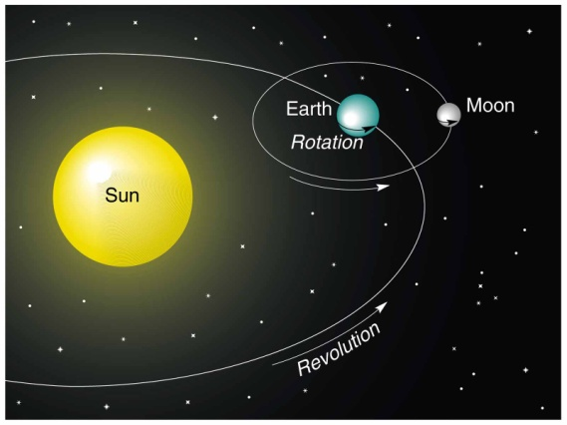
C  Solstice with the longest day is the_____  Solstice with the longest night is the_____ | F  Equinox means ______ in Latin.  We are in the northern hemisphere therefore the Sun will be over the tropic of ______ during Summer. | I  There is a leap year because...it takes approx. 365 days plus 6 hours.  The moons revolution is the same length as the rotation because...

1  Solstice | 2  Equinox | 3  Revolution Rotation

