The Forbidden City was majestically built at the very heart of Beijing, and has served as the home of 24 emperors of the Ming Dynasty (1368–1644) as well as the Qing Dynasty (1644–1911). This palace was first constructed in the year 1406, during the 4th year of Ming Dynasty’s Emperor Yongle. It was completed in 1420.
During the ancient times, Emperor Yongle was believed to be a son of heaven and was thought to possess supreme power bestowed upon him. Hence, the residence of the Emperor here on earth is designed to be a reproduction of the Purple Palace, where it is believed that God lives in heaven.
Having been regarded as a divine and sacred place, the Forbidden City got its name due to the fact that ordinary people are forbidden from entering it, only high ranking officials could enter the palace walls
As part of its security, the Forbidden City is constructed fully enclosed by a 10-meter high of solid defensive walls, with an impressive circumference measured at 3,430 meters. At every angle of the palace is a magnificently designed watchtower, which was heavily protected centuries ago. In addition, there is a moat that serves as its first line of protection.
The Forbidden City spans across an area of 178 acres, boasting a total floor space of 150,000 square meters. It is made of impressive 90 palaces and courtyards, with a total of 980 buildings as well as 8, 704 intricately furnished rooms. The Forbidden City is made up of two parts, the outer court and its inner palaces.
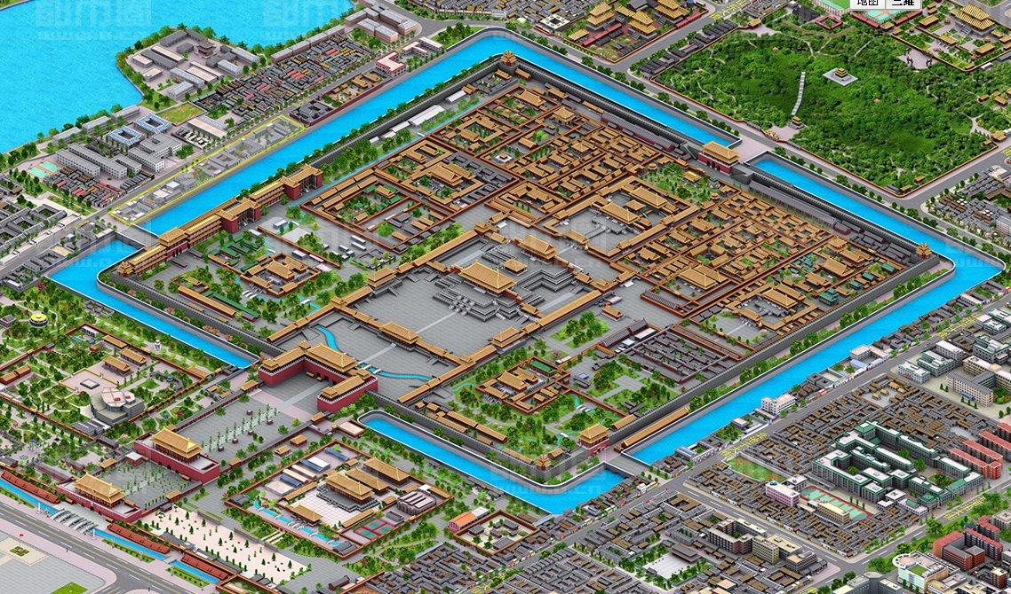
The Forbidden City

