FIGHTING HITLER

THOUSANDS OF JEWISH TEENS FOUGHT THE NAZIS DURING WORLD WAR II. BEN KAMM WAS ONE OF THEM.
BY LAUREN TARSHIS

You probably know a kid like Ben Kamm—the guy with big ideas and a quick smile, the one who will lead you off on an adventure and make sure you get home safely.
He grew up in a different place and time than you— in Warsaw, Poland, in the 1920s and ’30s—but he was enough like you and your friends that you should be able to picture him: a blond boy with bright-blue eyes, short but strong, his clothes rumpled from wrestling with his little brothers.
Try to imagine him, running through the crowded city streets with his friends, zigzagging around fancy ladies and fruit sellers and men with long, gray beards. you can hear him laughing with his friends and shouting goodbyes as they all head home for dinner.
But wait, do you hear that too? As Ben walks by a neighbor, the man hisses something.
Brudny Zyd.
Dirty Jew.
Ben’s skin prickles, but he doesn’t glance at the man. The truth is that he is used to these words. Anti-Semitism—prejudice against Jewish people—was a fact of life in Warsaw, as it was in many European cities. Like most of Warsaw’s 350,000 Jews, Ben doesn’t dwell on the petty hatreds of ignorant people. The man’s words are like the cold wind that blows off the nearby Vistula River.
Ben shivers for a few seconds. But he holds his head up and keeps walking. He quickly forgets about this man.
Keep picturing Ben in your mind as he walks up to his spacious apartment—where his four little brothers happily pounce on him, where his father looks up from his evening paper and smiles, where his mother serves a delicious dinner in their cozy dining room. This is where Ben’s story takes a sharp turn into one of the darkest and most evil chapters in history: the Holocaust.
As Ben’s family is enjoying their dinner, Germany’s leader, Adolf Hitler, is plotting the annihilation of Europe’s 9 million Jews.
Germany had been struggling since 1918, when it was defeated in World War I. The German people felt humiliated, tired, and bitter. Hitler and his Nazi Party rose to power by tapping into these feelings. Hitler declared that Germans were superior to everyone else. He also found a scapegoat for all of Germany’s problems: the Jews.
In speech after speech, Hitler attacked Europe’s Jewish people. He compared them to “vermin,” calling them “subhuman,” and “an inferior race.” These words fanned the flames of centuries-old bigotry against Jewish people, whose religion and rituals had often kept them separate from the rest of the population.
“Eliminate the Jews,” Hitler exclaimed, “and you will eliminate all of Germany’s problems!”
Soon, many Germans turned against their Jewish neighbors. Synagogues were destroyed. Jewish-owned businesses were burned and vandalized. By 1945, 6 million Jewish men, women, children, and babies would be dead. Nazi troops and their collaborators shot them, starved them, worked them to death, and systematically murdered them in the gas chambers of death camps. But in the days before World War II, when the Kamms were happy and comfortable, nobody could even conceive of such horrors. “Who could imagine such things?” Ben would say decades later. “Who could imagine?”

Nazi Invasion
Ben was 18 when, in 1939, German troops invaded Poland. With shocking swiftness and brutal efficiency, the Nazis and Polish police cracked down on Warsaw’s Jews. Many Jewish-owned businesses, including Ben’s father’s, were confiscated. Jews were not allowed to set foot in public parks, use public libraries, or go out after 9 p.m. Those who violated these laws could be shot on the spot.
The Kamm family often spoke about leaving Poland, but they had nowhere to go. Germany was at war with England, France, and the Soviet Union, and the Nazis controlled a vast expanse of Europe. All of the borders were closed.
Then, on October 16, 1940, all of the Jewish people in Warsaw and its surrounding towns were rounded up and forced to move into one tiny area of the city. The area, which became known as the Warsaw Ghetto, was surroundedby an 11-foot wall topped with barbed wire and broken glass.
Armed police herded hundreds of Jews through the streets. Ben looked with sorrow at those around him—women holding tight to their babies, men in business suits, teachers from his school, little girls wearing their finest dresses and shoes. One man, a well-known violinist, carried only his instrument. No one was permitted to bring more than a few belongings.
Ben saw a sneering policeman shove an old woman who lagged behind the crowd. The policeman’s eyes were filled with disgust. Ben gripped his littlest brother’s hand, his heart pounding with fear and hatred. He realized then that the Nazis and their Polish helpers did not see them as humans. He felt like an animal—a helpless animal.
Ben’s family moved into one room. The ghetto gates closed. And nobody was allowed to leave.

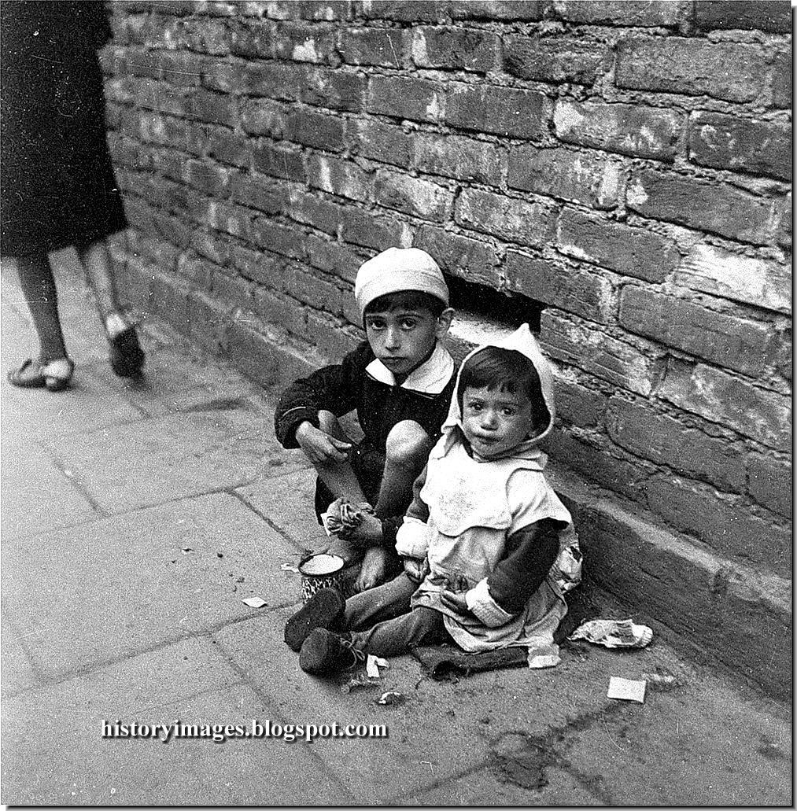
Children in Warsaw Ghetto

Terrible Rumors
Rage at the Nazis burned inside Ben as conditions became more desperate. One day, a policeman drove through the streets with a smile on his face, firing his gun. He killed a pregnant woman. An epidemic of typhus swept through the crowded apartments, killing thousands of people. Bodies piled up in the streets. Each week, police rounded up people to work as slave laborers. None returned. People heard terrible rumors that the Nazis had set up death camps where Jews were being killed in gas chambers.
Each ghetto resident was entitled to a tiny ration of food, barely a tenth of what a person should eat each day. Like many young people, Ben soon learned tricks for sneaking out of the ghetto to find food for his family. There were holes in the wall and tunnels that led to the other side. With his blond hair and blue eyes, Ben blended in easily with the Polish population. Plus, he had an aunt on the outside. None of her neighbors knew she was Jewish, and she managed to help Ben without attracting suspicion.
But even with his aunt’s help, Ben and his family were slowly starving. They could do nothing, it seemed, other than wait for death.

Jewish Fighters
As Ben would soon learn, there was something he could do after all—if he dared. All around Eastern Europe, tens of thousands of people, including thousands of Jews, were fighting back against the Nazis. They were called partisans. Like characters out of The Adventures of Robin Hood, they operated from bases hidden deep in the thick forests of Eastern Europe. Some were hardened fighters. Others were teenage boys (and a few girls). They blew up factories, sabotaged railroads, stole weapons shipments, and upset the flow of supplies to German troops.
In several partisan forest camps, fighters protected large numbers of Jewish families who had escaped from the ghettos. The most famous was commanded by the Bielski brothers, three Jewish men who’d fl ed when the Nazis invaded their village in Belorussia (now called Belarus). The brothers fought German troops and ran sabotage missions, though their focus was protecting
a community of 1,200 Jewish men, women, and children.
Stories about partisans like the Bielskis spread through the Warsaw Ghetto, offering a glint of hope to boys like Ben. One day, Ben’s aunt told him about a Polish partisan group in a forest 100 miles away. With his family’s blessing, Ben snuck out of the ghetto and joined up.
Ben struggled to adjust to life with the partisans. He learned to shoot, to fall asleep on the cold forest ground, to endure days in rain-soaked clothing, and to ambush Polish policemen and steal their weapons. Danger lurked everywhere in the hostile countryside, where Poles could earn rewards for turning in Jews to the Nazis. But Ben’s rage had toughened him. His bravery and skill soon earned him the respect of the most experienced fighters.
Just months after joining the partisans, Ben received word that his family in Warsaw was in dire straits. He rushed back to help them and was shocked by what he found. Orphaned children begged on the street. The dead lay slumped in doorways. His family lived in despair, sharing their single room with three other families.
Ben stayed for two days, sneaking in and out of the ghetto to steal food for his family. He considered taking his brothers back to the forest with him. But many in the ghetto believed that the war would soon be over, that the Soviet army would crush Hitler’s troops and free the Jews from their ghetto prison. Ben’s parents believed the younger boys would be safer in the ghetto.
For the rest of his life, Ben Kamm would break down in tears when he recalled the moment he left his family to rejoin the partisans.
He would never see them again.

Luck and Sorrow
For the next two years, Ben fought with a legendary band of partisans commanded by a former Soviet general. Their group eventually grew to 1,600 fighters operating from a large compound in the forest. The compound became almost like a town, with cobblers who repaired damaged shoes and musicians who provided moments of joyful escape.
Ben volunteered for dangerous missions blowing up cargo trains carrying supplies meant for German troops. Often, the group discovered Jews hiding in the forests.
“We took them with us,” Ben said. “Old, young, children. We took them with us and they survived the war.”
In 1945, the war finally ended with Germany’s surrender. Ben was 24 years old. There was little left of that laughing boy who once sprinted through peaceful Warsaw streets. His entire family was dead. The Nazis had “liquidated” the Warsaw Ghetto in 1943, first burning down buildings, then taking the surviving 42,000 men, women, and children by train to the death and forced labor camps. Most were killed in gas chambers.
Hitler committed suicide. Many of the men who helped murder Ben’s family and friends were executed for their crimes.
As for Ben, he married and moved to America, where he built a happy family and a successful life. Before his death last year, Ben spoke at length about his experiences. You can see him on video, his eyes still bright, his voice strong, his handsome face shockingly free of bitterness. The rage and sadness were still smoldering inside him, of course, but he also had a strong sense of his own good fortune.
“I can’t forgive the people who killed innocent babies, innocent women, innocent people,” he said.
“But I am lucky that I’m alive and can tell the story.”

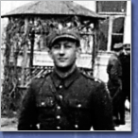

Ben Kamm in Chelm, 1945

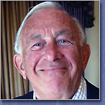
Ben Kamm before his death in 2010.

Questions:
Write your answers on the back of this packet or on a separate sheet of paper. Be sure to answer ALL parts of every question. Think critically! Write a minimum of 3 sentences for each question.

1) Go back and review the beginning of the article. Tarshis begins the piece in an interesting way. Discuss how she begins and her intent for beginning the story the way she does. Why does the author begin the story in this way? How does starting this way help you to connect with the piece?

2) After the war is over, what is the most painful memory for Kamm? Discuss WHY you think this is the most painful part of this atrocity for him.

3) What details provided by Tarshis give you a sense of the massive scale of the Holocaust?

4) Discuss what you find to be most shocking, painful, or moving from Kamm’s story.

