Part I Elodea Microscope Lab
Step 1— Preparing Elodea for Observation
- Take one plant from a finger bowl and break off one of the younger leaves near the tip of the branch.
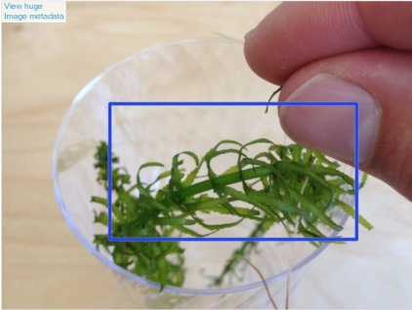

Step 2— Place Elodea on Slide ¶
- Place it bottom-side-up in a drop of water on a clean slide.
- Put on a coverslip
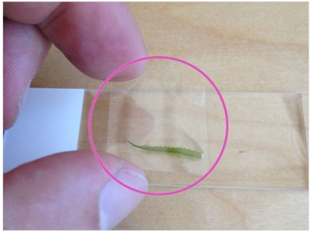

Step 3— Place Elodea Slide on Microscope Stage ¶
- Put your slide on the microscope stage and focus at low magnification (4x objective)
- Draw an image of the Elodea on your microscope lab sheet
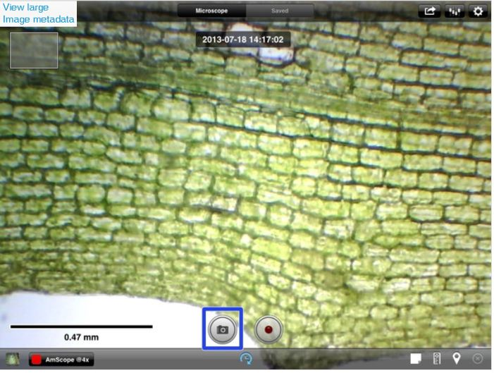

Step 4— Observe Elodea with 40x Objective
- Switch to and focus at high magnification (40x objective)
- Draw an image of the Elodea on your microscope lab sheet
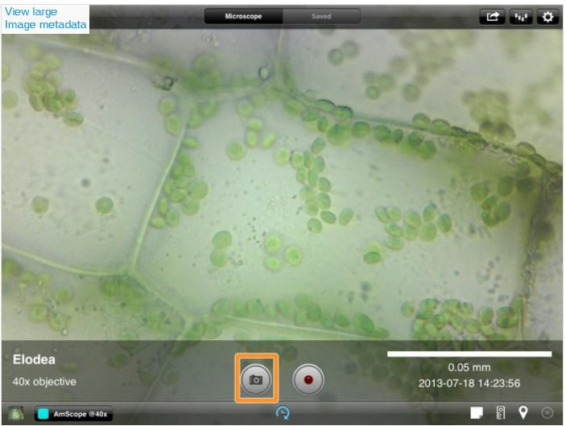
Part II Elodea & Photosynthesis Lab
Problem: To what extent does distance from a light source (5cm, 10cm, & 15cm) affect the rate of photosynthesis (measured in bubbles / 3 min.) in Elodea water plants?
Research: 1) According to your text in Ch. 4, what is the equation for photosynthesis?
2) Where do plant get the CO2 for this process (what organisms release this gas)?
3) What organelle in plants is responsible for photosynthesis (producing food)?
4) What is the pigment found in this organelle that absorbs light to power photosynthesis?
5) If a plant were under water and was photosynthesizing, what gas would be visibly bubbling from the plant?

Hypothesis:_______________________________________________________________________
_________________________________________________________________________________
PART A. Setting Up the Experiment
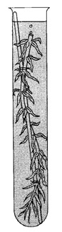
1. Obtain a green sprig of Elodea. Remove several leaves from around the cut end
of the stem. Slice off a portion of the stem at an angle and lightly
crush the cut end of the stem.
2. Place a small pinch of sodium bicarbonate into a test tube (this increases carbon
dioxide in the water).
3. Place the plant into the test tube, stem end up.
4. Filled the test with distilled water so that the stem is completely submersed.
PART B. Running the Experiment
1. Place a source of light about 5 cm from the plant.
2. Wait one minute
3. After one minute, count and record the number of oxygen bubbles rising
from the cut end of the stem for 3 minutes. If bubbles fail to
appear after 2 minutes repeat part A.
4. Run a second 3 minute trial at 10 cm from the light sources (sun, room,
overhead lamp, lamp, grow light). Record your results.
5. Run a third trial 3 minute trial with at a 15 cm distance from a light and
record your results.
6. Prepare a graph of your results. The X-axis will be distance from light (IV) and the Y-axis will be number of bubbles (DV) in 3 minutes.
Part I Elodea Microscope Lab

Elodea at 4x Magnification Elodea at 40x Magnification
Part II Elodea & Photosynthesis Lab
Problem: To what extent does distance from a light source (5cm, 10cm, & 15cm) affect the rate of photosynthesis (measured in bubbles / 3 min.) in Elodea water plants?
Research:
- According to your text in Ch. 4, what is the equation for photosynthesis?

- Where do plant get the CO2 for this process (what organisms release this gas)?

- What organelle in plants is responsible for photosynthesis (producing food)?

- What is the pigment found in this organelle that absorbs light to power photosynthesis?

- If a plant were under water and was photosynthesizing, what gas would be visibly bubbling from the plant?

Hypothesis:_______________________________________________________________________
_________________________________________________________________________________
_________________________________________________________________________________
Data Table:
Distance from light source (cm) | # Bubbles / 3 min

Graph (bar):
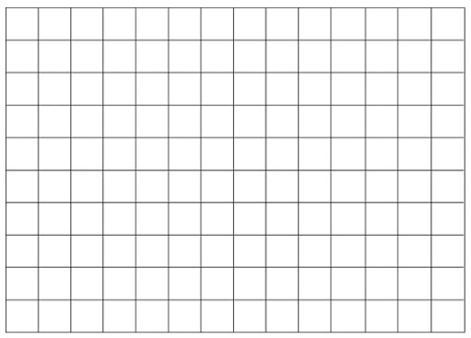
1) Did your data support your hypothesis? Explain.
2) What went well OR what went wrong with the experiment?
4) What new problems (questions for study) arose as you did this experiment?
5) What did you learn from this experiment?

