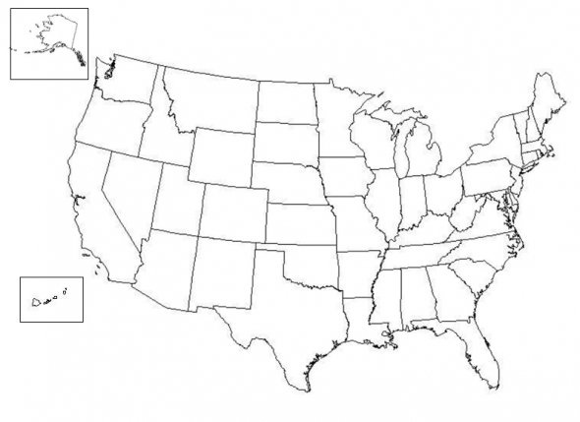

Western Frontier Map

Add the following features to the map on the back. Your map must be neat and colorful, and it needs to include a key.

____ Council Bluffs, Iowa
____ Sacramento, California
____ San Antonio, Texas
____ Abilene, Kansas
____ Rocky Mountains
____ Great Plains
____ Klondike Gold Rush
____ Colorado Gold Rush
____ Chisholm Trail
____ Transcontinental Railroad (just draw from its beginning to end, no branches)

How did each of the following physical and human geographic features impact the settlement of the west?
1. Great Plains

2. Gold

3. Transcontinental Railroad

